dream, believe, aspire, achieve

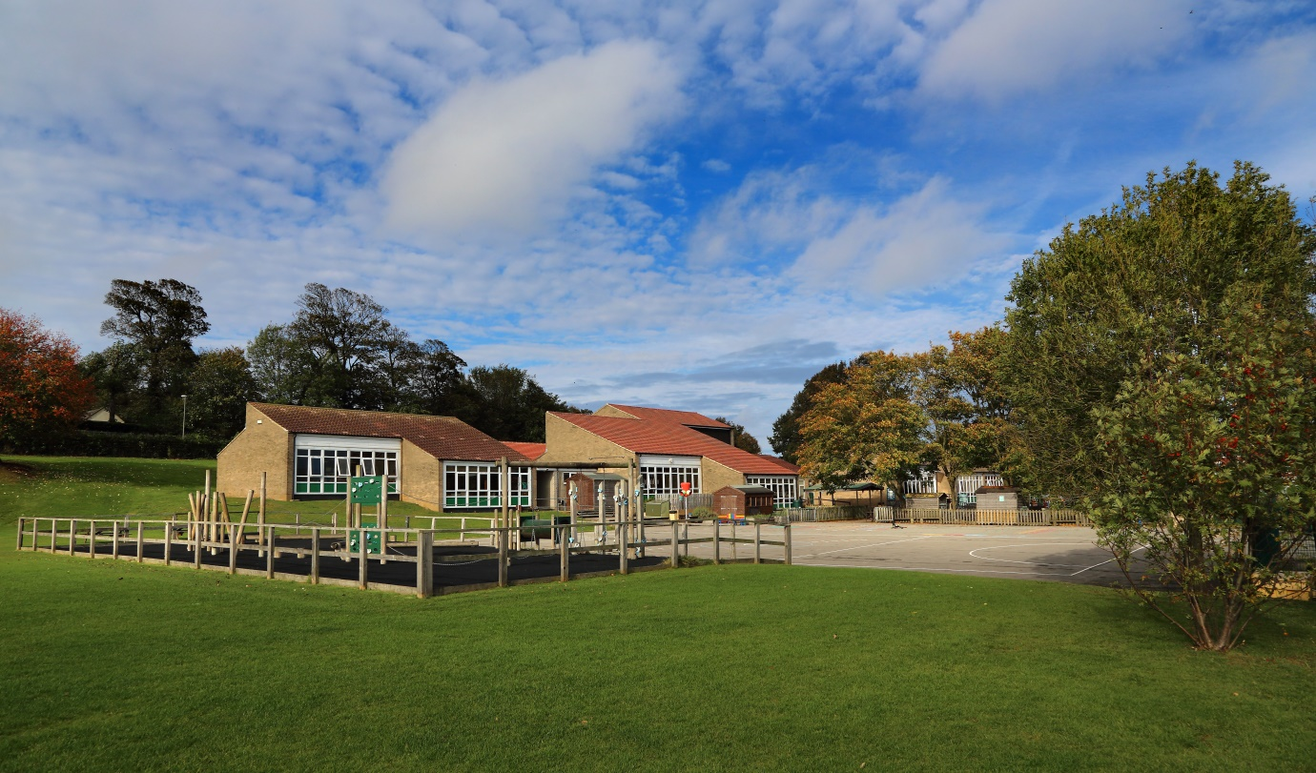

Airy Hill Primary School
Recruitment Information Pack

Y1 Class Teacher
Maternity Cover 10/1/2022 – 31/12/2022 (anticipated)

Welcome from the Co - Headteachers

Dear Applicant,

Allow us to extend a warm welcome from all governors, staff and children at Airy Hill Primary School. We are so pleased you have shown interest in joining us and we look forward to sharing with you, details about our wonderful school.

We are very proud of our school in which pupils succeed and flourish. They achieve well across the whole curriculum. We have a very strong school community where staff care for our pupils and their well-being. Children’s behaviour is excellent throughout our school and reflects our high expectations. Not only do pupils behave very well, but they look out for one another and are helpful, polite and welcoming to visitors. Children are keen to talk about how much they enjoy their learning. They feel safe and know that there are adults that they can talk to if they have concerns. Our school values run deeply through the life of our school and are easily identified by anyone visiting us. Relationships between adults, children and our wider community are excellent. Children learn about their local heritage as well as aspects of culture from around the globe - they value and celebrate the differences in each other.

Any new post in our school is an important part of our journey and we look for colleagues who share our ethos and values, understands our context and can provide the inspiration our children thrive on and deserve.

The school is part of the Yorkshire Endeavour Academy Trust. We are also a strategic partner in the Esk Valley Alliance and work closely with the English Hub. As such, we provide all our staff with substantial, high quality CPD throughout each year.

We hope that you will take the time to visit our school so that you can experience Airy Hill first hand.

We look forward to reading your application.

Catherine Matthewman and Chrissy Yates
Co - Headteachers

Dream, Believe, Aspire, Achieve
Airy Hill Primary School’s vision is to develop enthusiastic and ambitious citizens of the future equipped with the knowledge, skills and understanding to achieve their true potential.
Ambitious teaching and learning is delivered to ensure that every child meets their true potential
Independent learning skills are developed and promoted throughout the school
Reading is at the centre of all learning at school and at home
Young children are developed into positive, conscientious citizens with thoughtful behaviour and attitudes

Have a zero-tolerance approach to poor school attendance
Involve the community in extending a broad and balanced curriculum that excites children
Link the skills of fluency, reasoning and problem solving to create efficient mathematicians
Let children experience success and failure to create resilient individuals

What can Airy Hill Primary School offer you?
- Amazing children who will make you smile EVERY DAY!
- Outstanding School Leadership
- High quality CPD with opportunity to learn from the best locally and Nationally
- Opportunities to work with colleagues from across the Yorkshire Endeavour Academy Trust
- A friendly, welcoming and supportive staff team
- A thorough induction
- A robust package of support for Early Career Teachers
- Dedicated school governors

How well do children at Airy Hill Primary School

In 2019, the school’s results increased in a number of key areas from 2017 and 2018. As a school we feel incredibly proud of the improvements we have seen and of the hard work of children and staff alike.
You can read the official information about our school by following the link below but here are our data headlines:
Early Years
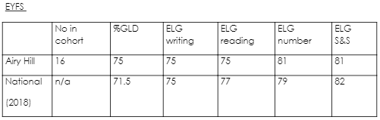
Phonics Screening Check
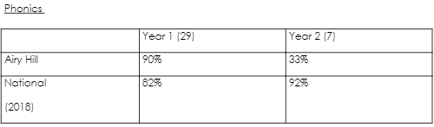
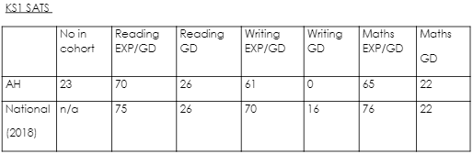
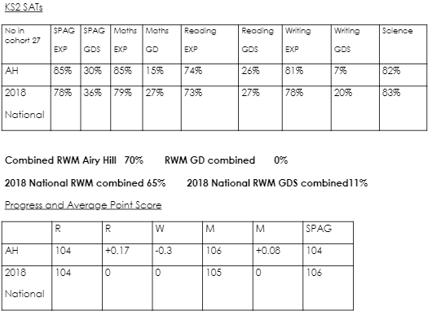

Where can you find more information about us?

Website: airyhill.n-yorks.sch.uk
Trust Website: yeat.co.uk
Facebook: facebook.com/Airyhillprimaryschool
Ofsted: reports.ofsted.gov.uk/provider/21/144679

Application Process

The closing date for applications is: Thursday 9th December 2021

Interviews will be held on: Wednesday 15th December 2021

Completed application forms should be returned to: garry.morrison@northyorks.gov.uk

If you think you’re the person for the job, please complete the attached application form to the email address above, by the closing date.

An email will be sent to shortlisted candidates with details of the interview process. If you have not heard from us within a week of the closing date, please assume your application has been unsuccessful.

Airy Hill School is committed to safeguarding and promoting the welfare of children and young people and expects all the staff and volunteers to share this commitment. We actively promote the fundamental British values of democracy, the rule of law, individual liberty, and mutual respect and tolerance of those with different faiths and beliefs.

Job Description
JOB TITLE: Class Teacher
GRADE: Main Pay Scale
RESPONSIBLE TO: Headteacher
RESPONSIBLE FOR: Deployment of support staff allocated (where relevant)
JOB PURPOSE: Promote effective learning, appropriate achievement and educational, social and personal progress of all pupils for whom the teacher is designated as being responsible, consistent with the aims of the school and the unique needs of each individual.
JOB CONTEXT: This school is committed to safeguarding and promoting the welfare of our pupils and young people. We have a robust Child Protection Policy and all staff will receive training relevant to their role at induction and throughout employment at the School. We expect all staff and volunteers to share this commitment. This post is subject to a satisfactory enhanced Disclosure and Barring Service criminal records check for work with children.
KEY RESPONSIBILITIES:
1. Develop and maintain an up-to-date knowledge and understanding of the areas of teaching and pupil support for which post-holder is responsible
2. Plan work to meet the learning needs of allocated pupils in a consistent and effective way
3. Use appropriate teaching and classroom management strategies to motivate pupils and enable each to progress
4. Monitor the progress of pupils for whom the postholder is responsible to set expectations and give constructive feedback
5. Maintain appropriate records to demonstrate progress made by pupils
6. Participate fully in professional development activities to develop practice further, sharing the learning from these as appropriate
7. Make an active contribution to the policies and aspirations of the school
To fulfil all of the requirements and duties set out in the current Pay and Conditions Documents relating to the conditions of employment of teachers
To fulfil all of the responsibilities and duties required by the School’s policies on teaching and learning.
To achieve any performance criteria or targets arising from the School’s Performance Management arrangements
Person Specification
Insert SP here

