job description
teacher of a-level physics
reports to: Head of Physics
hours: Part time (0.5), full time available if able to offer an additional subject.
salary: T1-T9 £30,500- £47,133 (FTE)
start date: 20th August 2024
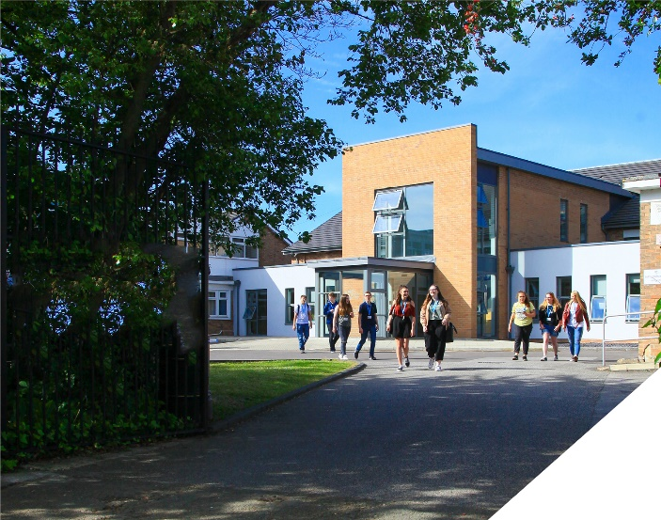
This is an exciting opportunity to teach A-level Physics in a thriving Sixth Form College.
about the role.
This is an exciting opportunity to join a successful Science Department at a highly regarded Sixth Form College. We seek to appoint a committed and hardworking Physics teacher who is keen teach exclusively at Post 16 level. Experienced teachers and NQTs are encouraged to apply. Whatever your experience you will be supported in a way that best supports your development in a College renowned for its innovation as well as the exceptional progress of its students.
The role is to teach A-level Physics, OCR Specification. This is a part time position with a 0.5 FTE, you will teach two A-level Physics classes over 4 days. However if you are able to offer an additional subject then a full time position will be considered.
The A-level Physics Course is a well-established course at the College which is becoming increasingly popular with over 70 students currently studying the subject. We seek to appoint a hard-working, committed Physics specialist who has a passion for the subject and is a positive role model for scientists of the future.
Within the department there is a real team ethos with regular opportunities for collaboration and dialogue with colleagues. The department has 8 fully equipped laboratories and has a team of 5 dedicated technicians to support with practical work and resourcing.
about the College.
You will be joining a highly successful, innovative and nationally recognised sixth form College. The College is currently College of Year awarded by Educate and has been graded outstanding in all areas by OFSTED in December 2016. All staff play a vital role in the experience that students have with us and ultimately their success.

The College currently has a 16 to 19-year-old student population of 1550. Demand for places for places at the College is very high and as a result the College has recently expanded with two new state of the art teaching blocks in September 2021. A further brand new 3 storey classroom block opened in April 2023 as part of the College’s expansion project.

In response to the pandemic and disruption to the learning of students the College introduced a new timetable in 2021/2022 to combat the deficits that students have. This includes teaching time increasing by 60 minutes each week we are confident that the 5.5 hours students receive each week is one of, if not the highest in the country. Whilst student teaching time has increased the new timetable has reduced the overall teaching time for teachers each week. Full time teachers will teach a maximum of 4 classes, 4 times a week and teachers have their own groups, we do not have shared teaching groups at the College.

The College is committed to its core values of Positivity, Ambition, Resilience and Thoughtfulness, and these values shape everything we do. Our ethos is centred on the scientific evidence that tells us that everyone can achieve success through purposeful hard work as opposed to the talent myth, and this enables learners to make rapid progress unshackled by any limits previously placed upon them.

person specification.
Qualifications | essential | desirable
Degree in a Physics of Physics related discipline | 
Qualified Teacher Status | 
Experience
Experience of teaching A-level Physics | 
Experience of teaching another related subject |  | 
Experience of working as an examiner for Physics |  | 
Experience of working in a demanding environment where high levels of organisation are required | 
Knowledge / Skills / Abilities
Ability to teach A-level Physics | 
Up to date knowledge & understanding of the OCR Physics specification | 
Ability to work flexibly as part of a team | 
Ability to form & maintain appropriate relationships & personal boundaries with young people | 
Ability to respond flexibly & creatively to new challenges & opportunities | 
Ability to prioritise & meet deadlines | 
Ability to use Information Technology effectively | 
Excellent communication, interpersonal & organisational skills | 
To demonstrate a commitment to
The Colleges values of Positivity, Ambition, Resilience & Thoughtfulness | 
Personal development and training | 
Safeguarding & promoting the welfare of students | 
Equality & diversity | 
how to apply.
If you are ambitious and determined to make a meaningful difference in one of the country’s leading sixth form colleges then we would be thrilled to have you join our team.

- Please complete the Teacher Application Form which is available on the College website: www.bsfc.ac.uk
- Last 3 years of examination results (if appropriate – if you are an NQT please skip this part of the application procedure)
- On a separate document, answer the following specific questions (each question should be answered separately with each answer being no more than 150 words):

- Aside from your stated qualifications, please outline what you believe makes you academically suited to the position applied for.
- The College does not currently operate a gifted and talented programme. What is your view on this approach?
- Please identify one or two skills or techniques you have used in the classroom to drive learning.
- Select one of the college values and describe ways you demonstrate this in your day to day work.
- You should have provided an accompanying sheet summarising the results you have achieved over the last three years. Is there any context or background you would like to give to these?

Please email these to: hrdept@bsfc.ac.uk

closing date: 12 Noon, Monday 18th March 2024

Application Form can be downloaded from the College website: www.bsfc.ac.uk

