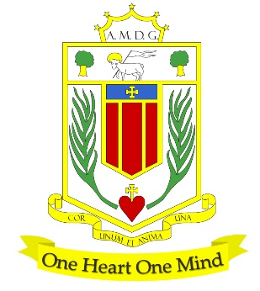
Broughton Hall Catholic High School

Art & Design Technology Department

General Overview

The Department Intent

Rationale
The overarching aim of the department is to give students the opportunities to develop creativity, ingenuity, innovation and problem-solving skills.
- In Art and Photography we aim to develop the creative and artistic ability of our students. Embracing the importance of art in a wider context through the study of the work of traditional and modern artists and designers, both with local connections and worldwide reach.
- In Design Technology subjects students are encouraged to identify needs and opportunities and access the necessary knowledge of skills and processes to respond by developing ideas and making products.
- In Cooking and Nutrition our aim is to instil in our students a love of cooking. They will access the skills and knowledge to cook a range of products and apply the principles of nutrition and healthy eating.
- We aim to ensure that there is a variety of courses at levels that meet the needs and aspirations of all of our students.

Department overview (staffing)
- The department employs 9 teaching staff members. In addition, we are supported by 3 part-time technicians.
- Many of our Art and Technology teaching staff where designers in industry prior to beginning their teaching careers. This brings with it a wealth of industrial knowledge and experience and supports our students in their creative career choices.

KS3
Art & Design Technology - You will start along the path of becoming an innovator and creative problem solver by experiencing a range of subject specific areas:
- Textiles
- Product Design
- Cooking and Nutrition
- Art and Design
- Graphics
You will be encouraged to think about form, function, materials, safety and develop high quality making outcomes using the vast range of tools and equipment that the department has.

KS4
Art & Design Technology
- Creative subjects are popular subjects at KS4. Courses have been selected to support the range of student needs. Students have a choice of both GCSE and Applied courses.
- You will build on the skills and techniques explored throughout KS3 and work with a wider variety of materials, tools/equipment, and art media. In addition, depending on your specialisation, you will develop your creative skills using digital media, specific ICT packages and computer aided design (CAD). You will develop knowledge in areas such as materials, manufacture and sustainability.
- The department offers a wide range of qualifications and material specifications to suit your needs and interests. These include:
- GCSE Design Technology
- GCSE Food preparation & Nutrition
- GCSE Art and Design
- GCSE Photography
- BTEC Level 1/ 2 award Art & Design in practice
- EDUQAS Level 1 / 2 Award Hospitality & Catering

KS5
At KS5 progression to A Level is good, class sizes exceed 10 in each material area. Pupils follow the AQA Art and Design curriculum. We offer 3 A level choices:
- GCE Textiles
- GCE Fine Art
- GCE Photography
We have a number of students who will take 2 of the 3 subjects. Attainment is consistently above national expectations and a number of our students are successfully supported in their post 18 choices, securing places at University Art and design courses.
