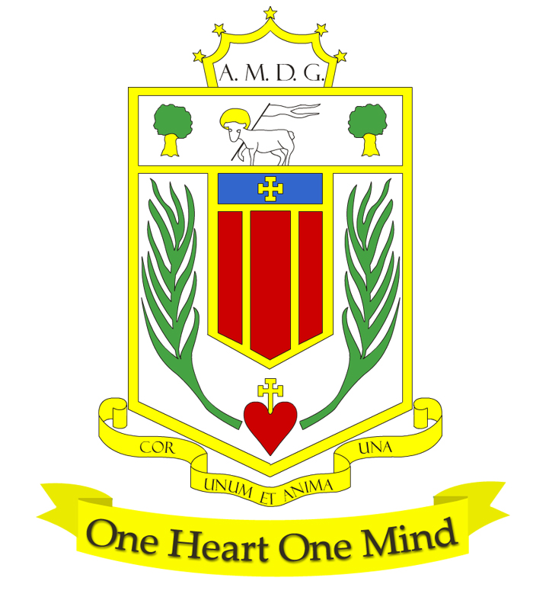
BROUGHTON HALL CATHOLIC HIGH SCHOOL
Yew Tree Lane

Liverpool

L12 9HJ

Telephone 0151 541 9440 / Fax 0151 259 8448
E.mail:smithg@broughtonhall.com
Head Teacher: Mr G Preston B.A. (Hons), NPQH, PGCE
Number on Roll 1211 including 182 in Sixth Form

TEACHER OF ART & PHOTOGRAPHY - PART TIME (0.6 FTE)
Required for September 2021

SALARY: MPS/UPS
CONTRACT: Permanent
HOURS: 0.6 FTE
CLOSING DATE: 10th May at 12 noon
INTERVIEWS TO BE HELD: To be confirmed

The Governors wish to appoint an outstanding and enthusiastic Teacher of Art and Photography. The role would be an opportunity for the successful candidate to join an outstanding and well-resourced department in a school where Art and Photography are popular exam options at KS4 and KS5.

The successful candidate must be willing and able to teach GCSE and A Level Fine Art & Photography and contribute to the teaching of Art & Design Technology across KS3. The post is suitable for an NQT or more experienced teacher.

The person we are looking for will:
- be a high caliber, experienced practitioner who can teach all students across Key Stages 4 and 5.
- be able to show a strong record of raising student attainment through their teaching of examination groups.
- be dynamic in their ability to teach both academic and vocational subjects.
- have the ability to implement strategies that will inspire and further enhance our students’ love of Art and Photography .
- have the capacity and drive to develop their teaching and bring innovative ideas to the classroom and the department.
- hold QTS and a relevant undergraduate degree.

About Broughton Hall Catholic High School
Broughton Hall is a Catholic High School, proud of its strong Catholic ethos and values. The school has an excellent reputation and promotes an inclusive education which develops creativity, confidence and independence. The school is committed to the continuous professional development of all staff including our Aspiring Leaders, NPQML and NPQSL programmes.

The Trustees are the Sisters of Mercy

Application is by way of email: Please forward your completed application form together with covering statement to smithg@broughtonhall.com . For further information about the school and application pack please visit our website at www.broughtonhall.com

The post will be subject to an enhanced DBS clearance & satisfactory references.

Broughton Hall High School actively supports continuous professional development for all staff and follows a whole school approach to staff performance and development.

Broughton Hall is committed to safeguarding and promoting the welfare of children and young people and expects all staff and volunteers to share this commitment.

