

Teacher of Art & Design
Candidate Pack
(Part time or full time – ability to offer another subject advantageous for full time)

MPS1 – UPS3
£28,000 - £43,685

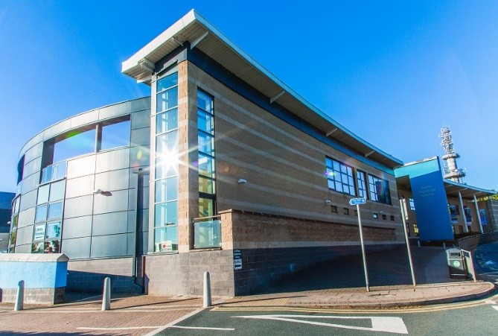

Ralph Thoresby School, recruitment@ralphthoresby.com Headteacher: Will Carr
Holtdale Approach, 0113 3979911
Leeds, ralphthoresby.co.uk
LS16 7RX

Welcome

Dear Candidate,

Thank you for expressing an interest in working at Ralph Thorsby School.
We are keen to recruit high calibre staff with a passion for leading student learning and if successful, you would be joining an exceptional team of staff, dedicated to challenging students and follow the high expectations of the school. We are proud to be a successful, truly comprehensive school serving a diverse local community. RTS is a fantastic environment in which to work and study. Our innovative curriculum is implemented by a talented and cohesive group of staff. The calm and purposeful atmosphere around school is underpinned by an emphasis on restorative practice and a clear focus on staff and student well-being.
Our school motto is ‘ambition and achievement for all’. We firmly believe in giving all students the opportunity to achieve their very best regardless of the circumstances in which they find themselves. We also have a strong emphasis on staff well-being with a professional staff coach, a staff well-being committee and a range of well attended social, sporting and fun activities. Our staff are proud to be at RTS and the team spirit is second to none.
We are excited about the future here at Ralph Thoresby and, having read the information included in this pack, I hope you feel you can play an important part and submit an application. Please also ensure that you visit our website which will give you an insight into the work of the school. I look forward to welcoming you to the school as a candidate in the near future.
Yours faithfully,

Mr Will Carr (Headteacher)


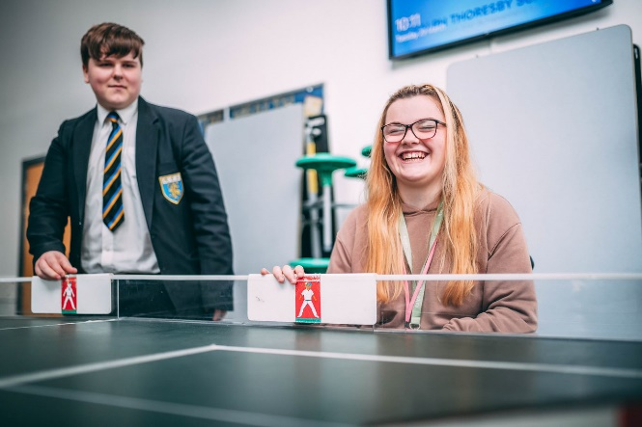






About Ralph Thoresby School

The school is a mixed community school with over 1,000 students on role. Approximately 30% of our students come from ethnic minority backgrounds and we have a resource provision for physically impaired students which really adds to the positive and harmonious atmosphere around school. Our superb, modern school building further enhances the atmosphere and supports students’ learning. ‘This is a school where staff and pupils celebrate diversity and promote values of tolerance, mutual respect and care for others’ (Ofsted).
The school has repeatedly been judged good by Ofsted and we have a strong record of academic achievement, whilst ensuring that all students are well supported. Students make good progress here because, ‘the working atmosphere in classrooms is positive’ and ‘pupils take pride in their work’ (Ofsted).
We have an excellent 6th form partnership arrangement with Lawnswood School (another good local school) and together we offer post-16 provision to rival the best in the city – ‘The quality of provision for post-16 students remains good. Students make consistently good progress over time’ (Ofsted). We are a Trust school in partnership with several of our local partner Primary schools. We have a strong relationship with the Local Authority and are also part of the highly regarded Red Kite Alliance teaching school hub, ‘Partnership working is strong’ (Ofsted).
Our school motto is ‘ambition and achievement for all’. We firmly believe in giving all students the opportunity to achieve their very best regardless of the circumstances in which they find themselves.
Why work for us - https://www.ralphthoresby.co.uk/why-work-at-ralph-thoresby/









Information for Candidates – Art & Design Department

Key Stage 3
All students in Y7-Y8 participate in 2 lessons of Art and Design per fortnight. Projects are set termly.
Students select GCSE Options in Y8 but do not start looking at GCSE content until Year 10, with Year 9 being used to broaden their experience in Art and Design. In Year 9, all pupils have a term of Art and Design delivered to them through the Wider Modern World curriculum as part of the Arts which includes Music and Drama

Students are taught in mixed ability groups and there are 7 sets in each year group.
Key Stage 4
AT KS4 we offer Art Craft Design, Photography and have recently introduced Textiles as part of the GCSE provision.
It is important to have had the experience of teaching GCSE Art & Design to a high level as well as being able to work with a broad range of abilities. As part of the student’s personal journey with their individual GCSE projects it is important to be able to recognise and support each students individual strengths and vision.
Pupils are set into mixed-ability groups and we seek to achieve the best possible outcome as a product of our aspirational targets.
All students follow the AQA course.
Key Stage 5
Ralph Thoresby School works in partnership with Lawnswood School to offer a joint 6th Form curriculum. We offer A Level Art, Craft, Design and Photography.

Job Description
Teacher of Art & Design

Accountable to:
HoD/ Leadership Team
Line Managing:
N/A
Post type:
Permanent
Salary/Grade:
MPS1 – UPS3
Liaising with:
Leadership Team, Subject Leaders/Teachers, Support/Administration staff, Parents/Carers.

Safer Recruitment Statement:
We are committed to safeguarding and promoting the welfare of children and young people and we expect all staff and volunteers to share this commitment. This post requires Enhanced Disclosure (DBS). We promote diversity and want a workforce which reflects the population of Leeds.
- Work towards and promote the vision, beliefs, aims and expectations outlined in the School Improvement Plan
- Support and contribute to the achievement of every child’s outcomes
- Support and contribute to the safeguarding of all students
- Undertake professional development activities to enhance personal development and performance
- Maintain high personal professional standards of attendance, punctuality, appearance, conduct and positive relations with students, parents and staff.
Purpose of the role:

- Be a role model to students through personal presentation and professional conduct.
- To make a positive contribution to the wider life and ethos of the school
- To take responsibility for improving teaching through appropriate professional development, responding to advice and feedback from colleagues
- To communicate effectively with parents about students’ achievements and well-being
- To make a significant contribution to MFL Department so that the department meets the school’s aims and vision.

Wider professional responsibilities

- To identify clear teaching objectives, specifying how they will be taught and assessed.
- To set tasks which challenge students and ensure high levels of achievement.
- To ensure students meet national and school targets.
- To provide clear structures for lessons maintaining pace, motivation and challenge
- To use an appropriate range of teaching methods to ensure that all students achieve their potential
- To ensure that students acquire and consolidate knowledge, skills and understanding
- To plan teaching to achieve progression for students’ learning
- To support positively all students’ individual learning needs, including students with specific learning support needs
- To ensure full coverage of examination board syllabus requirements
- To ensure the effective and efficient deployment of any classroom support

Teaching and Learning

- To assess how well learning objectives have been achieved and use them to improve specific aspects of teaching
- To regularly mark and monitor students' work, providing feedback and setting targets for progress and development
- To assess and record students' progress systematically, keeping appropriate records.
- To undertake assessment of students as required by examination boards and departmental/School procedures
- To use comparative data to set clear targets for student achievement and follow reporting procedures within the School.
Monitoring, Assessment, Recording, Reporting, and Accountability

- To have clear rules and routines for behaviour in classrooms, and take responsibility for promoting good and courteous behaviour both in classrooms and around the school, in accordance with the school’s behaviour policy
- To have high expectations of behaviour, and establish a framework for discipline with a range of strategies, using praise, sanctions and rewards consistently and fairly
- To manage classes effectively, using approaches which are appropriate to students’ needs in order to involve and motivate them
Managing behaviour effectively to ensure a good and safe learning environment

- All staff will make themselves familiar with the requirements of the Health and Safety Policy which are relevant to their work and ensure that they lead their faculty in Health and Safety requirements
- This Job Description is to be performed in accordance with the provisions of the School Teachers’ Pay and Conditions Document and within the range of duties set out in that document so far as relevant to the postholder’s title and salary grade. The post is otherwise subject to the Conditions of Service for School Teachers in England and Wales (the ‘Burgundy Book’) and to locally agreed conditions of employment to the extent that they are incorporated in the postholder’s individual contract of employment. Copies available upon request.
- Given the dynamic nature of the role and structure of Ralph Thoresby School, it must be accepted that, as the School’s work develops and changes, there will be a need for adjustments to the role and responsibilities of the post. The duties specified above are, therefore, not to be regarded as either exclusive or exhaustive. They may change from time to time commensurate with the grading level of the post and following consultation with the postholder.
Additional duties

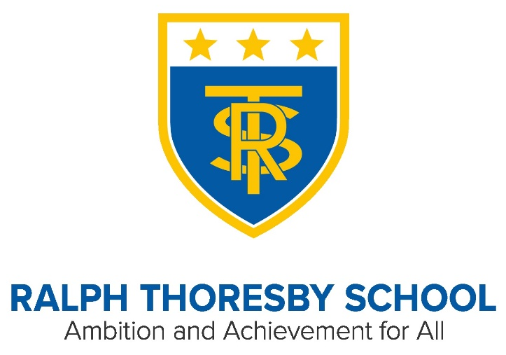

Person Specification
Teacher of Art & Design
Essential
- Qualified Teacher Status (QTS) and good Honours degree relevant to subject
- Outstanding classroom practice that inspires students and adds value to their progress
- Proven track record of having impact on students’ outcomes in current post/teaching practice school
Desirable
- Further formal Professional Development
Qualifications & Experience

Essential
- Substantial knowledge and understanding of developments in the teaching and learning of the relevant subject
- Ability to relate to teaching staff, other professionals, parents, students and Governors.
- Experience of new technologies to support teaching and learning.
- Ability to use data effectively to monitor student progress
- Ability to work as a member of a team and /or independently
- Ability to teach two languages (French, German, Spanish) to KS3 and one language to KS4.
Desirable
- Ability to support other school staff in their use of the relevant subject in teaching and learning
Skills & Knowledge

Essential
- Excellent punctuality and attendance record
- Willingness to participate in the extracurricular life of the school

Special Requirements
Essential
- Enthusiastic, sensitive, flexible, hard working with a sense of humour and ability to remain calm
- High level skills of communication, time management and prioritisation
- Ability to keep confidences
- Excellent interpersonal skills and organisational skills
- Ability to support and challenge
- Ability to inspire, motivate and influence others
Desirable
- Ability to ask for help if required
- Concern for the welfare of all members of the school community
Personal qualities and skills

THE SELECTION PROCESS
How to Apply
Thank you for taking time to read and digest our information. If you wish to apply for the post of Student Support Worker at Ralph Thoresby School, then you should:

- Complete fully the enclosed application form including the section for a personal statement, ensuring all details are accurate and all declarations are signed. Please ensure you enclose two professional referees with one being your current employer (with email addresses if possible). Do not enclose additional CVs.

- Submit your application form via email by Tuesday 17th October, no later than 12.00 noon on this date to recruitment@ralphthoresby.com
________________________________________

Timetable for the selection process

- Post advertised in LCC Website: 2nd October 2023
- Closing date for applications: 12 noon Tuesday 17th October 2023
- Short listing: Thursday 17/18th October 2023
- Invitation to interview by telephone: Upon shortlisting.
- Reference requested: Upon shortlisting.
- Selection day scheduled: W/C Monday 23rd October 2023

