RANELAGH SCHOOL



Part Time (0.5) TEACHER OF ART & DESIGN

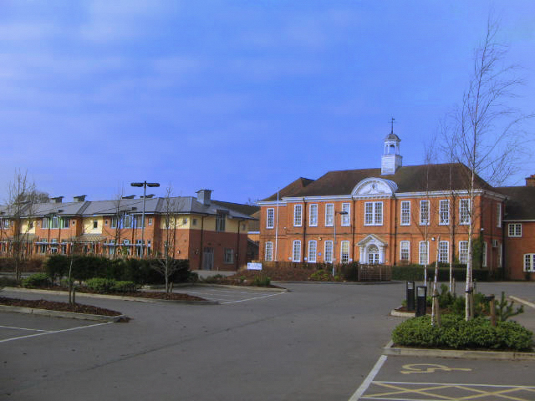




Dear Colleague,

Thank you for your interest in the post of Teacher of Art at Ranelagh School. In this letter, we aim to provide you with some further insight into our school and our priorities.

Our school has an excellent reputation at local and national level. The last inspection by Ofsted in 2024 judged us to be outstanding in all areas. This was our fifth outstanding report and, whilst we are very proud of this achievement, we are in no way complacent.

In addition to excellence in terms of academic outcomes, our purpose is to provide a supportive, stimulating and secure environment in which young people can thrive. As such, we seek to employ inspirational and energetic staff, committed to the school’s ethos. In return, we aim to provide opportunities for continuing professional growth and development for all staff, beginning with a well-established induction programme.

Given that we spend such a significant proportion of our time in the workplace, it is important to take pride and pleasure in what we do here. Teaching and non-teaching staff collaborate well. They are mindful of one another’s well-being and there is a strong sense of collective purpose.

If you are interested in learning more about the role, then please do contact me. If you would like to apply, please submit your application using the form available on our website www.ranelagh.bonitas.org.uk

We look forward to hearing from you.

Yours sincerely
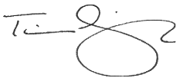
Mr Timothy Griffith
Headteacher

JOB DESCRIPTION

Job title | Subject teacher – Art and Design  We are looking for an enthusiastic candidate who is an outstanding practitioner and is passionate about teaching and learning Art and Design. The successful candidate will join a dynamic, strong and supportive team in a highly valued and forward-thinking department.  This post requires a reflective and ambitious teacher who is well qualified and able to teach across the key stages. The person appointed will be expected to work as part of a team to support the ethos and aims of the school and be prepared to take part in whole school initiatives.
Salary range | Teacher Pay Scales
Contract | Part Time/Fixed term
Accountable to | The post holder will be accountable to the Headteacher and be line managed by, and responsible to, the Curriculum Leader.
Job Purpose | - To teach Art and Design to students in key stages 3 and 4  - To ensure high standards of learning and achievement  - To ensure effective implementation of school policies and protocols
Safeguarding | The school is committed to safeguarding and promoting the welfare of children and young people and expects all staff and volunteers to share this commitment. Candidates must be willing to undergo screening, including checks with past employers and an Enhanced Disclosure via the Disclosure and Barring Service.

KEY FUNCTIONS OF THE ROLE

Principal areas of responsibility | - To work with colleagues to ensure that teaching, learning and achievement are of the highest possible standard  - To support and implement the initiatives agreed by the department and the school  - To work with the department in developing relevant schemes of work and programmes of study
Key tasks
Teaching and learning | - To set and share clear aims, goals and objectives  - To plan, deliver, review and evaluate learning experiences with particular regard to continuity and progression  - To ensure that a variety of teaching methods and styles are deployed  - To ensure that the learning environment in the teaching space is stimulating, well organised, attractive, safe and secure  - To ensure that work for students is sufficiently differentiated in order to promote progress, engagement and challenge  - To provide effective feedback which promotes high expectations and enables all students to make progress  - To ensure that high quality resources are used to support and enhance learning  - To ensure that all students have an equal opportunity to succeed
Assessment, monitoring and reporting | - To undertake accurate, relevant and regular assessment, recording and reporting of attainment and achievement which is aligned with department and whole school policy and practice
Professional training and development | - To undertake appropriate professional development to support effectiveness in role
Wider engagement | - To contribute to cross-curricular initiatives as appropriate  - To make an active contribution to the school/department’s programme of curriculum enrichment
General responsibilities | - To undertake the general responsibilities of all staff  - To implement the most recent Conditions of Employment issued by the Department for Education  - To undertake such activities as can be reasonably expected by the Headteacher or his/her representative

PERSON SPECIFICATION

Attributes | Essential | Desirable
Education and Qualifications | - Degree  - Qualified Teacher Status | - Post graduate study in a subject related to Art
Knowledge and understanding | - A thorough working knowledge of teaching Art and Design through Key Stages 3 and 4
Experience | - Experience in planning, reviewing and re-evaluating lessons and sequences of lessons  - Experience of teaching Art at GCSE | - Experience in taking part and assisting in the preparation of extra-curricular visits
Skills and attributes | - A very good classroom teacher  - Excellent oral and written communication skills  - The ability to work collaboratively  - The ability to use data to personalise and develop learning | - Able to develop resources at KS3 and KS4
Strategic Development | - To support initiatives agreed by the department and school  - To engage in professional research and development groups/teaching and learning workshops within the school | - Willingness to develop links with external agencies
Teaching and Learning | - The capacity to create an exciting, stimulating and safe learning environment  - The ability to use a variety of teaching methods, styles and resources  - To be supportive of the Ranelagh ethos  - The ability to teach PSHE (as a Form Tutor) | - An interest in different pedagogical approaches to Art teaching
Motivation and personality | - Commitment to equal opportunities  - Sense of humour  - Empathy  - Initiative  - Team-player  - Energy  - Enthusiasm
Other | - Disclosure and Barring Service Clearance (The successful applicant will be DBS checked through school)  - Willingness to enhance professional development

ART & DESIGN DEPARTMENT

The Art & Design Department is a dynamic, thriving environment where students are encouraged to explore and fulfil their creative potential.

The department is well resourced and takes pride in the outstanding achievements of the students, as well as its highly committed and experienced staff.

The department enjoys an excellent reputation both locally and nationally. There is a strong community element and the department works with creative partners to deliver innovative cross-curricular initiatives to enhance teaching and learning. As a school we have achieved Artsmark Gold status.

Results in Art are excellent with GCSE, AS and A2 students achieving 100% pass. Art is a popular GCSE and A level choice with two classes in each year at GCSE and one in each year at A level. Many of our students study an arts related degree or follow a foundation arts pathway in higher education.

There are three purpose built areas providing two spacious KS3 and KS4 classrooms for two and three dimensional artworks, including kiln area. The sixth form have their own specialist room and equipment. There are Apple Macs and PC facilities in all three spaces.

Subject Teacher’s Responsibilities

The person appointed will be expected to assist the Curriculum Leader in ensuring that high standards of learning and achievement are attained in and that school policies are implemented.

1 To support and implement the initiatives agreed by the department and the school

2 To encourage and enable all students to achieve the highest standards of learning possible by:
- setting and sharing clear aims, goals and objectives;
- planning, conducting, reviewing and evaluating learning experiences with particular regard to continuity and progression;
- making sure the learning environment in the teaching space is stimulating, well organised, attractive, safe and secure;
- providing effective feedback which promotes high expectations and progress enables all students to make progress;
- ensuring that the best possible quality resources are used;
- ensuring that a variety of teaching methods and styles are deployed;
- making sure that all students have an equal opportunity to succeed;
- undertaking accurate, relevant and regular assessment, recording and reporting of achievements.

3 To work with the department in developing relevant schemes of work and in implementing the national curriculum.

4 To undertake cross subject/cross curricular investigations as appropriate.

5 To take a positive attitude towards professional development.

6 To contribute to the department/school’s curriculum enrichment programme for students.

7 To undertake specific responsibilities in the Department as agreed with the Curriculum Leader.

8 To undertake the general responsibilities of all staff.

9 To undertake the responsibilities of a form tutor.

Ranelagh School Vision

‘Though we are many, we are one body.’
[Eucharistic Prayer, Common Worship]

Following the ministry of Jesus, we empower all to use their gifts in faithful service. We inspire and encourage each individual to develop and nurture unique skills, interests and talents, in order that they can flourish. Our school is a unifying heartbeat, enabling everyone to feel welcomed and valued as members of our community.
Context
We draw students from over forty primary schools spread over a diverse geographical area. Some of our young people and their families have experienced worship from a range of Anglican traditions, whilst others practise different denominations and faiths, or hold a wide variety of beliefs, values and ways of looking at the world. Our aim is for Ranelagh to offer a unifying heartbeat. Our vision is rooted in the example of Jesus’ ministry – we are all one body, part of one church; we are all known and welcome and our unique skills and attributes are valued.

We endeavour for each individual to be included within our supportive community in which those of all circumstances and contexts are able to learn and work together to experience love, hospitality, service, solidarity, forgiveness and the possibility of new beginnings.

We are unrelenting in our support of each individual, in order that we all might have hope and aspiration for the future. Everyone is enabled to develop their unique skills and talents and to aspire for excellence, being empowered to take responsibility for making wise choices. In order for all students to thrive and excel, we aim to foster confidence and delight in learning through a rich diet of scholastic, practical, cultural and spiritual opportunities.

In addition to encouraging intellectual rigour, we nurture a vibrant and creative environment in which members of the school community are able to work together to seek the wisdom, knowledge, truth, understanding and skills which will support all to fulfil Jesus’ promise of life in all its fullness.

How to Apply

Please complete the online application form available via the school website:

www.ranelagh.bonitas.org.uk

Please note that CVs cannot be accepted. No agencies



