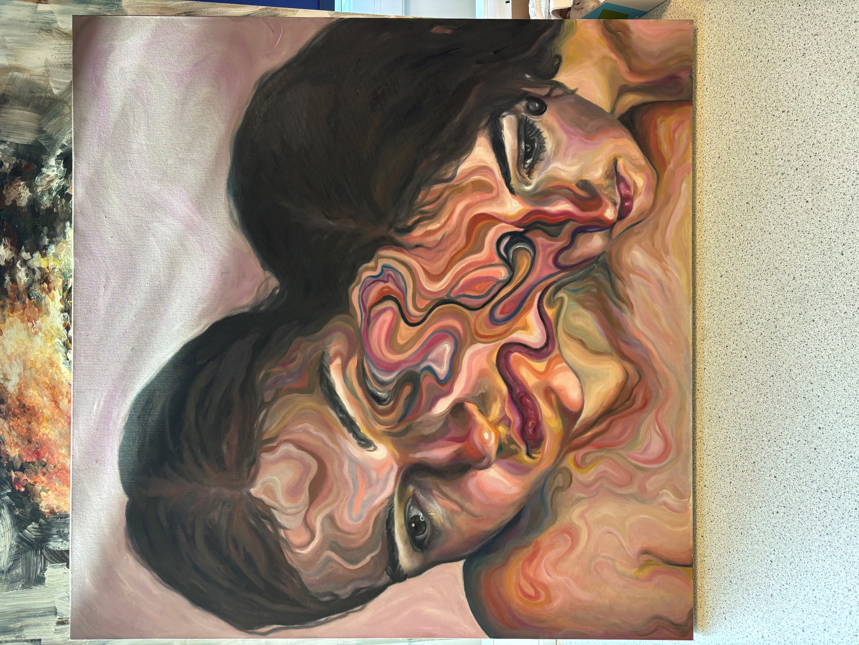**Turton School Art & Design Department: Philosophy & Vision**

*“We all know that Art is not truth. Art is a lie that makes us realize truth.”* (Pablo Picasso, 1972) Art is a moment of calm in a chaotic world. It is a release of expression, emotion and thought that can be aesthetically beautiful and harmonious whilst simultaneously challenging, confrontational, unnerving, disturbing or confusing. Art moves us, influences us, changes us and speaks to us on a level that language, text and numbers do not. Art is autobiographical, self-reflective and is born from our basic human need to communicate, to record, to create. Art is an attempt at immortality for *“Life is short, art is long”* (Hippocrates, c.460–357 BC). Art is evolutionary, revolutionary and in a constant state of flux. From the earliest prehistoric cave paintings to the most contemporary objet d’art, the human race desires art.

Studying arts subjects help to develop critical thinking and the ability to interpret the world around us. The leading people in any field are those who can think creatively and innovatively. These are skills that employers value alongside qualifications. Making and participating in the arts aids the development of these skills.

**Key Stage 3**

**Year 7**

In Year 7, the students’ journey begins with an introduction to the formal elements of art. Students undertake formal drawing exercises to explore line, measurement, proportion, mark making, colour, texture and pattern through studies of natural forms. Designs are then generated inspired by Celtic art from the Middle Ages and the ornamental illustrations in The Book of Kells (c. 800AD). Students explore traditional iconography, typography and calligraphy appreciating the geometry and symmetry of archetypal Celtic knots, nature inspired motifs, and mythical creatures to create an illuminated letter design. Students then experience the birth of The Renaissance Revolution in Florence, Italy: a period of significant cultural change, underpinned by the belief that people should be better educated, and that art, music and science could make life better for everyone. They explore the influential work of famous Renaissance artists including Giotto, Botticelli, Raphael, Leonardo Da Vinci, Albrecht Durer and Michelangelo to understand the background to this exciting development in European art from the early 14th to mid-16th centuries. Increased attention to detail encourages accuracy and precision; techniques adopted during the renaissance are taught to achieve realism. Students end the year studying portraiture and symbolism, making comparisons between historical and contemporary portrait artists to stimulate imaginative design ideas for a self-portrait.

**Year 8**

In Year 8, pupils study Impressionism and Post-Impressionism with specific reference to landscapes and still life (1865 – 1910). We look at how artists recreated landscapes during the Impressionist/Post-Impressionist period, considering movement, line and mark making. Pupils are introduced to the work of Monet, Cezanne, and Van Gogh, with the specific reference to the way light can be depicted within a painting and how each artist used colour*.* Students are then introduced to the concept of perspective and a link back to the Renaissance when the idea was first conceived by artists such as Raphael. Techniques of linear perspective are mastered which leads effectively on into the next part of the journey Surrealism. To conclude year eight, we delve into the unusual world of Surrealism and its diverse meaning. Salvador Dali and Rene Magritte form the basis for our exploration into the way dreams and subconscious thoughts can be conveyed through art. We use formal drawing exercises, observational studies and imaginative thinking using a range of materials to turn the real into the surreal.

​

**Year 9**

Students study the work of contemporary art practitioners such as David Hockney and Antony Gormley aiming to give students an insight into art in the real world and see inside an artist’s studio. Inspired by Hockney, Gormley and their diverse portfolios of People and Places students undertake a series of workshops allowing them to explore a wide range of fine art techniques including drawing, painting, printmaking and sculpture. In Graphics Students study the iconic British designer, Neville Brody, investigating his interest in art movements: Dadaism, Futurism and Constructivism, which heavily shaped his artwork to influence his iconic magazine designs: *The Face* (1981-86) and *Arena* (1987-1990). We later study Lazlo Maholy-Nagy’s early 20th Century experiments with photographic image and text to understand the terminology “Typophoto”. Maholy-Nagy’s passion for typography and photography led to the unification of the two disciplines and gave birth to the first photographic poster. Students look at early examples of illuminated texts created in the Middle Ages, through to the influence of Gutenberg’s mechanical printing press. They then consider more recent developments which include work from the Constructivist era to leading figures in the world of design today. Finally, fine art students develop design ideas to create social change in response to current issues that challenge our society such as sea pollution and single use plastic.

**Key Stage 4**

For those students continuing their artistic journey, we aim to build upon practical skills and contextual knowledge by investigations into both traditional and contemporary artists. Students have the option of specialising in one of three disciplines at GCSE; Art and Design (to include the option of Fine Art, 3D, Art Craft and Textiles), Graphics or Photography. At GCSE, we study a selection of artists’ work as stimulus, all of which draw upon the rich knowledge acquired throughout Key Stage 3. Students complement and compare their historical knowledge with modern practising artists and designers through gallery visits, workshops and other art enrichment opportunities, and use these experiences as a basis upon which to build a personal response and substantial artistic portfolio. Students experience contextual referencing, design development and refinement, initial research, photography and observational drawing studies. In Art and Design students enhance existing artistic skills in addition to learning new techniques including: mono and lino printing, inks and dying, ceramics, collage, textiles, manipulation of photography, three-dimensional studies, relief sculpture and large-scale painting. Graphic Design students develop their visual vocabulary by exploring the use of both traditional and digital media techniques. Students develop a portfolio of work that includes lino printing, drawing, photography and digital media via the use of Photoshop. Investigations into the work of renowned designers such as Reid Miles, Wolfgang Weingart, along with more recent contemporary design practice, encourages students to develop a more acute awareness of the use of type, colour, image and compositional ideas. Students experience a broad range of graphic styles and genres by responding to series of carefully sequenced design briefs for which they need to consider specific requirements and constraints. Photography students begin with an investigation of the formal elements through the lens of the camera and learning about compositional and lighting techniques. A repertoire of knowledge and skills is built through a series of short projects that builds in complexity and encourages growing independence and confidence with the camera. Students are taught digital editing skills through photoshop in addition to manipulation of imagery by hand to create a range of interesting outcomes. All students are expected to develop and extend their work outside of lesson time and make use of the art rooms after school.

**Key Stage 5**

Students may explore a range of art pathways including Fine Art, Art, Craft & Design, Three-Dimensional Design, Graphic Communication, Photography and Textiles Design. Students undertake a practical investigation supported by written material in which students, again, are given the freedom to explore themes poignant to them. Students are exposed to diverse ways of working: exploratory drawing, photographic manipulation, textiles, sculpture, ceramics, print and paint, all of which are supported by contextual references from both traditional and contemporary periods. In Fine Art, Textiles Design and Art, Craft & Design Year 12 forms the basis of a foundation year with natural forms, man-made structures and portraiture being topics of exploration. Photography students study English scientist, inventor and pioneer of photography, William Fox Talbot creating pinhole cameras or camera obscura. Graphic Designers develop a portfolio following design briefs on influential British designers Neville Brody, Ken Garland, Alan Kitching before moving on to being responsible for selecting their own artistic references. They explore the use of traditional and more contemporary digital media, combined with collage, print, drawing, paint and photography.

