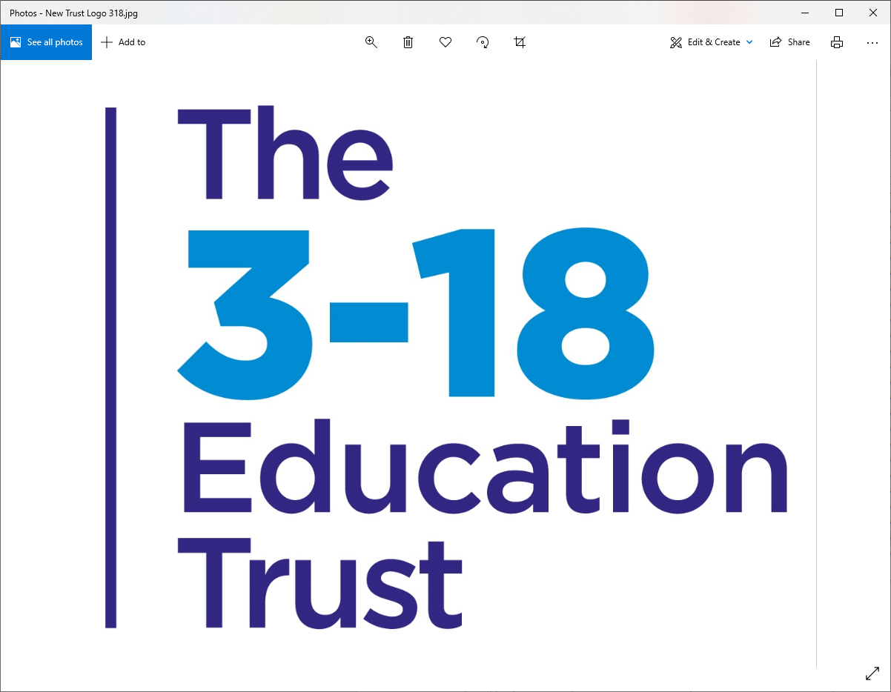
The Priory School
Longden Road
Shrewsbury
SY3 9EE
01743 284000 pri-hr@pri.318education.co.uk

Teacher of Art & Graphics
Permanent – 0.44 FTE (11 hours)
MPS to UPS depending on experience (suitable for ECTs)
To start September 2023

We currently have an exciting opportunity for an enthusiastic Art & Graphics Teacher, to join our successful Art & Graphics department. You will be based at The Priory School, Shrewsbury and will teach at KS3 and GCSE level, working closely with the Head of department, to maintain high levels of progress and excellent behaviour.
Applicants must have:
- A recognisable passion for Art & Graphics
- The ability to maintain the high standards of a successful Art & Graphics Department
- An honest commitment to ensure all students make outstanding progress

Closing date for receipt of applications is 10am on Monday 3rd July 2023

Interviews will be held on Wednesday 5th July 2023

Full details of the post can be found in the Applicant Information Pack available on the school website http://priory.tpstrust.co.uk/contact-us/current-vacancies/

The Priory School, is part of The 3-18 Education Trust, a multi-academy trust with students aged from 3-18 and which works collaboratively to provide interesting and exciting opportunities for staff to share ideas, resources and expertise, for the benefit of the students.

The 3-18 Education Trust is committed to safeguarding and promoting the welfare of children and young people, as such this post requires acknowledgement and understanding of safeguarding and child protection policies which can be found on the school website. Successful candidates will be subject to an enhanced DBS check and satisfactory references.

