Applicant Information Pack
Teacher of Art & Graphics
Part-time – 0.44 FTE

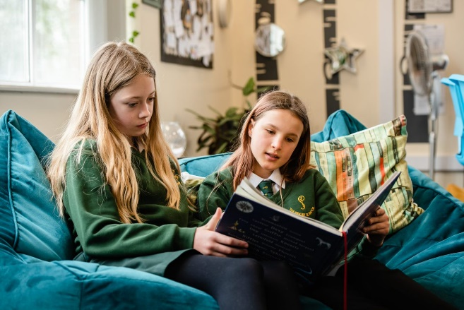

Selfless – Self Assured - Successful

Headteacher Letter to Applicants

The Priory School is an oversubscribed, 11-16, comprehensive situated in a popular, residential area of the County Town of Shrewsbury. There are approximately 840 students on roll with a six-form entry. The school has an excellent reputation across the county.

Our main school building dates from the late 1930s, with a mix of additional classroom blocks added over time, to cater for the growing needs of the school. Our latest ‘Maths Block’ opened in 2019 and symbolises our determination to provide our students with a first-class environment, conducive to learning.

As soon as you enter our school you gain a ‘feel’ for our very special ethos and culture. Students conduct themselves in an exemplary manner and have high expectations of their own and others’ conduct, both in and out of lessons. They are a pleasure to teach and be with. We are an inclusive school and value the diversity of our student body. Outcomes for our students are above average and progress over the last three years has improved year on year. We are determined to ensure this remains the case and constantly reflect on all that we do to ensure we continually improve.

We have a vibrant House System that embodies all we stand for and our students participate in a range of activities, in large numbers. The system helps us to celebrate a range of talents and interests, complementing an extensive extra-curricular programme and has become an integral part of ‘Priory Life’. We believe education is about developing the individual holistically, not just academically. As a result, we have a rich and broad curriculum, to ensure the development of all our students into Selfless, Self-Assured, and Successful individuals.

Our staff are a close-knit team who are dedicated to ensuring our students have the best experience of school life. School leadership are committed to their continued professional development and have placed significant emphasis on staff well-being; reviewing workload to support a healthy work-life balance.

The successful applicant will be joining us at an exciting time of our development, both as a school and as part of an evolving multi-academy trust. They will work within a school, which prides itself on being outward facing, dynamic and aspirational whilst retaining an important feel of the traditional.

If you choose to join The Priory School you will not only benefit from joining an exceptional school, you will greatly benefit from working within an aspirational family of schools. Please take time to view our website https://priory.tpstrust.co.uk/ for more details.

Alison Pope, Headteacher

About our Trust

The 3-18 Education Trust is currently made up of five schools and derives its name from the age range of the pupils and students who attend those schools. We have an inclusive ethos, defined by age and we recognise that education is a continuous process, secured through consistent values and a strong transition (through the key stages).

Our Vision:
To ensure every individual is in a great school.

Our Mission:
To celebrate the diverse nature, culture and identity of our individual schools, whilst enjoying the benefit of the team, so that each school is reciprocal in their support for one another and achieves together.

Our Values:
- Accomplished: to provide high quality education and training for all
- Resilient: to be solution focused and able to intelligently manage challenges
- Compassionate: to show care and understanding towards others
Not only do we pursue the important dimension of achieving the best results for each student regardless of their starting point, but we also believe strongly that education is about developing well-rounded individuals who are ready, willing and able to make their contribution to society.
Please take a look at our Trust website https://www.3-18education.co.uk/ for more details. For further information about our schools, please click on the links to their websites below:

https://www.3-18education.co.uk/schools/bowbrook-primary/

https://www.3-18education.co.uk/schools/coleham-school/

https://www.3-18education.co.uk/schools/the-priory-school/

https://www.3-18education.co.uk/schools/st-martins-school/ https://www.3-18education.co.uk/schools/thomas-adams-school/ https://www.3-18education.co.uk/schools/william-brookes-school/
Faculty Information

Art & Graphics department at The Priory School

The Art & Graphics department is a talented and committed team with two other experienced Art & Graphics teachers. Art & Graphics plays a significant role within the school and students’ work is showcased throughout the school building. Results are consistently high in both Art and Design and Graphics Communication which are popular subjects at GCSE. There are two specialist adjoining Art rooms, one of which is fully equipped with industry standard software for the teaching of Graphics to all year groups. Students in Key Stage 3 enjoy painting, printmaking, photography and ceramics in addition to a well-established digital art programme. Our students enjoy inspiring and stimulating lessons and take great pride in their work.

Job Description

Title of Post: | Teacher of Art and Graphics
Post Status: | Permanent
Accountable to: | Head of Art & Graphics
Responsible for: | The post holder may be responsible for the deployment and supervision of other adults supporting learning within the classroom.

Responsibilities
Planning, Teaching and Class Management

Teach allocated pupils by planning their teaching to achieve progression of at least good if not outstanding learning through:

- Identifying clear teaching objectives and specifying how they will be taught and assessed.
- Produce relevant documentation to support the learning of students and track their progress e.g. student support plans, seating plans, class data analysis
- Setting tasks which challenge pupils and ensure high levels of interest;
- Effective use of internal and external data, in order to build on prior attainment;
- Identifying SEN, PP and very able pupils and structure appropriately differentiated tasks and activities;
- Make effective use of assessment and ensure coverage of programmes of study;
- Ensure effective teaching and best use of available time;
- Monitor and intervene to ensure sound learning and discipline;
- Ensure pupils acquire and consolidate knowledge, skills and understanding appropriate to the subject taught;
- Evaluate their own teaching critically to improve effectiveness;

Monitoring, Assessment, Recording and Reporting

- Use appropriate internal and external data sets through school systems and procedures to track and monitor the ongoing progress of all students within their classes.
- Devise clear action plans in order to address pupil underachievement;
- Assess and record pupils' progress systematically and keep records to check work is understood and completed, monitor strengths and weaknesses, inform planning and recognise the level at which the pupil is achieving;
- Prepare and present informative reports to parents;
- Use Show my Homework to record any homework set.

Other Professional Requirements:

- Work as a House Tutor contributing to the personal development and holistic welfare of our students;( see Priory School House tutor job description)

- Promote and safeguard the welfare of all children they come into contact with;
- Have a working knowledge of teachers' professional duties and legal liabilities;
- Establish effective working relationships and set a good example through their presentation and personal and professional conduct;
- Endeavour to give every child the opportunity to reach their potential and meet high expectations;
- Contribute to the life of the school through effective participation in staff meetings, and House event.
- Take responsibility for their own professional development and duties in relation to school policies and practices;
- Liaise effectively with parents and governors;
- Take on any additional responsibilities which might from time to time be determined.

Other Responsibilities

- Comply with and assist with the development of policies and procedures relating to child protection, health, safety and security, confidentiality and data protection, reporting all concerns to an appropriate person.
- Be aware of and comply with all school policies and procedures
- Be aware of and support difference and ensure equal opportunities for all
- Contribute to the overall ethos and aims of the School and Trust
- Appreciate and support the role of other professionals
- Attend and participate in relevant meetings, training and learning activities as required

The postholder may be required to carry out any other duties that the Headteacher feel is commensurate with the post. Whilst every effort is made to explain the main duties and responsibilities of the post, each individual task undertaken may not be identified.

This job description is subject to review by the Headteacher in consultation with the post holder at any time. However, an annual review of this job description and allocation of responsibilities will take place as part of agreed performance management arrangements.

Person Specification

 | Essential | Desirable
Qualifications | - An honours degree or equivalent in an Art subject  - A-Levels in one or more Art subjects with a good grade  - QTS
Experience | - Be or have the potential to be an outstanding classroom practitioner  - Monitoring standards – acknowledge excellence and challenge poor performance  - Setting and achieving ambitious goals and challenging targets  - An up to date knowledge of ICT and its use within the classroom.  - Specialist teaching ability in Art and Graphics at KS3  - Proven track record of ensuring high attainment and progress scores with students  - An outstanding form or house tutor. | - Ability to teach Graphics at KS4
Professional Development | - Evidence of relevant further professional development  - Successful engagement in trainee teacher target setting or performance management process | - Membership of professional association
Knowledge/special aptitudes | - Ability to interpret and analyse class data to track and monitor student performance.  - Knowledge of the characteristics of good and outstanding teaching and learning  - Understanding and commitment to safeguarding procedures  - High expectations of students and the ability to ensure that all students needs are met  - The ability to build positive relationships with colleagues, students and parents  - Understanding of a broad range of current relevant education issues/initiatives | - Knowledge of successful intervention strategies  - Extensive curriculum knowledge  - Experience of planning, implementing and evaluating successful strategies for school improvement with regard to the Art curriculum.  - Experience in a range of different contexts
Personal Qualities/skills and Characteristics | - Enthusiastic and passionate about Art and Art History  - Has a high level of technical ability and creativity  - Sets high standards for themselves and their students including safety  - Is able to motivate and encourage students of all abilities  - Is able to work collaboratively as part of a team  - Is able to organise and meet deadlines  - Is able to work under pressure  - Has ambition  - Has the capacity to evaluate their own performance and strive for excellence  - Ability to research, disseminate and deliver innovative approaches to teaching and learning across Art & Graphics.

Additional Information about The Priory School

Set up as a girls’ grammar school in 1939, The Priory School became a mixed comprehensive when Priory Boys’ Grammar School (now Shrewsbury Sixth Form College) joined in 1980.

The Priory School has a reputation for academic excellence and it is our aim to ensure that every child is encouraged to pursue their own personal excellence and provide an education that will encourage students to become lifelong learners. It is also our belief that this can only be achieved if parents, staff and governors work together to ensure the best possible support and provision for each child.

The Priory School encourages students to take on responsibility. In Year 10, students are able to apply for the positions of School Captians. The duties of the School Captains and Deputies are various and include them acting as ambassadors for the school, setting an annual theme which is then pursued throughout the whole school. There is also The School Council, which is used to act as an executive body receiving reports from and consulting with different student groups with specific responsibilities within the school.

The school operates a house system comprising of six houses Attenborough, Frank, King, Hawking, Nightingale and Parks. One form in each year group belongs to one of the houses, which are run entirely by Year 11 students. The activities that they run vary from inter house sports through to fund raising. In March the House Cup is awarded to the winning house.

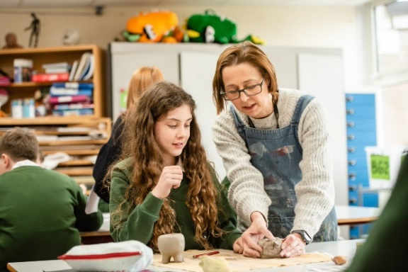
The Priory School is the lead school for Shropshire and Telford Education Partnership the DfE sponsored Teaching School Hub which covers Shropshire and Telford and Wrekin. We work in collaboration with three other former teaching school alliances to deliver the Early Career Framework, act as an Appropriate Body for Early Career Teachers, deliver the full suite of NPQs, offer School Direct PGCEs through our wider partnership as well as provide accredited CPD to meet the needs of the area. This signals a very exciting new chapter for the school in its contribution to the wider development of teaching and support staff across the local area.
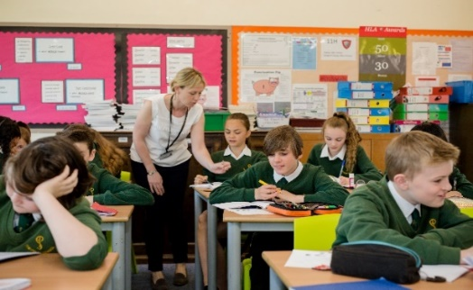
We are also the lead school for the Shropshire, Herefordshire and Wolverhampton (SHaW) Maths Hub. Our Maths Hub work, which arises through our Teaching School status, covers Shropshire, Herefordshire and Wolverhampton, and has seen significant growth and success since its inception in 2014.

What We Offer

In addition to a comprehensive induction and a commitment to your ongoing training and career progression, we also offer:

- A competitive salary
- Access to the Trust’s Employee Assistance Programme, which includes 24 hour access for you and your family members to legal, financial, health, parenting and life advice
- 1:1 Counselling Service
- Discount Scheme for high street retailers, mobile phone providers, holidays, electrical goods, supermarkets, restaurants, cinema, etc.
- Cycle to Work Scheme
- Childcare Voucher Scheme or Tax-Free Childcare Scheme
- Access to freshly made hot meals or deli-style food on site
- Teachers Pensions (23.68% employer contributions)
- Local Government Pension Scheme (17.9% employer contribution)
- Generous Sickness Payment Scheme
- Eye Testing Scheme
- Flexible Working Policy
- Special Leave Policy
- Member of the Valued Worker Scheme (accredited by our recognised unions)
- A Disability Confident Committed Employer
- Continuous Professional Development (CPD)
- Collaborative working culture and professional development opportunities across our Trust schools

We are also currently exploring:
- Electric/Hybrid Car Lease Scheme
- Healthcare Scheme

The Appointment Process
An application form is available to download from the school website: Please send completed applications to: pri-hr@pri.318education.co.uk
Interviews will be offered to those applicants who best demonstrate how skills, abilities and experience match the person specification, taking into consideration the job description.

Closing date for applications: 10am Monday 3rd July 2023

Interviews will take place on: Wednesday 5th July 2023

Please note:

- It is essential that all elements of the application form are completed in full.
- We do not accept CV’s in support of an application.
- Appointments will be subject to clearance in respect of medical fitness, satisfactory references, right to work in the UK and criminal disclosure.
- This post is exempt from the Rehabilitation of Offenders act 1974 and as such the applicant who is appointed to this post will be subject to an Enhanced Disclosure before the appointment is confirmed. This check will include details of cautions, reprimands or warnings, as well as convictions and non-conviction information. Once appointed, the successful applicant may also be required to apply for an Enhanced Disclosure at intervals during the course of their employment whilst in this post.

If invited for interview, you are required to bring evidence of your qualifications and appropriate documents to initiate the DBS application process should you be the successful candidate.

The 3-18 Education Trust is committed to safeguarding and promoting the welfare of children and young people, as such this post requires acknowledgement and understanding of safeguarding and child protection policies. Policies can be found on the school website https://priory.tpstrust.co.uk/contact-us/current-vacancies/

