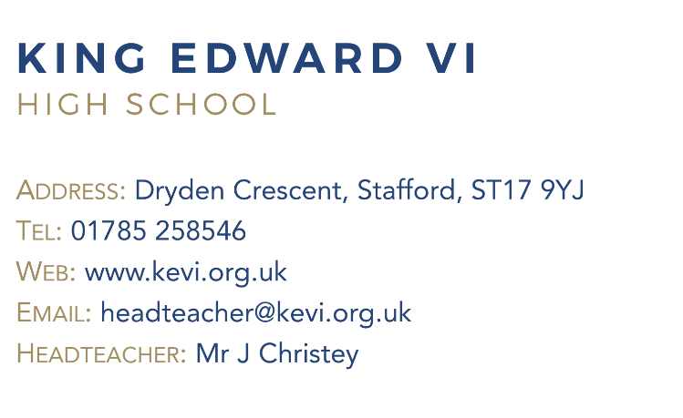
Teacher of Art
2 days per week

Are you passionate about Art and inspiring creativity in young people? King Edward VI High School is seeking a dedicated and enthusiastic Teacher of Art to join our thriving department on a part-time basis (2 days per week).

The role involves:

- Teaching engaging Art lessons to Key Stage 3 and Key Stage 4 pupils
- Contributing to the development of the Art curriculum and schemes of work
- Fostering a positive and creative learning environment

We are looking for someone who:

- Holds QTS and has a degree in Art or a related subject
- Has experience teaching Art to secondary school students
- Is committed to supporting the academic and personal development of all pupils

This role is suitable for ECTs

Why join us?

- Supportive and collaborative staff team
- Opportunities for ongoing professional development

Application packs are available from Ms Coughlan, Bursar. (email applications@kevi.org.uk)

Closing date: Monday 20th April 2026 at 9.00 am.

King Edward VI High School is committed to safeguarding and promoting the welfare of children and expect all staff and to share this commitment.
The successful candidate will be subject to all necessary pre-employment checks, including: an enhanced DBS; Prohibition check; qualifications medical fitness; identity and right to work. All applicants will be required to provide two suitable references.
An online search will also be carried out as part of due diligence on all short-listed candidates.

