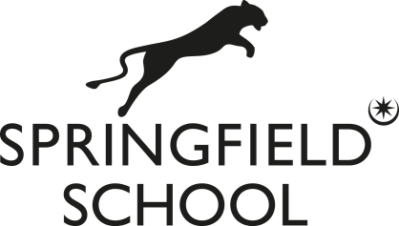

Teacher of Art
Required from September 2024
Pay Scale MPR1 to UPR3; Salary £30,000 to £46,525
Springfield is a popular and high performing 11-16 school, in which ‘leaders are determined to provide a high-quality education for all pupils, regardless of their ability or circumstances’. Ofsted judged the school to be ‘good’ in October 2019.
You will be ambitious, well-qualified and highly motivated. The flexibility to offer photography would be advantageous, but is not essential. ECTs are welcome to apply, as are more experienced teachers. The successful candidate will benefit from wide ranging CPD opportunities.
For an informal discussion regarding the post, please telephone Mr Wharton (Deputy Headteacher).

Springfield School and The De Curci Trust are committed to safeguarding and promoting the welfare of children and young people and expect all staff and volunteers to share this commitment. DBS Disclosure at Enhanced level, and any other background checks, including overseas checks, will be required prior to any offer of employment.

For further information and an application form, please see our school website: www.springfield.uk.net.

Please return completed applications to: contact@springfield.uk.net.

Closing date for applications: 9am on Monday, 29 April 2024

Please note that short-listed candidates are normally be contacted within a week of the closing date. If you have not been contacted within this time, please assume that you have been unsuccessful on this occasion. Thank you for your interest in a post at Springfield School.

Tel: 023 9237 9119
Email: contact@springfield.uk.net

