Application Pack

**xxxxx**

Welcome from the Headteacher

Jesus said, “I have come that they may have life – life in all its fullness.”

John 10:10

Dear Applicant,

Thank you for your interest in this post at The Deanery Church of England High School. I hope the attached documentation will provide you with the information you need and that you will feel encouraged to apply for the post.

The Deanery is an 11-18 Church of England school at the heart of the local community in Wigan. We are a successful and heavily oversubscribed school of around 1450 pupils with a thriving and growing Sixth Form. Serving the Diocese of Liverpool and the parishes of the Wigan Deanery, we aim to provide an education for life, enabling all of our community to flourish and live life to the full. We live by our Christian values of Faith, Hope, Love, Wisdom, Courage and Integrity and our mantra Work Hard, Be Kind, Make a Difference.

In December 2021, the school received the highest grade of ‘Excellent’ across all areas of our SIAMS inspection.

As a school, we nurture young people in body, mind and spirit, recognising that there is a spiritual dimension to the fullness of life. We see all young people as individuals, recognising their unique God-given talents, potential and purpose and seeking to nurture these through a rich, deep and horizon-broadening curriculum. We promote a culture of academic excellence and the highest expectations, set firmly within a guiding framework of lived and visible Christian values, beliefs and practices. We are passionate about excellence in education and aim to give pupils the very best start in life with the firm belief that excellent teaching transforms lives. We are unapologetically ambitious for every child, no matter what their background, prior attainment or needs.

At The Deanery, we believe that a traditional ethos and common sense approach to the curriculum and behaviour works best in promoting pupils’ progress, both academically and socially. This includes:

* Strict discipline
* Smart school uniforms
* Academic rigour
* High expectations

We have dedicated and highly motivated teaching and support staff, who are committed to the continual improvement of the school. We place a very high value on managing staff workload and wellbeing, as recognised by the NASUWT’s Valued Worker Scheme.

The Deanery enjoys a magnificent new £27m building, opened in 2017. We have outstanding facilities, including advanced science laboratories, state of the art purpose-built curriculum suites, sixth form centre, a modern ICT network, new 4G all-weather pitches, activity studio, gym and a fully equipped technology suite. Learning here has never been more exciting.

Please do take a look at our website to get a fuller picture of our school and what we stand for. On it you will be able to see our prospectus, details of our curriculum offer and the wide-ranging opportunities available to pupils.

We expect all colleagues to support our ethos, whatever their own personal faith position may be. Our aim is simply to serve our local community through providing an outstanding education to children of all faiths and none. We emphasise our Christian distinctiveness through regular acts of worship, but more importantly by valuing and caring for every member of our community.

If you would like to visit us prior to applying please contact my PA, Mrs Wogan, on 01942 597501. If you wish to make an application please complete the form and write a letter (no longer than 2 sides of A4 – font Tahoma 11) outlining how your skills and experience fit you for the post and how you will contribute to the life of The Deanery.

The Deanery is a very welcoming and close-knit community and a great place to work! If you share our vision and would like to be a part of this dynamic and successful school, I would encourage you to apply for the post. Alternatively, you can send us your CV to add our talent pool for any future vacancies that may be of interest to you.

**Mr M Wood**

Headteacher

About us

**Introduction**

A school with a church foundation has existed on this site for 92 years. In 1932, All Saints’ Senior Church School was founded for *‘the nurture of the hearts and minds of children’* in Wigan. In 1970, All Saints’ School closed to allow the formation of a new high school. For the last 53 years, The Deanery Church of England High School has honoured that rich legacy and has been a beacon of distinctive Christian education for generations.

Our school sits at the heart of Wigan and serves young people and families from every parish of the town.



Our school’s history can be seen in its badge:

* + 30 dots, representing the 30 traditional parishes in the Wigan Deanery
  + The Red Rose of Lancashire
  + 3 crosses to represent the 3 original constituent schools
  + A branch from the Wiggin Tree

**Key Information**

* Our pupils and students are fantastic – they are highly motivated and engaged young people with supportive and caring parents
* As a Church of England school, we aim to maintain a distinctly Christian ethos while being genuinely welcoming and inclusive
* We have over 1,450 pupils and students, including almost 200 in our Sixth Form
* The school admits 250 children into Year 7 each year and is heavily oversubscribed
* In 2024, we had over 820 applications for our 250 places in Year 7
* We offer a rich co-curricular provision, including music, drama and sport
* Our school building was completed in September 2017 offering state of the art facilities
* Our Sixth Form Centre gives a modern area in which to work and study; this allows us to have a distinctive sixth form which is still closely linked to the main school

**Leadership**

Martin Wood, taking on his second headship, joined the school in 2019 as Headteacher, leading a dynamic and forward-thinking Senior Leadership Team.  This team comprises two Deputy Headteachers, seven Assistant Headteachers and the Director of Business & Finance.

*“A school in which pupils and adults flourish.”*

***SIAMS Inspection Report - December 2021***

About the Role

**Our Curriculum Vision**

Our science curriculum is designed to instil an awe and appreciation for the world around us. We aim to equip pupils with a sound understand of science, so they are able to discuss scientific ideas and challenge misconceptions. We guide our pupils to observe the ‘what’, and discover the ‘why’ and ‘how’ so that meaningful links are formed between the classroom and the real world. By studying science, pupils will have developed the wisdom to make informed, ethical decisions and be able to confidently hold their place in society. We value practical skills and embed practical opportunities seamlessly into the curriculum to support the understanding of scientific principles and allow first-hand experience of phenomena. Through this, our students will learn how to observe, communicate, analyse and problem-solve, ensuring they have the skills they need to become scientists of the future.

*“A wonderful, inclusive, nurturing community is created in which every individual is deeply valued and cherished. Everybody is enabled to flourish richly and live life to the full.”*

***SIAMS Inspection Report - December 2021***

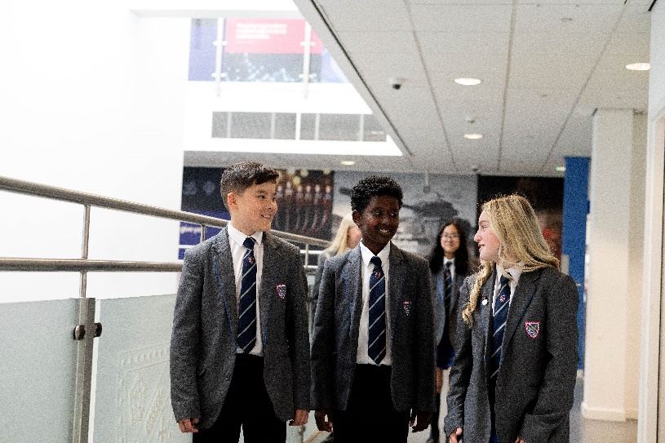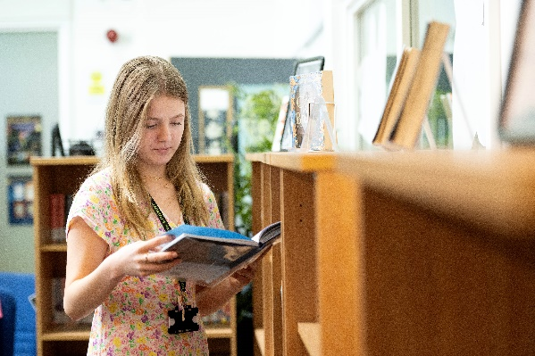

**Our Courses**

At KS3, pupils have 6 lessons per fortnight. The KS3 curriculum is taught as inter-related topic areas which are based on the ambition of the national curriculum and are sequenced in such a way to build knowledge and skills incrementally to ensure that key themes are re-visited. The aims of the KS3 curriculum include the development of ‘scientific literacy’ and ‘science capital’, providing a good understanding of the ‘big ideas’ for science, and a firm foundation of knowledge to build success for the future study of science at GCSE and A Level.

At KS4, the majority of pupils currently study AQA Combined Science, with a small number studying the separate sciences within combined science lessons with some extra provision. During the options process in 2022-2023, we have re-introduced the single sciences as an option choice for pupils.

KS4 pupils have 10 lessons per fortnight, with each class taught by three members of staff (one for each of the three science disciplines). The curriculum is based around the units of study required for the AQA specification which form the basis of the Deanery KS4 Schemes of work. There is an ambition for SEND pupils to achieve well and access the same curriculum as non-SEND pupils. SEND pupils are challenged and scaffolding/ support is included within the curriculum intent to promote good outcomes for SEND pupils.

There are good opportunities to continue with the study of science post-16, with A-Level classes for Biology, Chemistry and Physics. We also offer a post-16 L2 BTEC Science course for students to take as part of the Sixth Form’s L2 route.

**Co-Curricular opportunities**

We offer a range of opportunities for pupils to expand on their experiences of science beyond the classroom. These include:

* STEAM club- weekly after-school sessions
* Trips and visits, e.g. Jodrell Bank, Chester Zoo
* Visiting speakers
* Aspiring Medics Club
* Residential Field Course for A level Biologists
* University visits

*“The atmosphere and environment of the school is calm and purposeful with a powerful hallmark of respect and excellent relationships at all levels.”*

***SIAMS Inspection Report - December 2021***

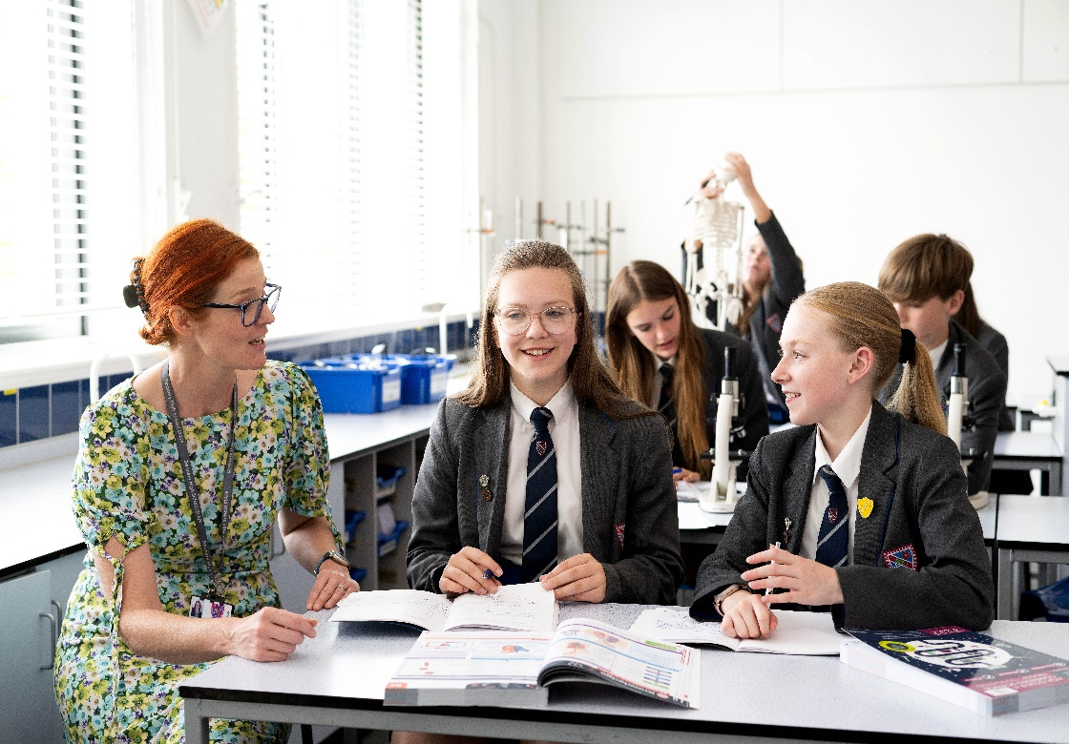

**Our Staff**

The staff within the science department are all highly dedicated subject specialists. Science staff work as a close-knit team and support each other exceptionally well. Staff regularly share teaching and learning ideas, and resources are shared willingly. We have a highly skilled team of three experienced laboratory technicians to support teaching staff with practical lessons and resources.

* Mrs M Cowley, Acting Head of Science
* Miss B Derbyshire, Teacher
* Mrs A Friend, Deputy Head (Curriculum & Standards)
* Mrs S Grady, Teacher
* Mr J Knowles, Teacher
* Mrs M Lay, Teacher
* Mrs K Lee, Teacher
* Miss A Northey, Assistant Head of Science
* Mrs K O’Brien, Assistant Head (Teaching & Professional Development)
* Mrs A Robinson, Assistant Head of Science
* Miss N Ruddick, Associate Assistant Head (Operations & Assessment)
* Mr J Sales, STEM Co-ordinator

**Our Facilities**

We have 10 purpose-built, fully equipped and spacious science laboratories, and two science teaching rooms with demonstration facilities. All science teaching laboratories and rooms are located in a cluster on the third floor of the main building, near to a large science prep room. All labs and teaching rooms contain interactive whiteboards, a teacher PC, projector, sound system and a visualiser. Rooms are clean, bright and well-resourced. We have a suite of tablets available for science staff to book for lessons.

A great place to work …

Our core employee rewards and benefits include:

* A professional working environment in which all staff are valued, listened to and able to fully use their gifts and talents
* ‘Warm and strict’ behaviour systems, meaning pupils can learn and teachers can teach
* The opportunity to teach A Level in our expanding Sixth Form
* Exceptionally visible Senior Leadership Team with open door policy
* A Well-Being Team which is responsible for wellbeing of staff and students
* A bespoke CPD programme for all staff, exciting career opportunities and individual teaching and leadership coaching
* Access to a range of middle and senior leadership programmes – NPQML, NPQSL, NPQL+B
* Collaborative planning with centralised, shared schemes of work and resources
* Personal mentors for Early Career Teachers
* A comprehensive induction programme
* State of the art facilities, located in the centre of the wonderful town of Wigan
* Competitive salaries for all postholders

*“An outstanding environment where pupils naturally live out the school mantra ‘work hard, be kind, make a difference’.”*

***SIAMS Inspection Report - December 2021***



* Higher preference in our Admissions Policy for children of staff
* Family friendly leave, pay and working arrangements
* Free on-site parking
* Free staff laptop
* Discounted gym membership
* A dedicated, enthusiastic and highly professional staff team
* We have been awarded the NASUWT Valued Worker Scheme in recognition of exceptional support for staff
* We are members of the DFE’s Education Staff Well-Being Charter

The Valued Worker Scheme is an initiative jointly promoted by the NASUWT, GMB, UNISON and Unite to recognise and support good employment relations in schools and colleges. The Valued Worker Scheme aims to recognise those employers that are committed to valuing their staff. The scheme recognises employers who commit to treating all employees fairly, equitably and with dignity.

We are a Disability Confident Committed employer. Our recruitment process is inclusive and accessible. We guarantee to interview all disabled applicants who meet the minimum criteria for the vacancy.

Job Description – Role

|  |  |
| --- | --- |
| Responsible to |  |
| Salary | MPS / UPS |
| Start date |  |

**To be effective in the classroom, all teachers are expected:**

* To be accountable for pupil progress in the classes they are responsible for
* To have a secure knowledge and understanding of the relevant curriculum area and keep up to date with current developments
* To plan and teach challenging, well-organised lessons and sequences of lessons across the age and ability range in line with the school’s Learning and Teaching Policy
* To maintain the highest standards of pupil behaviour and conduct both inside and outside of the classroom and to follow the school’s Behaviour Policy
* To encourage resilience and hard work amongst pupils
* To keep up to date with the assessment requirements for the subjects taught, including those relating to public examinations
* To use both school and national data to evaluate the effectiveness of teaching, to monitor progress and to raise attainment
* To use assessment and prior attainment as part of teaching to diagnose pupils’ needs, set realistic and challenging targets for improvement and plan future teaching
* To set and mark homework and to give feedback which is meaningful, in line with school policy
* To contribute to the work of the faculty as instructed by the Subject Leader in the development of syllabuses, teaching materials and schemes of work

**To develop professionally, all teachers are expected:**

* To be reflective practitioners and engage with further research and reading to inform and improve teaching
* To receive and act on feedback to build on strengths and improve performance
* To take ownership of their own professional development, engaging in professional development activities as appropriate to the teacher’s own career stage
* To contribute to the professional development of others as appropriate to the teacher’s own career stage
* To develop knowledge and understanding of technology to support teaching
* To keep up to date on current teaching, learning and behaviour management strategies and know how to adapt them, including how to personalise learning to provide opportunities for all learners to achieve their potential

**To manage young people effectively, all teachers are expected:**

* To understand how young people develop and to make effective personalised provision for children with specific learning needs including higher prior attaining pupils
* To act in the capacity of a Form Tutor
* To manage pupils’ behaviour constructively by establishing and maintaining a clear and positive framework for discipline, in line with the school’s Behaviour Policy
* To promote the self-control and independence of pupils through a range of behaviour management strategies and through developing pupils’ social, emotional and behavioural skills
* To know how to identify potential safeguarding issues and follow safeguarding procedure

**To provide the best possible learning environment, all teachers are expected:**

* To establish a purposeful and safe learning environment which enhances learning
* To be responsible for the safety of those working in the classroom; this includes ensuring that the room is free from clutter and untidy storage, that faults are reported according to procedures laid down; this includes awareness of the dangers of equipment and material being used, availability of first aid materials and knowledge of procedures in case of accidents

**All staff are expected to model the following values, behaviours and attitudes:**

* Actively supporting, articulating and promoting our Christian values and ethos
* Putting pupils first and being positive about young people
* Committing fully to the safeguarding of pupils
* Having a commitment to excellence and high standards in everything we do
* Having and communicating the highest expectations of young people academically and personally
* Having a commitment to social justice and equality of opportunity
* Being committed to ethical behaviour: demonstrating integrity, honesty, resilience, professionalism, kindness and humility
* Behaving in a professional manner with staff and pupils at all times, treating all members of the school community with dignity and respect
* Contributing to the overall aims of the school by complying with and implementing school policies and by working collaboratively as part of pastoral and academic teams

**Applicable contract terms**

The school will endeavour to make any necessary reasonable adjustments to the job and the working environment to enable access to employment opportunities for disabled job applicants or continued employment for any employee who develops a disabling condition. This job description is to be performed in accordance with the provisions of the School Teachers’ Pay and Conditions Document and within the range of duties set out in that document so far as relevant to the postholder’s title and salary grade. Copies of the relevant documents are available for inspection at the school. This job description (role definition) is current at the date shown, but in consultation with you it is liable to variation by the management of the school via the Headteacher to reflect or anticipate change in or to the job commensurate with the responsibility level (grade).



*“Staff are very proud to be part of the school.”*

***Ofsted Inspection Report – May 2022***

Person Specification

|  |  |  |
| --- | --- | --- |
| Attribute | Essential | Desirable |
|
| **Training and Qualifications** | | |
| Qualified teacher status | ✓ |  |
| Degree in a relevant subject | ✓ |  |
| Higher Degree |  | ✓ |
| **Church connection** | | |
| Fully supportive of Church school ethos and the school’s mission statement | ✓ |  |
| **Teaching experience** | | |
| Effective teaching experience either as a qualified teacher or trainee teacher | ✓ |  |
| Knowledge of a range of teaching methodologies | ✓ |  |
| Successful experience of teaching Post-16 |  | ✓ |
| Ability or willingness to teach an additional subject from the school’s curriculum to at least GCSE level; please make it explicitly clear which subject you can offer |  | ✓ |
| Involvement in co-curricular activities | ✓ |  |
| **Professional knowledge and understanding** | | |
| The subject curriculum | ✓ |  |
| The principles of effective teaching and assessment | ✓ |  |
| Current educational issues | ✓ |  |
| Ensuring the highest standards of safeguarding | ✓ |  |
| Effective behaviour management | ✓ |  |
| **Behavioural competencies** | | |
| Letter and application form are fully completed and error-free | **✓** |  |
| Excellent communication and interpersonal skills | ✓ |  |
| Build and maintain effective relationships | ✓ |  |
| Demonstrate personal enthusiasm and commitment to teaching | ✓ |  |
| Manage conflict | ✓ |  |
| Prioritise, plan and organise themselves | ✓ |  |
| Think creatively to anticipate and solve problems | ✓ |  |
| Listen to and reflect on feedback | ✓ |  |
| Develop effective teamwork | ✓ |  |
| Strong support/positive recommendation from referees | ✓ |  |

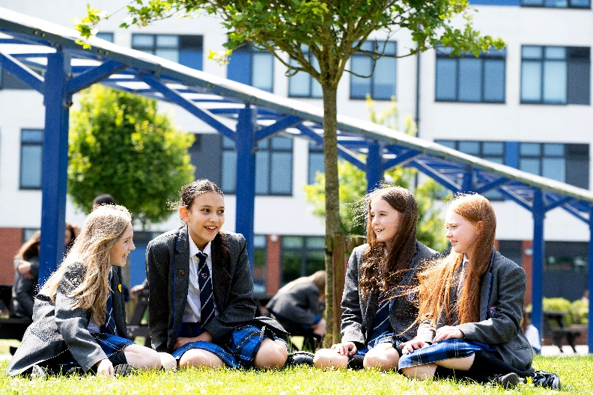

*“Leaders and Governors are considerate of staff’s workload and well-being. Staff described the school as a happy place to work.”*

***Ofsted Inspection Report - May 2022***

Key Dates

**Monday 16th October 2023**

Deadline for receipt of applications is 9.00am.

Applications should be emailed to Mrs T Wogan, Executive Assistant to the Headteacher:

[swogant@deanery.wigan.sch.uk](mailto:swogant@deanery.wigan.sch.uk)

**Thursday 19th October 2023**

Formal interviews will take place at school.

**Wednesday 18th October 2023**

If you have not heard from us, please assume that you have not been shortlisted and accept our thanks for your interest and best wishes for your future career.

Selection Process

|  |  |  |
| --- | --- | --- |
| **Application** | **Interview Tasks** | **Interview** |
| Please make sure your letter of application is a maximum of 2 sides A4, font Tahoma, size 10. It must directly address the following:   1. Why you want to work at The Deanery 2. What makes you a great teacher 3. Your personality and what makes you unique 4. What positive impact you could have on our school | Shortlisted candidates may be asked to carry out the following tasks:   * Deliver a lesson * Pupil discussion activity * Subject knowledge assessment * Tour of the school | The interview panel will comprise the Headteacher, senior staff and governors |

*Please see our website for privacy notices.*

*We are committed to safeguarding and promoting the welfare of children. We expect all staff to share this commitment. Appointments are made subject to satisfactory references and to an enhanced Disclosure and Barring Service check.*

**Completed applications should be emailed to:**

Mrs Tracy Wogan, Executive Assistant to the Headteacher

E: [swogant@deanery.wigan.sch.uk](mailto:swogant@deanery.wigan.sch.uk)

T: 01942 597501

About Wigan

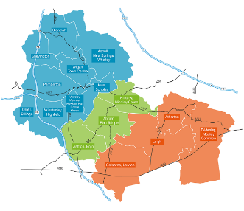

Getting Around

At the heart of the motorway network, Wigan has easy access to the M6, M58 and M61 so there is no better place to live.

The West Coast rail line runs right through Wigan, which makes London and other great cities of the UK accessible within a few hours. We are located only a 10-minute walk away from both train stations. We are also only a 5-minute walk from Wigan’s bus station.

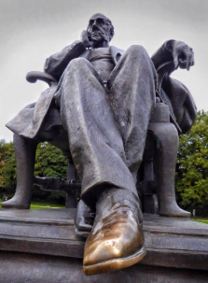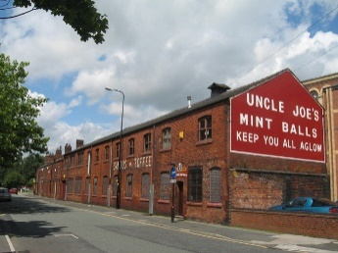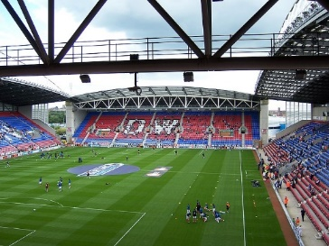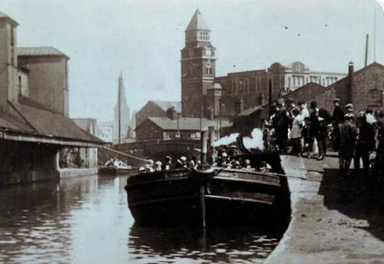

We are Haigh Hall and the Plantation Gates,

We are the Market, Galleries and Grand Arcade,

We are Mesnes Park and feeding the ducks,

We are rubbing the statue’s shoe for luck,

We are the River Douglas flowing through gaily,

We are George Formby and his ukulele,

We are Galloway’s pies and De Roma ice cream,

We are the town that always believes.

We are our history:

Our pubs, our mills, our mines,

Our accent, our sport,

our happy times.

We are Wigan.

**By The Deanery Bard**

We are the town that is kept aglow,

With mintballs made by Uncle Joe,

We are Ben Watson’s FA Cup final goal,

We are Casino all-nighters and Northern Soul,

We are Orwell’s The Road to Wigan Pier,

We are Coccium when the Romans lived here,

We are notserbad, belting, bob on, oreet,

We are babby’s yed, gravy and mushy peas,

We are Thomas Woodcock’s Victoria Cross,

We are Davey Boy Smith and Hacker T Dog,

We are Sissay’s poems and Isherwood’s art,

We are Sir Ian McKellen’s acting parts,

We are a Bittersweet Symphony that’s life,

We are Challenge Cups and Offiah’s tries,

We are the Little Theatre and The Deanery,

We are the Diggers and Gerard Winstanley,

We are The Lathums fighting on,

We are Emily Borthwick when the medal is won,

We are the Battle of Wigan Lane,

We are Mokaev as he steps in the cage,

Sporting Traditions

Wigan has a proud tradition of sporting excellence, especially in Rugby League, with Wigan Warriors being one of the most famous and successful sporting clubs in the world.

In football, Wigan Athletic play in the English Football League and won the FA Cup in 2013.

A rich history

From the first century when the area was conquered by the Romans, through to the present day, Wigan has a vibrant and rich history meaning it is great for history buffs.

Wigan Pier, a wharf on the Leeds and Liverpool canal, was made famous by the writer George Orwell in his book, ‘The Road to Wigan Pier.’

After the decline of industrial activities in the region, Wigan Pier’s collection of warehouses and wharfs became a local heritage centre and cultural quarter.

Work Hard

Be Kind

Make a Difference

The Deanery Church of England High School

Frog Lane, Wigan WN1 1HQ

01942 768801

enquiries@deanery.wigan.sch.uk

[www.deanery.wigan.sch.uk](http://www.deanery.wigan.sch.uk)

