job description
teacher of biology.
reports to: Head of Science
hours: Full Time (Part time requests will be considered)
salary: £24,765- £40,418
start date: 24th August 2021
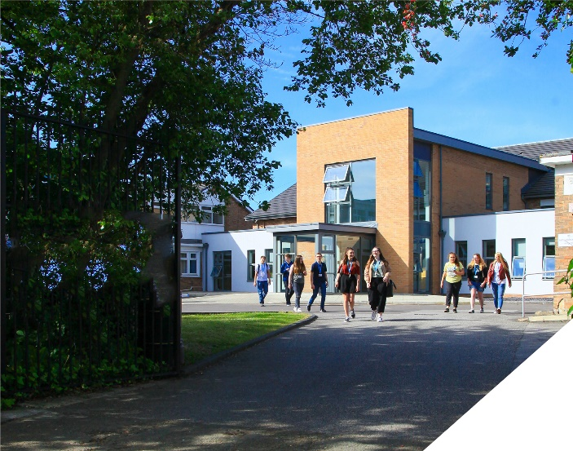
This is an exciting opportunity to teach A-level Biology
about the role.
This is an exciting opportunity to join a successful Science Department at a highly regarded Sixth Form College. We seek to appoint a committed and hardworking Biology teacher who is keen to make a difference to the educational prospects of our students. Experienced teachers and NQTs are encouraged to apply. Whatever your experience you will be supported in a way that best supports your development in a college renowned for its innovation as well as the exceptional progress of its students. Biology is a popular course at the College with over 140 students studying A Level Biology. The role will be to teach A-level Biology from the OCR A Specification.
The Science department is a successful part of an ambitious College, with highly dedicated and hardworking teachers. We are looking to appoint someone who will become an integral part of the team and who will contribute to the high quality educational experience of learners. The Science department also deliver A-levels in Chemistry and Physics as well as BTEC Applied Science. Within the department there is a real team ethos with regular opportunities for collaboration and dialogue with colleagues.
The department has 7 fully equipped laboratories. The Department has a team of 5 dedicated technicians to support with practical work and resourcing. The college is currently planning on expanding the number of science labs in response to the growing popularity of Science courses at the college.
about the College.
This is an exciting opportunity to join a highly successful and innovative sixth form college. The College was awarded the UK Sixth Form College of the Year by the TES in 2018 and this followed being graded outstanding in all areas by OFSTED in December 2016. All staff play a vital role in the experience that students have with us and ultimately their success.

The College currently has a 16 to 19-year-old student population of 1400 and is oversubscribed. Consequently, the College is embarking on an expansion project for 2020/2021 as student applications continue to increase year on year. Due to this high demand for places, work is underway on a 1.7m new state of the art teaching facility which will be opened in September 2021.

The College is committed to its core values of Positivity, Ambition, Resilience and Thoughtfulness, and these values shape everything we do. Our ethos is centred on the scientific evidence that tells us that everyone can achieve success through purposeful hard work as opposed to the talent myth, and this enables learners to make rapid progress unshackled by any limits previously placed upon them.

person specification.
Qualifications | essential | desirable
Degree in Biology or an equivalent qualification | 
Qualified Teacher Status | 
Experience
Experience of teaching A-level Biology | 
Experience of teaching OCR A Biology Specification |  | 
Experience of working in a demanding environment where high levels of organisation are required | 
Knowledge / Skills / Abilities
Ability to teach A-level Biology | 
Up to date knowledge & understanding of educational developments relating to the curriculum area | 
Ability to work flexibly as part of a team | 
Ability to form & maintain appropriate relationships & personal boundaries with young people | 
Ability to respond flexibly & creatively to new challenges & opportunities | 
Ability to prioritise & meet deadlines | 
Ability to use Information Technology effectively | 
Excellent communication, interpersonal & organisational skills | 
To demonstrate a commitment to
The Colleges values of Positivity, Ambition, Resilience & Thoughtfulness | 
Personal development and training | 
Safeguarding & promoting the welfare of students | 
Equality & diversity | 
how to apply.
If you are ambitious and determined to make a meaningful difference in one of the country’s leading sixth form colleges then we would be thrilled to have you join our team.

- Please complete the Teacher Application Form which is available on the College website: www.bsfc.ac.uk
- Last 3 years of examination results (if appropriate – if you are an NQT please skip this part of the application procedure)
- On a separate document, answer the following specific questions (each question should be answered separately with each answer being no more than 150 words):

- Aside from your stated qualifications, please outline what you believe makes you academically suited to the position applied for.
- The College does not currently operate a gifted and talented programme. What is your view on this approach?
- Please identify one or two skills or techniques you have used in the classroom to drive learning.
- Select one of the college values and describe ways you demonstrate this in your day to day work.
- You should have provided an accompanying sheet summarising the results you have achieved over the last three years. Is there any context or background you would like to give to these?

Please email these to: hrdept@bsfc.ac.uk

closing date: Tuesday 13th April - 12 Noon

Application Form can be downloaded from the College website: www.bsfc.ac.uk

