INFORMATION PACK
Altrincham Grammar School For Girls
Teacher of Biology
Full-time
Required from 1 September 2021
Fixed-term maternity cover until 28 May 2022 in the first instance
Bright Futures Educational Trust
Bright Futures Educational Trust (The Trust) is a multi-academy trust set up in 2011. The Trust is made up of a richly diverse group of schools in Greater Manchester and Blackpool. We are passionate about working together within and beyond the Trust to achieve our aspirational vision: the best for everyone, the best from everyone. We are an organisation that is underpinned by values of: community, integrity and passion. In everything we do, we remember that we are accountable to the children, families and communities that we serve.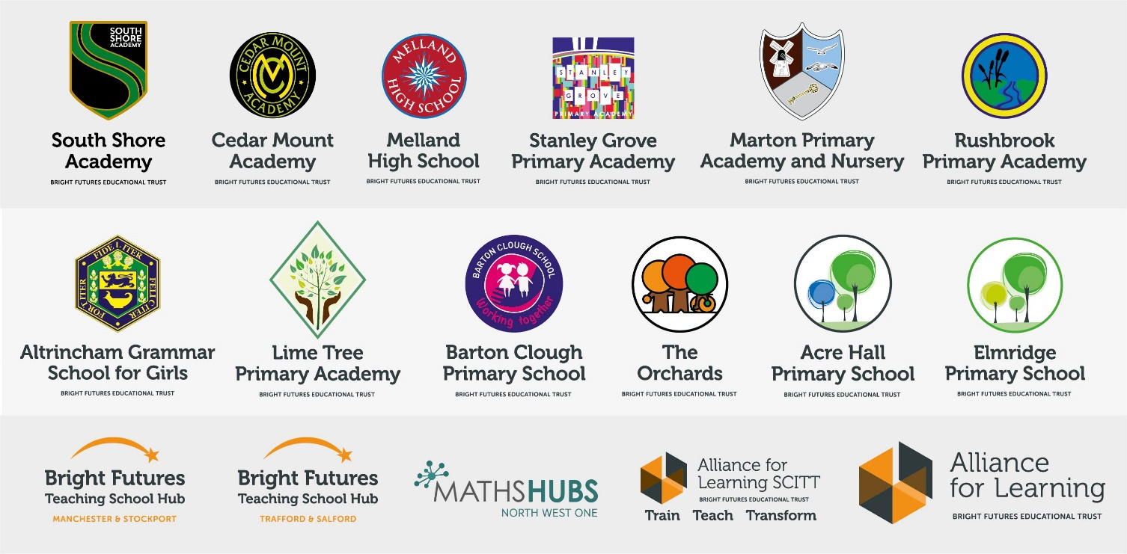
Our schools have their own identities and form one organisation and one employer, Bright Futures Educational Trust. Bright Futures’ Board of Trustees maintains strategic oversight of the Trust and delegates some of its responsibilities to the Executive Team, Principals and local governing bodies. We place a high value on integrity and probity and take seriously our accountabilities for making the best use of public money. How decisions are made is described in our delegation framework. You can find out more about the Trustees and the Executive Team on our website: http://bfet.co.uk/about-us/.

The central team, comprises the Executive Team: John Stephens, CEO; Edward Vitalis, Chief Operating Officer; Gary Handforth, Director of Education; Lisa Fathers, Director of Teaching School and Partnerships and Lynette Beckett, Director of HR & Strategy. The focus of these roles is to work with schools, providing high quality and timely guidance, leadership, challenge and support. In addition to the executive team, we have central operations for finance, HR, educational psychology and Digital Technologies. Please see our website brochure which explains our central operations: Working together for a Bright Future.

Collaboration and strong relationships form one of the ‘commitments’ in our Strategy and all components of the Bright Futures’ family work closely together. Our Strategy was developed collaboratively and can be found on our website: Our Strategy.

Bright Futures Development Network is another important outward facing component of our organisation. Underneath this umbrella we have 5 network hubs. ‘The Alliance for Learning’ (AFL) which provides school improvement services and CPD to over 700 schools (http://allianceforlearning.co.uk/); a North West Maths’ hub providing mathematics training and coaching to 500 schools: a SCITT (School Centered Initial Teacher Training) which is the largest in the North West. After significant national reforms to the teaching school policy, Bright Futures was designated with two new large-scale Teaching School Hubs in 2021. The areas we serve are Manchester, Stockport, Salford and Trafford.

Altrincham Grammar School for Girls
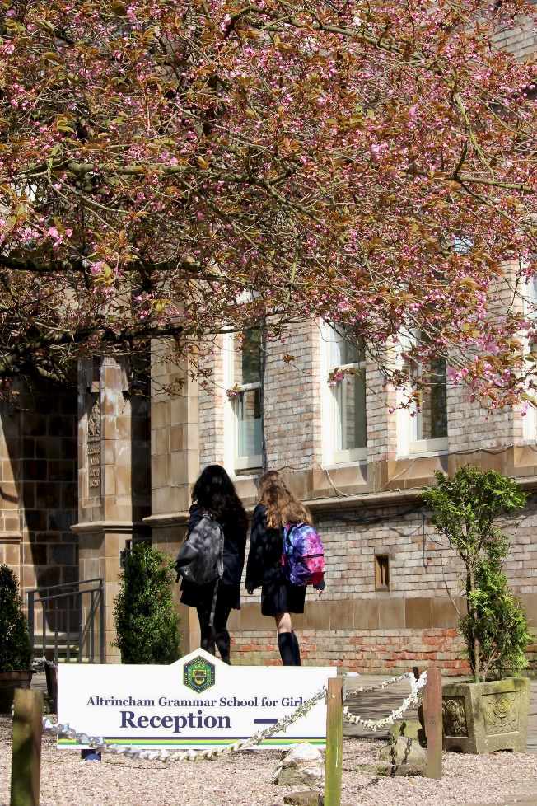
Altrincham Grammar School for Girls (AGGS) is a highly successful single sex 11 -18 academy in the South Trafford area. AGGS was in the first cohort of schools to be designated a national teaching school in 2011. AGGS is the lead school in ‘The Alliance for Learning’, which comprised schools of every type and phase, plus universities, throughout a wide geographical area. The impact of teaching school activities has been felt within the Trust and far beyond. We have a reputation for excellence regionally and nationally, of which we are very proud.

AGGS is committed to providing equal opportunity in recruitment and employment to all individuals. We will consider candidates without regard to race, ethnicity, gender, religion, sexual orientation and identity, national origin, age, military or veteran status, disability or any other legally protected status; and without discrimination based on socioeconomic, marital, parental or caregiving status, or any of the previously listed characteristics or statuses.

We value the diversity of our staff and reject any form of harassment, discrimination or victimisation. The Bright Futures Educational Trust vision is: ‘the best for everyone, the best from everyone’. To achieve this, we create and maintain a work environment and culture where people from different backgrounds, and with varying lifestyles, interests, opinions and responsibilities, treat each other with dignity and respect. It is a climate in which our staff feel safe and are inspired and motivated to be their best.

Our school is dedicated to sustaining and promoting diversity with respect to recruitment, promotion, training and general treatment during employment. We are actively seeking to extend the diversity of our staff. Furthermore, we welcome candidates who have not had previous experience of working in a grammar school.

We aim to ensure that our recruitment processes set up all candidates for success. At interview our aim is to provide a positive experience. We don’t want to catch anyone out, but rather to provide the opportunity for all candidates to be themselves and show us what they are capable of.

Why work for us?

We offer a great opportunity to join an organisation which really lives its values. Our working environment is very inclusive and whilst you can expect to be challenged in your role, you will be supported through professional learning, treated fairly and with dignity and respect. Please see the Equality, diversity and inclusion statement on our website: http://bfet.co.uk/vacancies/.

Terms and Conditions
Salary: MPR/UPR (School Teachers Terms and Conditions)
Location of work: Altrincham Grammar School for Girls
Pension: Teachers Pension Scheme: https://www.teacherspensions.co.uk/

Other: We offer salary sacrifice schemes for purchasing bikes used for travel to work and technology for personal use, through monthly interest free salary deductions.
How to Apply
We can only accept completed application forms, rather than CVs. This is because the regulatory guidelines of Keeping Children Safe in Education, require us to check various details of job applicants and an identical application format for each candidate enables us to do this.
Our website www.aggs.trafford.sch.uk contains our application form and disclosure of criminal background form. Both completed forms should be emailed to vacancies@aggs.bfet.uk by 12 midday on Monday 26 April 2021. Applicants who are not contacted during this period may assume that they have not been successful but are thanked for their interest. Unfortunately, we are unable to provide feedback to unsuccessful applicants who are not called for interview.

The selection will take place in the week commencing 3 May 2021.

Keeping Children Safe in Education
Bright Futures Educational Trust is committed to safeguarding and promoting the welfare of children and young people and we expect all staff and volunteers to share this commitment. This post is exempt from the Rehabilitation of Offenders Act 1974; pre-employment checks will be carried out and references will be sought for shortlisted candidates and successful candidates will be subject to an enhanced DBS check and other relevant checks with statutory bodies.
Data Privacy
You can the details of how we use the personal data that you provide us with in our Job Applicants’ privacy notice on our website: http://bfet.co.uk/wp-content/uploads/2018/07/BFET-Applicant-privacy-notice-002.pdf

A well-qualified, enthusiastic and experienced biology teacher is required to join this very successful science department within this selective grammar school. There are currently six teaching staff in the Biology Department, (including the Head of Biology and Second in Biology) and two part time technicians.

In Years 7 and 8 all students follow an integrated science course and biology is taught as a separate subject from Year 9. At KS4 each science discipline is taught by subject specialists and at GCSE the students are studying either AQA Trilogy or AQA Triple Sciences. Every year students perform extremely well at GCSE; the data is available to view on our website.

Demand for biology in the Sixth Form is very high. Currently we have five groups following the AQA biology specification in Year 12 and Year 13. Results at KS5 have been consistently outstanding and many students elect to follow a biology-related course at university. In recent years students have achieved national recognition in competitions such as the Biology Olympiad. Within the Biology Department, the students are offered a range of extra-curricular activities including Medical Society, Science Society, an extremely busy Biology Week in October and a programme of lunch-time speakers for KS5 pupils. There is also an over-subscribed KS3 STEM Club and a variety of science trips throughout the year.

Altrincham Girls’ Grammar School is a lead school in biology, contributing to the Teaching School accreditation by offering support and advice to other schools and encouraging work across schools to enhance teaching practice. In addition, the science department hosts Prince’s Teaching Institute training for recently qualified teachers on Saturdays and several members of the department are lead teachers on this course.

The Science Department comprises thirteen laboratories with the biology department’s laboratories situated on the first floor. There is a science staffroom and each member of staff has an allocated work area. Each laboratory in the school is equipped with a data projector and a networked computer.

The appointee will be expected to teach science at KS3 and biology at KS4 and, if possible, KS5. They should be able to deliver the subject in an enthusiastic way that will actively encourage the development of a real enthusiasm for the subject and a knowledge of the importance of biology and science in today’s society.

School-wide Responsibilities
- Being aware of and acting upon relevant school policies and, in particular, those associated with child protection/safeguarding children and health and safety issues.
- Being responsible for maintaining a clean and tidy environment.
- Attending relevant meetings as required.
- Acting as a role model for the pupils in school.
- Acting as an ambassador for school and ensuring that the school’s high standards are promoted at all times.

Additional Specific Responsibilities
- Carry out the duties of a form tutor
- Support the school in its open evenings and award evenings.
- Support the school in its entrance examination.

General Duties
- Carry out a share of supervisory duties in accordance with published schedules. Fulfil the conditions of employment of school teachers as laid down in the Pay and Conditions Document.
- Any other relevant duties requested by the Principal.

Other
- Attend relevant meetings as required, acting as a role model consistently promoting the Trust’s vision, values and commitments.

Acting as an ambassador ensuring that the Trust’s high standards are promoted at all times.
- A commitment to maintaining confidentiality and discretion inside and outside work

Probationary period
Your appointment is subject to a six month probationary period. At the end of this period, providing your service has been satisfactory, your appointment will be confirmed. If your service is not satisfactory your employment may be terminated within the probationary period.

If invited for interview, candidates are required to bring original copies of the following documents which we need to have sight of on the interview day:
- Degree certificate
- QTS Certificate
- Photo ID (passport and driving licence)
- Two other forms of identification that verify your name, address and date of birth. e.g. birth certificate, marriage certificate, bank or credit card statement, utility bill.
- Evidence of MPS - recent payslip and school salary notification letter stating where you are on the pay scale (if applicable)
- Evidence of threshold/UPS (if applicable)

PERSON SPECIFICATION
Category | Essential | Desirable | Method of assessment
Qualifications, Education, training | A good honours degree in biology.  QTS | Recent relevant in-service training | Application form  Certificates
Relevant Experience | Successful teaching experience of science at KS3 and biology to KS4.  Contributions to the work of a chemistry department, including lesson planning. | Experience of teaching of biology to A level.  Experience of being a form tutor. | Application form  Lesson  Interview
Safeguarding | Commitment to demonstrating a responsibility for safeguarding and promoting the welfare of young people. |  | Interview
Knowledge, skills and abilities | Excellent up to date subject knowledge and of current resources for biology teaching.  An enthusiasm for biology and the ability to generate this in others.  High standards of biology teaching and learning in the classroom.  Competence in the use of scientific apparatus: awareness of safe practice in laboratory lessons.  Very good oral and written communication skills with students, parents and colleagues.  Ability to show initiative.  Ability to encourage and maintain good behavior on the part of the students.  Good organizational and record keeping skills.  Excellent ICT skills and evidence of using a range of ICT to enhance teaching and learning.  Ability to work as part of a successful team  Ability to plan, organise, review and adapt.  Ability to build strong working relationships with all stakeholders  Ability to work under pressure and unsupervised on own initiative working to tight deadlines  Ability to preserve confidentiality and discretion, inside and outside school. |  | Application form  Interview  Task
Teaching School | A commitment to further training and a willingness to participate in the relevant CPD programmes.  Willingness for lessons to be observed as part of our school monitoring processes and teaching school brief (e.g. learning walks)  Willingness to be involved in lead school/Prince’s Teaching Institute work.  Willingness to be engaged in school to school support.  Positive view/ideas on contributions to language college status/teaching school status. |  | Application form  Interview
Others | Commitment to the aims and ethos of the school.  Commitment to pastoral care.  Commitment to further training and willingness to participate in relevant CPD.  Positive approach to challenges, which seeks solutions to problems and addresses difficulties with cheerfulness and good humour. |  | Application form  Interview
Our Values | Community: Evidence of working together for a common purpose and encouraging diversity |  | Interview  Tasks
 | Integrity: Evidence of doing the right things for the right reason |  | Interview  Tasks
 | Passion: Evidence of taking personal responsibility, working hard and having high aspirations |  | Interview  Tasks

