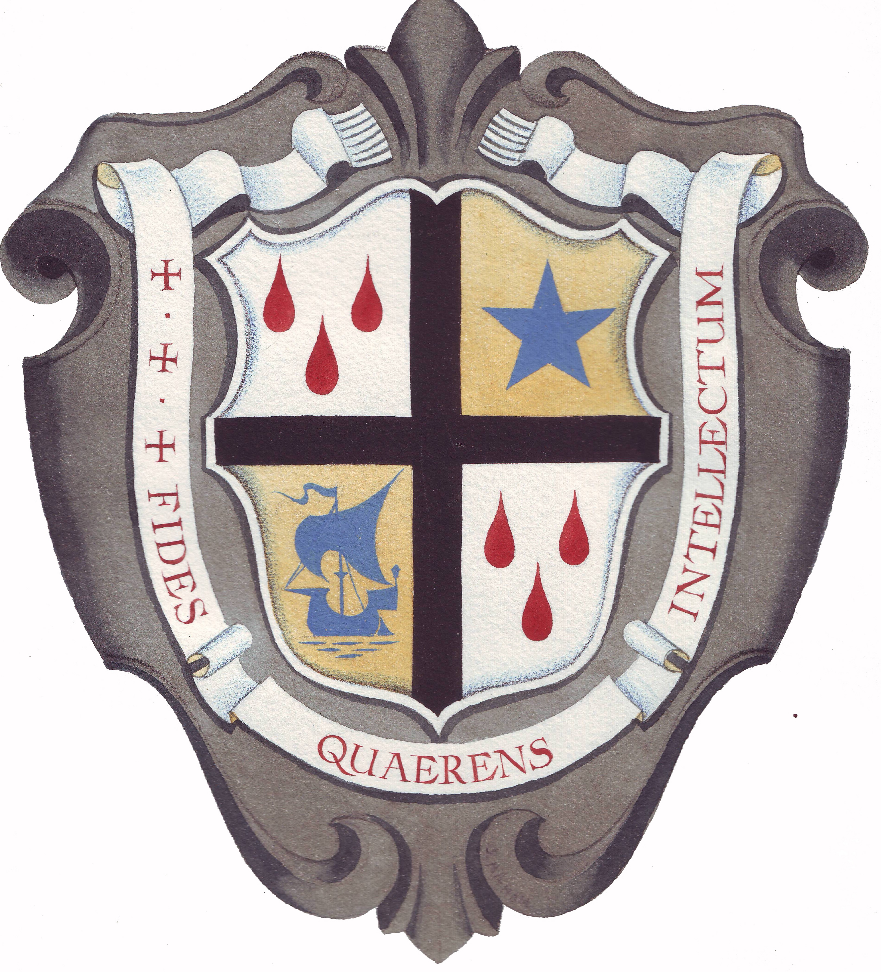
ST. ANSELM’S COLLEGE

Edmund Rice Academy Trust
Manor Hill
Birkenhead, Wirral CH43 1UQ

Required for September 2022

TEACHER OF BIOLOGY

at Key Stage 3, GCSE, BTEC and GCE (desirable)

This is an ideal opportunity for an enthusiastic graduate to join this leading department, within the Science Faculty, which contributes strongly to the overall success of the College. Biology remains one of our most popular GCSE and A Level subjects. This vacancy will be attractive to a recently qualified teacher or someone keen to develop their career. The ability to teach post-16 Biology is welcomed.

A willingness to contribute to the extra-curricular life of the Science Faculty is essential.

- ‘This is a good school’ (Ofsted 2019)
- 62% 7-9, 97% 5-9 at GCSE in 2019
- High uptake at GCSE and A Level
- Top of DfE 16-19 Progress Tables in Wirral 2018-20

“The leadership of teaching, learning and assessment is highly effective. Teaching is now good.”
“Pupils’ outcomes are good. They make good progress during their time at the school and successfully move on to next steps”.
“Leaders plan an effective curriculum for pupils. Pupils study courses which meet their needs.” (Ofsted July 2019)

The College was last inspected by Shrewsbury Diocesan Inspectors in March 2019 and judged to be, “a good Catholic Grammar School with many outstanding features.”

St. Anselm’s College is committed to the safety, protection and well-being of its students. The interview process will include questions on safeguarding children.

Job description and an application form can be downloaded from the College’s website www.st-anselms.com

Please either post your application form together with letter of application and CV or email it to acook@st-anselms.com

Closing date for completed applications: Friday 10th June 2022
Interviews held thereafter.

