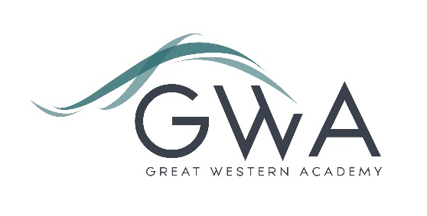

# Information for Applicants

**Teacher of BTEC Health and Social Care**

Great Western Academy opened in brand new, state-of-the-art facilities in North Swindon in September 2018. The Academy is heavily oversubscribed in years 7,8,9,10 and 11 and the results of our first three A-level cohorts in summer 2021, 2022 and 2023 were excellent and enabled 98% of university applicants to take up their offers, including three to Oxford and Cambridge: students have also secured prestigious apprenticeships with companies such as Airbus and Rolls Royce. We believe firmly that strong outcomes follow from high expectations, high quality teaching, and strong support in terms of behaviour structures and targeted academic and pastoral interventions.

2023 sees the first teaching of BTEC Health and Social Care at GWA as we expand our sixth form to accommodate the first cohort of year 11 students in the school as they make their way into year 12. We have created a climate in social sciences where our students are inquisitive, ambitious learners who have the desire to fully explore the diversity our curriculum has to offer, already achieving excellent outcomes.  As a result, the Health and Social course has proven to be a popular choice for our ambitious learners.  This post offers the opportunity to lead in this subject area and ensure the course becomes fully established. In these early days of delivery there is scope to really guide to development of Health and Social Care at GWA.

Application process

Please complete the application form, and the equalities form, supplied and enclose a supporting letter, either in the space provided on the application form or as a separate document. The application form should be completed in full in black ink or type. A CV is not requiredand should not be submitted as part of the application.

Your supporting letter should be no more than 2 sides of A4 (with a font size no smaller than 11) and should enhance your application by providing further information, matched to the person specification, about your suitability for the post. This should include evidence of the impact on student outcomes you have made in your career to date.

Electronic applications should be returned via email to [**recruitment@gwacademy.co.uk**](mailto:recruitment@gwacademy.co.uk)

**Closing Date: 9am Tuesday 20th February 2024**

**Interviews:** Interviews will take place as soon as possible after this date.

**References:** References will be taken up prior to interview.

The interview process will include observation of your teaching, and a variety of other tasks and activities. 

*Great Western Academy is committed to safeguarding and promoting the welfare of children, young people and vulnerable adults and we expect all staff to share this commitment and undergo appropriate checks. All posts within the Trust are therefore subject to an Enhanced DBS and barred list check.*