**Information for Applicants**

**Teacher of Business & Economics**

**T1 – T9 (£28,000 - £43,685)**

**0.5 FTE**

**Actual Salary £14,000 - £21,842.50**

**Permanent Contract**

**Required 1st September 2023**

**Closing date: 9am, Monday 20th March 2023**

**Interview date: w/c 27th March 2023**

**Welcome to The Bishop Fraser Trust from the Chief Executive, Tania Lewyckyj**



The Bishop Fraser Trust is Multi Academy Trust which was set up on the 1st December 2017. Our family of schools are as follows;

* St James’s Church of England High School (11-16)
* Canon Slade School (11-18)
* Bolton St Catherine’s Academy (3-16)
* Bury Church of England High School (11-16)
* St Catherine’s Church of England Primary (Horwich) (3-11)

The Trust’s vision is based on our strongly held Christian values: **“To allow all children to experience ‘Life in all it’s fullness’, no matter what their starting point.”** We offer a high quality, inclusive and distinctive education within a caring and nurturing environment based on our Christian values, recognising the uniqueness of each child.

Our schools are situated in Bolton and Bury. We are an outward facing Trust and constantly look to learn and collaborate with others. We also have an excellent provision via our Train Teach Lead Partnership (TTLP), which offers excellent CPD and school to school support. Our links with Manchester Diocese, GMLP and the Bolton Learning Partnership continues to be strong.

We are now developing our primary sector and hope to welcome at least two more primary schools over the next 12 months.

We became a Trust to secure the special nature of our individual schools as we do not think that one size fits all. We also wanted to secure our ethos and distinctiveness, enabling us to work together and to become the Trust of choice for local families and staff. Our employees are very important to us as we rise or fall by the professionalism and dedication of our staff.

It is an absolute privilege to have the opportunity to make a difference in the lives of our young people. From 2 to 18 years old, we have the potential to enhance life chances in all of our schools and improve the local communities at the same time. Our focus is on more than exams; it is about the development and wellbeing of the whole child, allowing them to effectively thrive in this fast-moving world in which we live. If this is the first time you have heard about us, we hope you are inspired and feel that you could thrive within our positive and aspiring Trust.



**Tania Lewyckyj**

**Chief Executive Officer**

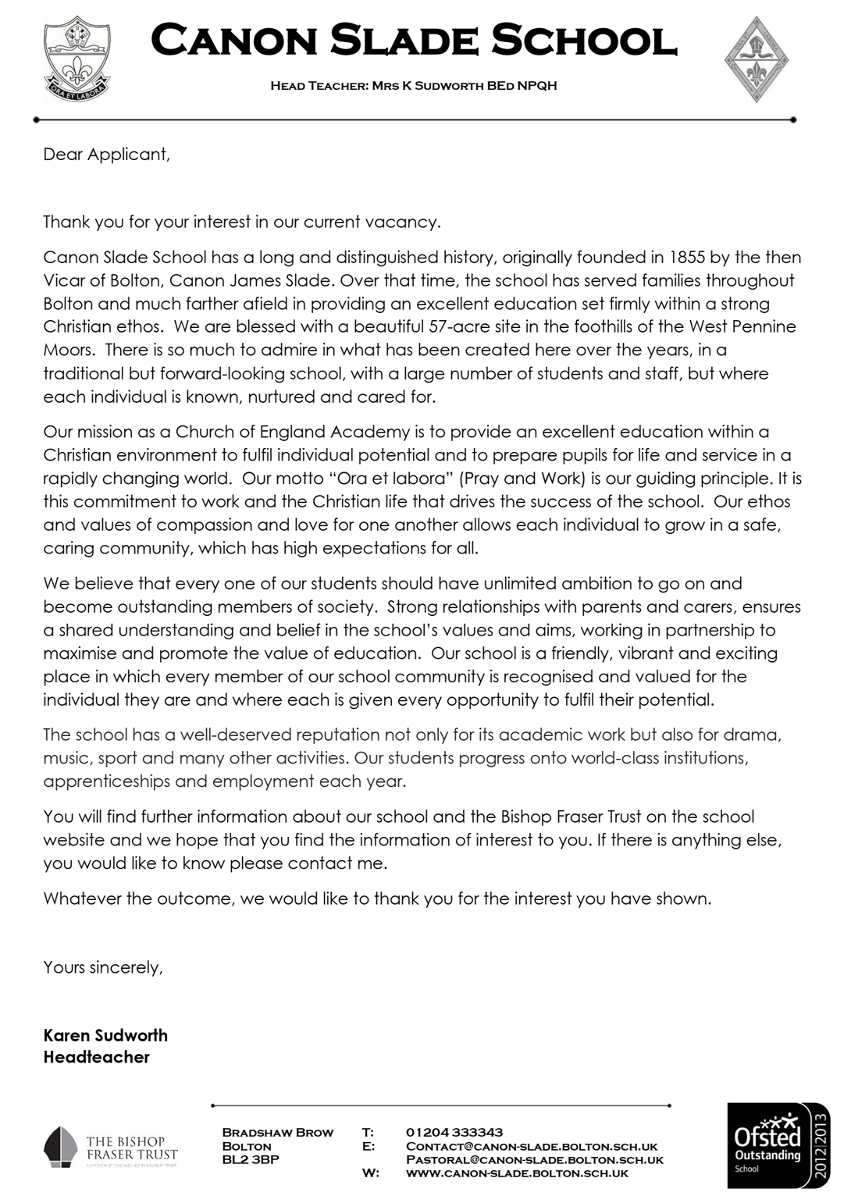

**How to apply**

We hope that you have enjoyed reading about The Bishop Fraser Trust and our school and that you will feel able to apply for this post.

We aim to recruit staff who:

* are excited by their role and by the prospect of working with young people, even those who are less well motivated;
* love the processes of learning and teaching and are keen to continually develop their own skills;
* recognise that teaching can be a demanding job but react positively to those demands with resilience;
* wish to make a real difference in the lives of others;
* will subscribe to the ethos of the Trust and ‘go the extra mile’ in terms of time and commitment to get the very best from our young people;
* are quick to praise and slow to criticise; and are not afraid to admit to seeing themselves as potential leaders of the future.

**To apply, please complete the application form attached and email this to** [**recruitment@thebishopfrasertrust.co.uk**](mailto:recruitment@thebishopfrasertrust.co.uk)

Please do not send CV’s or open references as part of your application as these will not be considered.

It is important that you provide a complete employment history from when you left full time education. If the application form is not fully completed or has unexplained gaps in your employment history, your application will not be considered. Copies of your qualifications will be required at the interview stage; please do not send these with your application.

Please also include within the body of your application form **a statement of no more than two sides of A4** to explain why you want to work at our school, why you are the best candidate for this post and what you would contribute to our Trust and school, with examples from your recent work if possible. We are keen to learn about your impact and your educational philosophy.

We will not be able to consider late applications.

In accordance with the General Data Protection Regulations, the details provided in the application form will be used for selection and interview procedures, and for employment records if your application is successful. Our recruitment privacy notice with further details is available both on our school website.

If you do not hear from the school within two weeks of the closing date, then please assume that your application has been unsuccessful on this occasion.

The school has an Equal Opportunities Policy**.**  If you are disabled, please give details of how we can ensure that you are offered a fair selection and interview process or if you would prefer, please contact [recruitment@thebishopfrasertrust.co.uk](mailto:recruitment@thebishopfrasertrust.co.uk)to discuss any requirements.

Successful candidates will be asked to provide, prior to taking up the appointment, documentary evidence (including National Insurance number) showing their entitlement to work in the UK. We will also carry out reference checks, an enhanced DBS and declaration of health check.