job description
teacher of business studies.
reports to: Head of BTEC Business Studies
hours: Full time (Part time negotiable)
salary: £28,125-£44,256
start date: 22nd August 2023
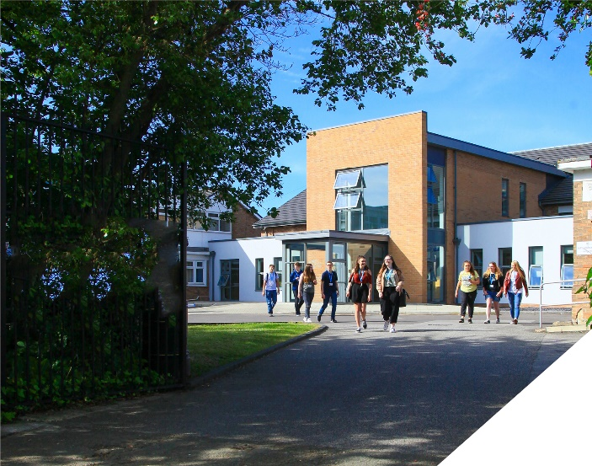
This is an exciting opportunity to teach Business Studies at a leading Sixth Form College.
about the role.
We seek to appoint a highly effective and outstanding Business Studies teacher. Business Studies is a popular course at the College with over 90 students studying A Level Business Studies and over 150 students studying Level 3 BTEC (RQF) in Applied Business.
The role is to primarily teach BTEC Applied Business however there will be increasing opportunities to also support the delivery of A-level Business Studies in future years. The successful candidate will be a Business Studies specialist who is an excellent classroom practitioner and uses the science of cognition and learning to inform their teaching.
Both experienced teachers and NQTs are encouraged to apply. Whatever your experience you will be supported in a way that best supports your development in a college renowned for its innovation as well as the exceptional progress of its students.
The Business studies department is a successful part of an ambitious College, with highly dedicated and hardworking teachers. We are looking to appoint someone who will become an integral part of the team and who will contribute to the high quality educational experience of learners.
about the College.
You will be joining a highly successful, innovative and nationally recognised sixth form college. The College was awarded the UK Sixth Form College of the Year by the TES in 2018 and this followed being graded outstanding in all areas by OFSTED in December 2016. All staff play a vital role in the experience that students have with us and ultimately their success.

The College currently has a 16 to 19-year-old student population of 1450. Demand for places for places at the college is very high and as a result the college has recently expanded with the opening of a 1.7m new state of the art teaching facility in September 2021. A further brand new 3 storey classroom block is opening in April 2023 as part of the college’s expansion project.

In response to the pandemic and disruption to the learning of students the college introduced a new timetable in 2021/2022 to combat the deficits that students have. This includes teaching time increasing by 60 minutes each week we are confident that the 5.5 hours students receive each week is one of, if not the highest in the country. Whilst student teaching time has increased, the new timetable has reduced the overall teaching time for teachers each week. Full time teachers will teach a maximum of 4 classes, 4 times a week and teachers have their own groups, we do not have shared teaching groups at the college.

The College is committed to its core values of Positivity, Ambition, Resilience and Thoughtfulness, and these values shape everything we do. Our ethos is centred on the scientific evidence that tells us that everyone can achieve success through purposeful hard work as opposed to the talent myth, and this enables learners to make rapid progress unshackled by any limits previously placed upon them.

person specification.
Qualifications | essential | desirable
Degree in Business Studies or an equivalent qualification | 
Qualified Teacher Status |  | 
Experience
Experience of teaching Business Studies | 
Experience of delivering BTEC Business Studies |  | 
Experience of working in a demanding environment where high levels of organisation are required | 
Knowledge / Skills / Abilities
Ability to teach up to Level 3 | 
Up to date knowledge & understanding of educational developments relating to the curriculum area | 
Ability to work flexibly as part of a team | 
Ability to form & maintain appropriate relationships & personal boundaries with young people | 
Ability to respond flexibly & creatively to new challenges & opportunities | 
Ability to prioritise & meet deadlines | 
Ability to use Information Technology effectively | 
Excellent communication, interpersonal & organisational skills | 
To demonstrate a commitment to
The Colleges values of Positivity, Ambition, Resilience & Thoughtfulness | 
Personal development and training | 
Safeguarding & promoting the welfare of students | 
Equality & diversity | 
how to apply.
If you are ambitious and determined to make a meaningful difference in one of the country’s leading sixth form colleges then we would be thrilled to have you join our team.

- Please complete the Teacher Application Form which is available on the College website: www.bsfc.ac.uk
- Last 3 years of examination results (if appropriate – if you are an NQT please skip this part of the application procedure)
- On a separate document, answer the following specific questions (each question should be answered separately with each answer being no more than 150 words):

- Aside from your stated qualifications, please outline what you believe makes you academically suited to the position applied for.
- The College does not currently operate a gifted and talented programme. What is your view on this approach?
- Please identify one or two skills or techniques you have used in the classroom to drive learning.
- Select one of the college values and describe ways you demonstrate this in your day to day work.
- You should have provided an accompanying sheet summarising the results you have achieved over the last three years. Is there any context or background you would like to give to these?

Please email these to: hrdept@bsfc.ac.uk

closing date: 12 noon on 23rd March 2023

Application Form can be downloaded from the College website: www.bsfc.ac.uk

