# Teacher of Business Studies & Computer Science (Maternity Cover)

Birches Head Academy logo

**Birches Head Academy**

Stoke-on-Trent

* New
* Quick apply

**Salary:**

£28,000 - £43,685 per year

**Job type:**

Full Time, Maternity Cover

**Start date:**

January 2024

**Apply by:**

25 September 2023

## Job description

**TEACHER OF BUSINESS STUDIES & COMPUTER SCIENCE (MATERNITY COVER)**

**Required for January 2024**

**Temporary, Full Time**

**Fixed Term, Maternity Cover**

**MPR1 - UPR3 (£28,000 - £43,685) per annum**

Birches Head Academy is part of the Frank Field Education Trust and we work collaboratively with others in our FFET family, allowing our students and staff many opportunities to develop. This is embodied in the FFET vision: ‘**Social Justice through Excellence in Education’** and in the Academy motto: ‘Aspire to be More’.

Birches Head Academy is looking to appoint a suitably qualified and highly committed Teacher of Business Studies & Computer Science, on a fixed term Maternity cover contract, to join this successful and well-resourced department and play a vital role in helping us to ensure our students receive a world-class education, thereby enabling each child to reach their full potential.

The successful candidate should be an outstanding practitioner, experienced in teaching both Key Stage 3 and Key Stage 4. You should have a proven track record of successful outcomes and delivering on your plans. An innovative teacher, you should teach with enthusiasm and vision, and be passionate about your subject, and teaching and learning research and practice.

Applications from both experienced teachers and ECTs (NQTs) are warmly invited.

We welcome applications from all parts of our community as we aspire to have a staff body that matches the social and cultural diversity of our student intake.

**Closing date for applications: Monday 25th September, 9.30am**

**Interviews to take place Thursday 28th September 2023**

For further information, including the recruitment pack and application form, please visit our website at: [www.bircheshead.org.uk](http://www.bircheshead.org.uk/). Alternatively, you can contact the school for an information pack.

Completed application forms should be emailed to [jbracegirdle@bircheshead.org.uk](mailto:jbracegirdle@bircheshead.org.uk)

Birches Head Academy requires an application form to be completed in order to be considered for this role. Please note that CVs alone will not be accepted.

Birches Head Academy is committed to safeguarding and promoting the welfare of children and young people. Applicants will, therefore, be subject to stringent vetting and induction processes, including an enhanced DBS disclosure. References will be requested prior to interview.

All applicants will be considered on the basis of suitability for the post regardless of age, sex, race or disability

## Attached documents

* [Teaching Staff Application Form - September 2021.docx76.89KB](https://d3giikteahxfyn.cloudfront.net/6b166c92-671a-44a5-837d-8d768c8ec60b/85689220-f008-471b-b6f3-29a36d2da4ab)

## About Birches Head Academy

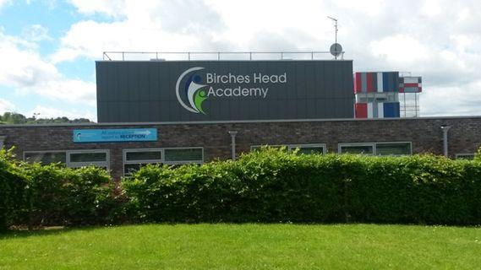

* [**Birches Head Academy**](https://www.tes.com/jobs/employer/birches-head-academy-1031332)
* Birches Head Road, Stoke-on-Trent
* Staffordshire
* ST2 8DD
* United Kingdom

[+44 178 223 3595](tel:+44%20178%20223%203595)

[View on Google Maps](https://maps.google.com/maps?q=loc:53.0401077271,-2.1476089954&z=16)

[Visit employer website](http://www.bircheshead.org.uk/)

Birches Head Academy has recently become part of the Frank Field Education Trust and we work collaboratively with others in our FFET family, allowing our students and staff many opportunities to develop. This is embodied in the FFET vision: ‘Social Justice through Excellence in Education’ and in the Academy motto: ‘Aspire to be More’.

**Our vision is to provide:**

* An exceptional academic education to all children (Intellectual Capital)
* A values led approach to education for every child (Cultural Capital)
* The right environment for every child to flourish by building learning communities in partnership with parents and carers (Social Capital)

Achieving these commitments will ensure that, when pupils leave the Academy, they are ready for the next step in their journey; leaving with the necessary skills and knowledge, and the desire to serve others, to become the next generation of leaders.

Our determination to do this, in its fullest sense, resonates with our Academy motto inspired by the words of Oscar Romero “Aspire to be More”. We have very high aspirations for the young people at Birches Head Academy.

We believe strongly in the power of high expectations. We understand that each student has their own potential, which we are determined to help fulfil through academic study and wider enrichment. All students will take part in exciting learning, both inside and outside the classroom, so they can make rapid and sustained progress.

Students at Birches Head Academy benefit from modern learning spaces designed to help them succeed. Classrooms are equipped with state-of-the-art technology to enable all students to meet the demands of the curriculum.

The curriculum at Birches Head prepares students for the challenges ahead. We strive to provide excellent teaching and expect the highest standards of behaviour at all times. Students are encouraged to become independent learners through a positive culture where hard work, motivation and resilience are valued and rewarded. We encourage students to reflect on their learning, and to overcome barriers by developing their problem-solving skills and ability to work with others. Our students are encouraged to question, discuss and review their learning through a variety of teaching styles to suit their different interests and ways of learning.

Our students are set aspirational targets, which challenge them to maximise their potential. Rigorous and regular monitoring of students’ progress assists in meeting these challenges and keeps parents engaged in the all-important combination of home and school support.

If you feel you can make a contribution to this important enterprise and help our children to be the best that they can be, then I look forward to receiving your application.

*Please note that you are wholly responsible for fact checking in respect of the information provided by schools. Please also check for the latest visa and work permit requirements that may apply. Tes is not responsible for the content of advertisements or the policies adopted by advertising schools. Tes asks that all schools follow*[*Tes' Fair Recruitment Policy*](https://www.tes.com/fair-recruitment-policy)*.*

.