

Applicant Information Pack

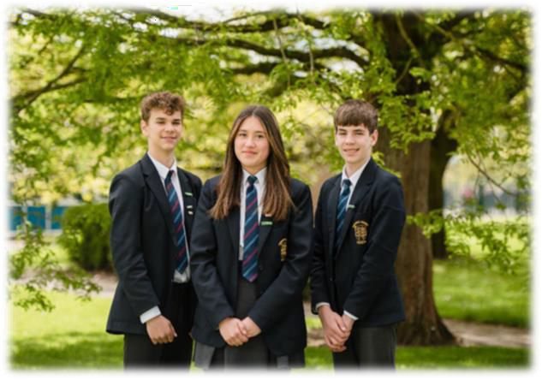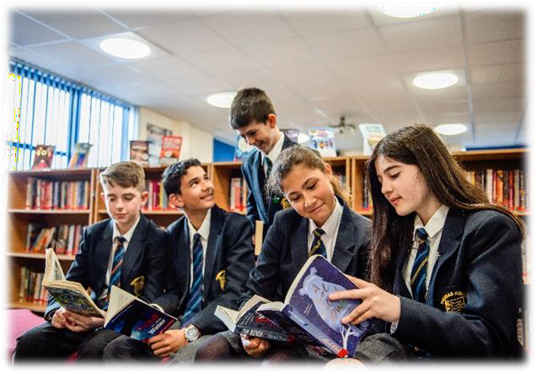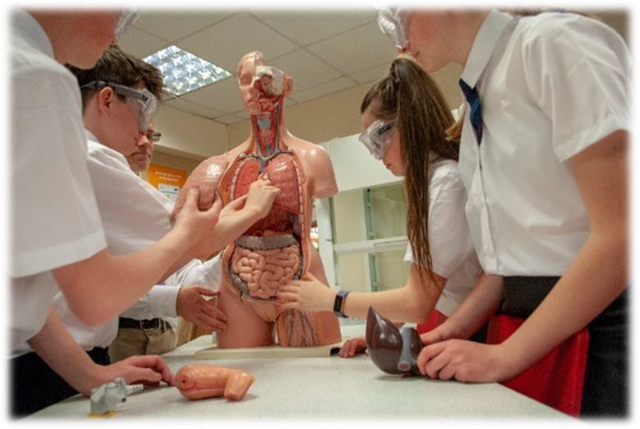

**Teacher of Business Studies**

*Respect – Resilience – Success*

# Headteacher Letter to Applicants

Thank you for the interest you have shown in our school. I am proud to be the Headteacher of The Thomas Adams School, a successful co-educational community school, sixth form and boarding house in the centre of Wem. Established in 1976 and with a strong history dating back to 1650, we provide quality teaching and learning for our 1200 students, aged 11 – 18 years old. Thomas Adams is now a member of the 3-18 Education Trust, a collaboration of successful schools in Shropshire, all with the same goal of excellence in education.



We have two main sites on our 30 acre campus in Wem, a small rural market town. Although many of our students live in Wem, our extensive transport links allow students from across North Shropshire to access our excellent provision. Our Lowe Hill buildings cater for years 7 – 11, providing excellent facilities for all curricular areas. At our Noble Street site, we have our Sixth Form, housed in the attractive grammar school building. We also have our thriving boarding provision, Adams House, which accommodates students from throughout the UK and overseas.

Large enough to offer choice and opportunity, we pride ourselves on seeing all students as individuals, providing quality pastoral care throughout a student’s academic journey with us.

The school is renowned for its Music, Drama and Sport. We have specialist centres for all of these subjects, with full performance facilities. We also have a multi-use sports centre and extensive playing fields, along with additional facilities including; tennis courts, basketball courts, hard surface play areas and many pitches for team games. We encourage all students to engage and get involved in our extra-curricular programme, be that a member of a sports team, working towards their Duke of Edinburgh award or taking part in the many educational or leisure trips on offer.

We are committed to continuous professional development for all our staff and foster open, professional and respectful relationships. Our staff well-being and happiness is paramount as we see them as our greatest asset.

For further information about The Thomas Adams School, please visit our website <https://thomasadams.net/>.

You can also find out the latest news via our social media pages:

 <https://www.facebook.com/ThomasAdamsWem>  <https://www.instagram.com/thomasadamswem/>

Mark Cooper, Headteacher

# About our Trust



The 3-18 Education Trust is currently made up of five schools and derives its name from the age range of the pupils and students who attend those schools. We have an inclusive ethos, defined by age and we recognise that education is a continuous process, secured through consistent values and a strong transition (through the key stages).



**Our Vision:**

To ensure every individual is in a great school.

**Our Mission:**

To celebrate the diverse nature, culture and identity of our individual schools, whilst enjoying the benefit of the team, so that each school is reciprocal in their support for one another and achieves together.

**Our Values:**

* Accomplished: to provide high quality education and training for all
* Resilient: to be solution focused and able to intelligently manage challenges
* Compassionate: to show care and understanding towards others

Not only do we pursue the important dimension of achieving the best results for each student regardless of their starting point, but we also believe strongly that education is about developing well-rounded individuals who are ready, willing and able to make their contribution to society.

Please take a look at our Trust website <https://www.3-18education.co.uk/> for more details. For further information about our schools, please click on the links to their websites below:

<https://bowbrookprimary.co.uk/>



<https://www.3-18education.co.uk/schools/coleham-school/>

<https://www.3-18education.co.uk/schools/the-priory-school/>

<https://www.3-18education.co.uk/schools/st-martins-school/>



<https://www.3-18education.co.uk/schools/thomas-adams-school/>  [https://www.3-18education.co.uk/schools/william-brookes-school/](https://www.3-18education.co.uk/schools/thomas-adams-school/)

# Job Description



|  |  |
| --- | --- |
| **Title of Post** | Teacher of Business Studies |
| **Post Status** | 1.0 FTE, Permanent |
| **Salary/TLR/ Allowance** | MPS |
| **Reporting to** | Line Manager |

## Main Purpose

The following subject job description is in addition to any statutory requirements and responsibilities of a Main Scale Teacher:

* Promote the highest standards of teaching Business Studies within the framework and share ideas to promote best practice within the department;
* Promote Business and Enterprise across the curriculum offer.
* Maintain and update innovative and challenging schemes of work in partnership with the Subject Leader;
* Ensure high standards of discipline and organisation within a practical environment;
* Demonstrate high standards of ICT competence in both teaching & learning and develop these as technologies change.
* Regularly assess, through verbal and written means, students’ work in accordance with the School’s and Department’s policies;
* Work with full regard to the Health and Safety requirements;
* Ensure the smooth running of internal and external controlled assessments;
* Ensure that Departmental records and information are regularly updated and keep informative records of students’ progress;
* In partnership with other members of the Department, assist with Information Evenings for parents, and attend Departmental meetings or any other meetings as deemed appropriate

## Professional development

* Help keep knowledge and understanding relevant and up-to-date by reflecting on your own practice, liaising with school leaders, and identifying relevant professional development to improve personal effectiveness
* Take opportunities to build the appropriate skills, qualifications, and/or experience needed for the role, with support from the school

## Other Responsibilities

* Comply with and assist with the development of policies and procedures relating to child protection, health, safety and security, confidentiality and data protection, reporting all concerns to an appropriate person.



* Be aware of and comply with all school policies and procedures
* Be aware of and support difference and ensure equal opportunities for all
* Contribute to the overall ethos and aims of the School and Trust
* Appreciate and support the role of other professionals
* Attend and participate in relevant meetings, training and learning activities as required

The postholder may be required to carry out any other duties that are commensurate with the post. Whilst every effort is made to explain the main duties and responsibilities of the post each individual task undertaken may not be identified.

This job description is subject to review, in negotiation with the post holder at any time. However, an annual review of this job description and allocation of responsibilities will take place as part of agreed performance management arrangements.

# Person Specification



|  |  |  |
| --- | --- | --- |
| **Criteria** | **Essential** | **Desirable** |
| **Qualifications** | * Good honours graduate * Qualified Teacher Status * Commitment to personal/professional development | * Evidence of CPD |
| **Experience** | * Experience of teaching Business Studies, especially at KS4 and KS5 | * Ability and willingness to teach other related subjects |
| **Learning & Teaching** | * Ability to challenge, support and motivate students * Ability to monitor and evaluate student performance * Ability to meet challenging targets * Secure knowledge and a good understanding of the key skills, concepts in specialist subject * Clear understanding of the secondary curriculum and its assessments * Committed to the role of form tutor for a group of students and the benefits of pastoral care | * Experience of, and sensitive to, the needs of teaching students with all ranges of needs and abilities |
| **Skills & Knowledge** | * Data analysis skills, and the ability to use data to set targets and identify weaknesses * Understanding of high-quality teaching, and the ability to model this for others and support others to improve * Effective communication and interpersonal skills * Ability to communicate a vision and inspire others * Ability to build effective working relationships |  |



|  |  |  |
| --- | --- | --- |
| **Personal Qualities** | * A commitment to getting the best outcomes for all pupils and promoting the ethos and values of the school and trust * Ability to work under pressure and prioritise effectively * Cheerful, enthusiastic and committed * Dynamic, positive, organised and constructive | * Willingness to take on other roles and responsibilities within the department |
| **Special Conditions** | * Commitment to safeguarding and promoting the welfare of children and young people * Commitment to equality of opportunity * Willingness to undertake an enhanced Disclosure and Barring Service (DBS) check. |  |

**What We Offer**

## In addition to exclusive access to a reward and discount scheme, comprehensive induction, commitment to your ongoing training and career progression, paid for enhanced DBS, we also offer:

* A competitive salary
* Access to the Trust’s Employee Assistance Programme, which includes 24 hour access for you and your family members to legal, financial, health, parenting and life advice



* 1:1 Counselling Service
* Cycle to Work Scheme
* Childcare Voucher Scheme or Tax-Free Childcare Scheme
* Access to freshly made hot meals or deli-style food on site
* Teachers Pensions (23.68% employer contributions)
* Local Government Pension Scheme (17.9% employer contribution)
* Generous Sickness Payment Scheme
* Eye Testing Scheme
* Flexible Working Policy
* Special Leave Policy
* Member of the Valued Worker Scheme (accredited by our recognised unions)
* A Disability Confident Committed Employer
* Continuous Professional Development (CPD)
* Collaborative working culture and professional development opportunities across our Trust schools

# Application & Appointment Process

Full details of the post can be found in the Applicant Information Pack available on the school website <https://www.thomasadams.net/vacancies/>

Please send completed applications to [bjh@thomasadams.net](mailto:bjh@thomasadams.net)

Interviews will be offered to those applicants who best demonstrate how their skills, abilities and experience match the person specification, taking into consideration the job description.



## Closing date for applications: 12.00 noon on Tuesday 26th September 2023

## Interviews will take place shortly thereafter

**Please note:**

* It is essential that all elements of the application form are completed in full.
* We do not accept CV’s in support of an application.
* Appointments will be subject to clearance in respect of medical fitness, satisfactory references, right to work in the UK and criminal disclosure.
* This post is exempt from the Rehabilitation of Offenders act 1974 and as such the applicant who is appointed to this post will be subject to an Enhanced Disclosure before the appointment is confirmed. This check will include details of cautions, reprimands or warnings, as well as convictions and non-conviction information. Once appointed, the successful applicant may also be required to apply for an Enhanced Disclosure at intervals during the course of their employment whilst in this post.

If invited for interview, **you are required to bring evidence of your qualifications and appropriate documents to initiate the DBS application process** should you be the successful candidate.

*The 3-18 Education Trust is committed to safeguarding and promoting the welfare of children and young people, as such this post requires acknowledgement and understanding of safeguarding and child protection policies. Policies can be found on the school website* [*https://www.thomasadams.net/key-information/*](https://www.thomasadams.net/key-information/)*.*