

Teacher of Chemistry
For Appointment of:
JOIN OUR TEAM
Based in Tonbridge, Kent, Hillview School for Girls is an 11 to 18 girls’ all-ability school with a thriving, mixed Sixth Form. We chose to become an academy in August 2011 and are one of the highest-achieving non-selective girls’ School in Kent. Our dynamic Performing and Visual Arts specialisms have a profound impact upon learning and contribute to the purposeful, friendly and stimulating atmosphere that permeates the school. We foster
self-esteem and high aspirations.

By encouraging a ‘can-do’ culture, our students become astute, ambitious and independent. Visitors often comment about how articulate and enthusiastic our students are. We believe in the pure potential of every child within the school, to develop, mature and thrive, leaving education fully ready for the world of employment. We place a high emphasis on education beyond grades, actively exploring a wide range of opportunities to develop the awareness and engagement of our students in the world around them.

Hillview is a fully inclusive school where independence is developed through an innovative education and inspirational opportunities.

Our vision is that: students unlock their pure potential to drive their future and thrive in society.

The pure potential belief is integral to everything that we do in school and the outcomes we expect for our students. The skills and beliefs at the heart of the pure potential graphic pull together the Performing Arts values, the desirable attributes of a future employee and awareness of the world. Hillview believes in success and achievement beyond grades and highly values the breadth of character and experience that enables our alumni to stand out from the crowd and secure a successful role in the ever-changing modern world. Through our inclusive Hillview society, we actively develop and promote the independent learner and thinker, encouraging students to try, make mistakes and learn for themselves.

We help students develop a range of transferable skills from teamwork, leadership and independence through to communication, self-expression and time management. Our strong pastoral system ensures that behaviour is excellent and there is a relaxed but purposeful atmosphere throughout the school where young people can thrive and feel supported.

We have a vibrant, mixed Sixth Form that provides a variety of pathways for students to extend their learning, gain work experience with one of our many industry partners and prepare for university or work.

Further details of the school, including breakdown of performance figures, can be accessed through: www.hillview.kent.sch.uk

Applicants are warmly invited to visit the school before applying.

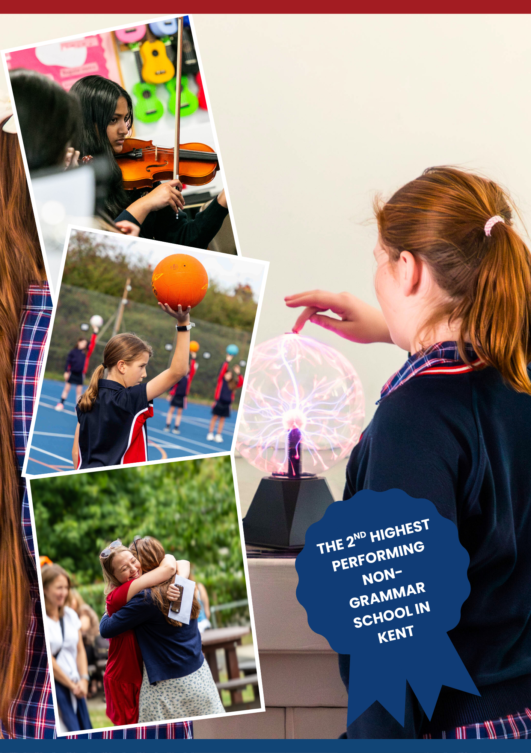


Line Manager: Director of Science

Core purpose of the post
- To provide a high quality educational experience for all children.

General duties and responsibilities
- To carry out the duties of a schoolteacher as set out in the School Teachers’ Pay and Conditions Document,
- To continue to meet the required standards for Qualified Teacher Status.
- To be fully involved in the department including the leading of extra-curricular clubs and activities.

Knowledge and understanding
- Understand how pupils’ learning is effected by their physical, intellectual, emotional and social development and understand all stages of child development.
- Have a sound knowledge of the Art curriculum.

Planning, teaching and class management
- Provide clear structure for lessons and for sequences of lessons, which maintain pace, motivation and challenge.
- Prepare sequences of lessons that ensure students are able to meet requirements for coursework within the set timescales.
- Make effective use of assessment information on pupils’ attainment and progress and in planning future lessons.
- Ensure effective teaching of whole classes, groups and individuals, establishing high expectations of behaviour and attainment, so that teaching objectives are met.
- Monitor and intervene when teaching to ensure sound learning and discipline and maintain a safe environment in which pupils feel confident.
- Use a variety of teaching and learning styles to keep all pupils engaged.
- Be familiar with the Code of Practice and identification, assessment and support of pupils with additional educational needs.
- Evaluate your own teaching critically to improve effectiveness.
- Be a safe practitioner.

Job Title: Teacher of Chemistry
Location: Tonbridge, Kent

MPS/UPS
JOB DESCRIPTION



Monitoring, assessment, recording, reporting and accountability
- Assess and record each pupil’s progress systematically with reference to the school’s and the department’s current practice and use the results to inform planning.
- Mark and monitor class work and homework, providing constructive feedback and setting targets for future progress.
- Provide reports on individual progress to the Headteacher and parents as required.

Other professional requirements
- Establish and maintain effective working relationships with colleagues and parents.
- Participate as required in meetings in respect of the duties and responsibilities of the post.
- Be aware of the need to take responsibility for your own professional development.

Person Specification
The following selection criteria are the skills and experience required for this position.

- The possession of relevant teaching qualification and/or experience of the academic discipline of Art/Fine Art.
- Knowledge and understanding of the demands of the Art/Fine Art syllabus.
- The ability to work towards and achieve high standards in teaching.
- An ability to differentiate effectively and to use a variety of teaching and learning styles.
- A commitment to developing teaching and learning styles in Art/Fine Art.
- Willingness and ability to work as a member of a team.
- A commitment to extra-curricular activities, including subject related trips.
- Good communication skills.
- Confidence to be pro-active and a good role model.

The Science Department at Hillview School for Girls has operated as part of an Academy since 2011, and the school uses Rosenshine’s Principles of instruction to underpin classroom practice across all departments.

Staffing
The Department is comprised of the equivalent of 10 full-time teachers, all graduate specialists. They are supported by two full-time technicians. The current department structure comprises of a Head of Department and a Second in Department.

The Department is involved in initial teacher training where staff from the Department deliver some of the theoretical aspects of the training as well as the day-to-day practical mentoring of the trainees.

Courses
Hillview School for Girls has a 2-week timetable that consists of 25 periods per week, and each period is 1 hour in duration. In Key Stage 3, Year 7 and Year 8 classes have 6 periods of Science, and we use the AQA ‘Big Ideas’ as a working framework. We operate an accelerated curriculum in the Science department and the Key Stage 3 course is mainly delivered over 2 years which provides a solid foundation for GCSE sciences. There is a heavy emphasis on practical work and discovery as well as developing investigative skills.

As part of Hillview’s Accelerated Curriculum, Key Stage 4 students start their study in AQA Biology, AQA Chemistry and AQA Physics courses in Year 9. In Year 9 all pupils study all 3 Sciences and have the option of either taking all 3 Separate Sciences or taking the Combined GCSE course for their further study into Years 10 and 11. In Years 9, 10 and 11, students studying the Combined course have 8 periods per fortnight, split between the two GCSEs over the three year course. Separate Sciences have 13 hours per fortnight, split between the three Sciences over Years 10 and 11.

Sciences are an increasingly popular choice in the Sixth Form. We are looking to keep developing this interest with our KS4 students. We currently offer GCE Biology, GCE Chemistry and AAQ BTEC Applied Science. Year 12 and 13 GCE students have 10 hours of study per fortnight with an additional fortnightly assessment hour which is supervised directed study time, while BTEC students have 1 hour less.

Extracurricular activities
Each Key Stage has its own homework club/drop-in sessions available to pupils to consolidate or receive help across all subjects. The Department is looking to expand the enrichment opportunities offered across the department. Key Stage 3 students can also currently attend a Science Club and have enrichment trips to Herstmonceux and Wakehurst. We would also like to work towards the Eco-Schools Green Flag Award and are always looking at STEM opportunities to develop understanding and engagement in Science across the school. KS5 Students also have the opportunity to attend public conferences that focus on new advances in scientific research.

The Post
We are seeking to appoint a committed member of staff with a passion for Science, who is capable and enthusiastic about teaching with the ability to deliver high quality lessons and achieve excellent results across all key stages. If you have a passion for Science and want to share this with students, then we want to hear from you.

Members of the department are encouraged to attend relevant CPD to keep themselves updated on teaching strategies and changes to the examination system. The school is committed to staff development and provides excellent opportunities for career development.

They are also expected to contribute to the various activities undertaken by the department including interventions to support A Level and GCSE students and revision classes.

A key attribute of the successful candidate will be the skill to further develop the talents of highly committed and enthusiastic Science teaching and support teams.

The Science Department Arts


A completed application form should be sent, by post or by email, to Mrs. A. Dennett (HR Manager) dennetta@hillview.kent.sch.uk

Closing date for applications: Friday 30 January 2026

Interview date: To be confirmed

THE APPLICATION PROCESS


Website:
https://www.hillview.kent.sch.uk/
Telephone:
01732 352793

Email:
dennetta@hillview.kent.sch.uk
Hillview School for Girls
Brionne Gardens
Tonbridge
Kent, TN9 2HE
SAT NAV POSTCODE: TN9 2DQ

