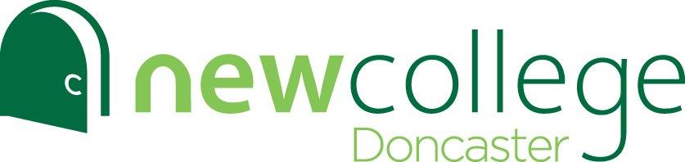

Working in partnership with New Collaborative Learning Trust (NCLT)

Hurst Lane, Auckley, Doncaster, DN9 3HG
Email: human.resources@nclt.ac.uk Website: www.ncdoncaster.ac.uk Telephone: 01302 976777

Teacher of Chemistry

Salary: NSP 1-9 (£25,826-£42,149) depending on experience.
A recruitment and retention allowance may be offered for an outstanding candidate.
Contract Type: Full time
Contract Term: Permanent
Start Date: 25 April 2022. A later start could be considered for an outstanding candidate.
Closing Date: 12 noon, Monday 7th February 2022

An exciting opportunity to be at the forefront of our organisational development

We are looking to appoint a Teacher of Chemistry, ideally from Easter, but will consider a later start date if necessary. The college is proud to have received an ‘outstanding’ rating in all areas in our Ofsted inspection report in January 2022.

The successful candidate will be able to evidence a proven track record of achieving good or outstanding results, though we also welcome applications from early career teachers. Able to demonstrate a genuine enthusiasm for your subject area and the ability to engage, motivate and inspire students of all abilities, you should have a commitment to raising achievement, raising aspirations and going the extra mile.

New College Doncaster is a great place to work and study, with excellent results in both A level and Applied General qualifications. The college was the top performing A level provider in Doncaster in the 2019 DfE performance tables and has outstanding achievement rates. With over 1300 students, New College Doncaster is an academic sixth form college offering a distinctive young adult ethos. The colleges and schools in the trust work closely together, presenting exciting opportunities for collaboration, support, development and progression.

This is a fantastic opportunity for an ambitious candidate to join our dynamic team at the forefront of change and to make a real difference to raising standards of education in the local community. New College Doncaster delivers primarily A Level provision, alongside a number of Level 3 applied general qualifications.

If you believe that you have the skills and abilities to take on this role, we’d love to hear from you.

To apply please visit https://nclt.ac.uk/vacancies/

Applications should be submitted to human.resources@nclt.ac.uk

