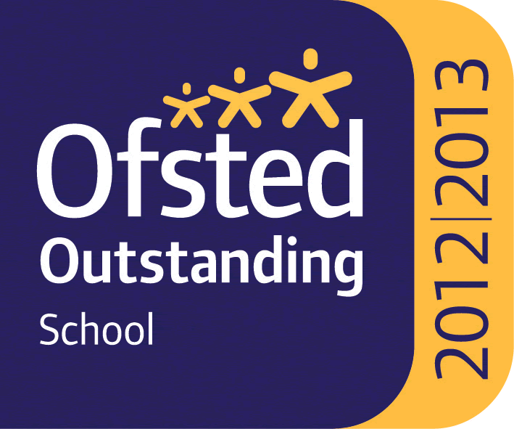

WHITLEY BAY HIGH SCHOOL
13-18 Mixed Comprehensive; NOR 1702 (590 in Sixth Form)

Deneholm, Whitley Bay, Tyne and Wear, NE25 9AS
Headteacher: STEVE WILSON

Outstanding – OFSTED May 2013
National Teaching School

TEACHER OF CHEMISTRY
(One year fixed term in the first instance)

We require for September 2021 a teacher of Chemistry to join a very successful and supportive science department. Candidates must be able to teach the full age and ability range including A’ Level. At KS4 we offer both Trilogy Science and separate sciences and at A’ Level we offer Biology, Chemistry, Physics and Environmental Science. Science is very popular at Whitley Bay High School with large numbers continuing their science studies in the Sixth Form.

The school is heavily oversubscribed, achieves very high standards and has benefited from substantial investment to improve facilities over recent years.

All staff who join the school benefit from a carefully structured programme of training and support. Any applicant should be committed to making a significant contribution to the wider life of the school.

Please find the job description, application form, application details and school information on the school website ‘Vacancies’ section at: www.whitleybayhighschool.org

Completed applications and a letter (800 words maximum) explaining why your experiences to date have prepared you for this role at Whitley Bay High School, should be sent to jackie.patterson@whitleybayhighschool.org before the closing date below.

Closing date for applications is Friday 25th June 2021 at 10.00am.

We are committed to safeguarding and promoting the welfare of children and expect all staff to respect this commitment. This post is subject to an enhanced DBS check.

