
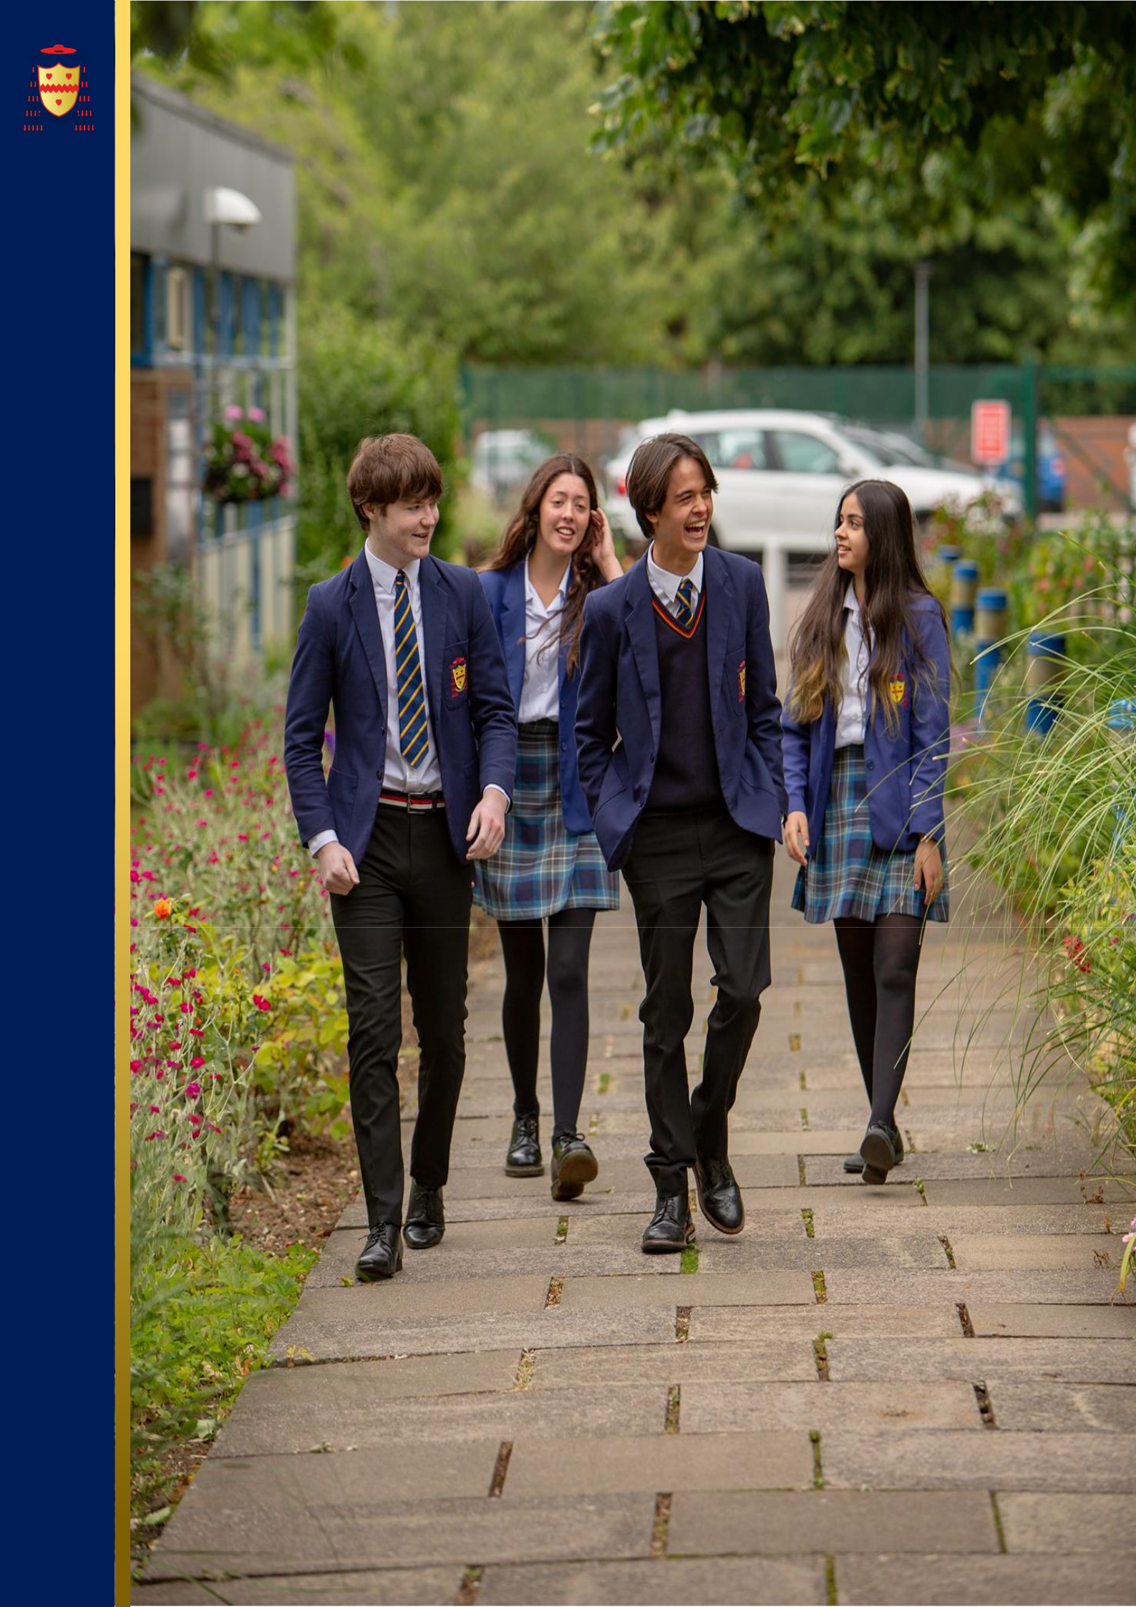
THE SAINT JOHN HENRY NEWMAN
CATHOLIC SCHOOL
Applicant Pack

Computer Science Teacher
September 2024

Welcome from our Headteacher

Dear Applicant,

Thank you for your interest in working at the Saint John Henry Newman School. I hope you find this information pack a useful introduction to our school. We are delighted that you see our school as a place where you can make an impact.

The Saint John Henry Newman Catholic School is a very distinctive community which unequivocally works to be a living Christian community in which each child and young adult is known and loved for who they are. We want our students to enjoy their education – to be happy, safe and secure and to grow in God’s love so that when they leave the school, they are equipped to change the world and make it a better place.

We firmly believe that our parents are the ‘prime’ educators and that our success is a result of the collaboration between parents, school and child working together for the good of the child. Our parents are encouraged to be fully engaged in their children’s education and there are many opportunities for parents to visit the school and contribute to their children’s adult formation and academic success.

This academic success is highlighted by the high rate of progress our students make. The school’s progress 8 score of 0.71 places the school in the top 8% of schools in the country, whilst at Sixth Form our students continue to achieve in excess of national standards. This success at key stage 4 and 5 means that the Saint John Henry Newman Catholic School continues to be officially recognised as one of the highest-achieving schools in the country.

We are however very clear that our ‘Mission’ is to create an environment in which children can discover who they are and what their role in this life is. In the words of our patron, the Blessed John Henry Newman, we believe that “God has created us to do Him some definite service”.

Thank you for your interest in Saint John Henry Newman School. My colleagues and I look forward to reviewing your application.

Yours faithfully,
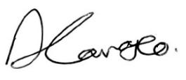

David Carrasco
Headteacher

Introduction of Our School

The Saint John Henry Newman school serves the North Hertfordshire Catholic community but our catchment area extends to Bedfordshire, East Hertfordshire and parts of Cambridgeshire. Originally, a 6-form entry School, the intake was increased to 210 in 1999 and increased to 8 form entry in September 2015. There is a high retention rate in the Sixth Form and many students apply to join our Sixth Form from other establishments. Consequently, the School has grown in size from 830 in 1993 to approximately 1600 in September 2023, with 400 students in the Sixth Form. The School became an academy as part of the Diocese of Westminster Academy Trust in 2012 and has benefitted from considerable investment in its buildings as a result, including a £3.5 million Sports and Performing Arts block (The Pavilion).

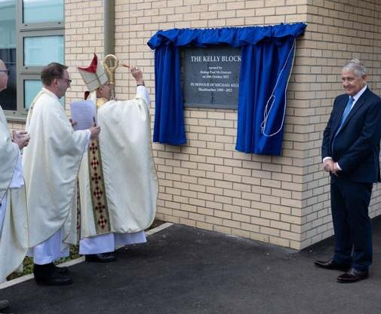
A major refurbishment of the school estate is currently being undertaken with the provision of two new blocks which are open and operational. These home new teaching accommodation, a dedicated sixth-form suite, a greater number of computer rooms and improvements to the Library, Dining and Hall facilities. The existing main block is being demolished as part of the final phase of the works. Following the demolition of the old teaching block the school will landscape the grounds to create a new prayer garden. The first of the new facilities was opened by former Headteacher Mr Kelly in October 2022. The second phase of the work which includes the opening of the new main block known as the Mathew Block had its formal grand opening in January 2024.

Our Mission Statement emphasises the practical nature of our religious character. We seek to offer a living Christian experience as a community in which each pupil is valued as an individual and is encouraged to achieve success in school life. Our Chapel is a central part of school life but it is in the day-to-day operation of school life that the School sees its aims being fulfilled. We want Students and students to enjoy the experience of being part of the Saint John Henry Newman Catholic School community, to gain in self-confidence and to become young adults instilled with a sense of personal responsibility, social commitment and, hopefully, an awareness of their own distinctive spirituality. We want them to be equipped to change their world.

The pupil population is mostly Catholic and the School is heavily oversubscribed for places. Although not all staff are Catholic (teaching staff 45.9% are Catholics), all maintain and support the distinctive Catholic nature of the School and support the Headteacher in implementing the School Mission Statement. There is presently 90 members of teaching staff and there is a generous complement of support, technical, clerical and maintenance staff.


In years 7 to 9 Students follow a broad and balanced curriculum based on the National Curriculum. Students in Year 10 and 11 follow a core curriculum of English, Maths, Science and RE with three subject choices. At Key Stage 4 we encourage students to follow the EBacc where this is appropriate, but we offer a wide range of GCSEs and the creative subjects (Art, Drama, Dance and Music) are very popular options. We offer a range of vocational courses for students for whom this is appropriate.

Our current provision offers vocational courses in Child Development, Catering and Sport. We have a large sixth form of approximately 400 students and there is a very wide range of A-level provision. Advanced Vocational courses are also offered in Art and Design, Production Arts, Digital Music Production, Music Performance, Applied Science, Sport and Health and Social Care.

The School has an excellent academic reputation. In 2022/23 the students achieved: 86% GCSE English and Maths at 9-4, 37% of all GCSE grades achieved were 9-7, 56% A Level at A*, A and B. At A-level the pass rate for the last three years has been over 99%.
The pass rate for Vocational courses has consistently been 100%. We are, however, conscious that we have the capacity to improve further and we are determined to do this on behalf of our Students and students. Exam results, important though they are for opening doors for Students in the future, do not determine success and happiness.

Therefore, we have a strong enrichment and well-being program that encompasses every student and a comprehensive career curriculum. We have been awarded with the Kitemark for emotional health and wellbeing for our work supporting students, their families and staff.


The number of Students entitled to free school meals is relatively low (7%) with 7.4% of Students receiving Pupil Premium. The ethnic composition of the School’s population reflects the community which it serves. It is predominately white British (46%) but with significant proportions of ethnic minorities reflecting the Church’s worldwide mission and the growing number of new migrants employed primarily in health care and scientific research. Attendance is above the national average with very low unauthorised absence figures.

A Diocesan Section 48 inspection in November 2019 concluded that we are an “Outstanding Catholic School”.

The 2018 Short OFSTED inspection concluded; ‘We were immediately struck by the many smiling faces of Students, who enjoy coming to school. When speaking to them, Students universally highlighted how their teachers ‘go above and beyond’ to help them achieve well. Students display a real pride in their school. They talk enthusiastically about their strong relationships with staff and the sense of community where ‘everyone goes out of their way to be friendly and make you feel welcome’. Consistent with its aim of encouraging everyone to reach their full potential, the School places great emphasis on its pastoral care.

We operate at a very human level and recognise that it is our good and caring staff who sustain and develop our school. Our challenge is to maintain high-quality provision, hopefully, to continue to make changes to improve this, but above all, to honour the promise we make to every parent who chooses to send their child to our School - that each child will be recognised and loved for who they are and that they will be offered excellent learning opportunities in a safe, caring and inspirational environment.

We are looking to appoint individuals who will enjoy being part of this distinctive community and who will contribute to it by sharing their individual talents, character and commitment and, hopefully, sense of humour!

The Saint John Henry Newman School is committed to safeguarding and promoting the welfare of children and young people.

All appointments are subject to a satisfactory enhanced DBS check.



Our Vision & Values



Community value statement
- We belong to a community where everyone is valued, as we do not prejudge or discriminate.
- We belong to a community where everyone feels safe,
as we do not threaten, intimidate or harm others.
- We belong to a community where diversity is respected,
as we celebrate difference and treat everyone equitably.
- We belong to a community where success is celebrated,
as we encourage and support others to succeed.
- We belong to a community where we can communicate our thoughts, feelings and ideas, and we do this with integrity and sensitivity to the feelings of others.
- We belong to a community where we can make mistakes, and we seek dialogue and reconciliation to restore relationships.
- We belong to a community which respects the environment around us, and we take pride in and look after the school buildings and outdoor spaces.
- We belong to a community which extends beyond the school walls, as we live by these values out of school

Our Catholic Life

O Lord and Saviour, in your arms I am safe.
Keep me and I have nothing to fear.
I know nothing about the future, but I rely upon you.
I leave it all to you, because you know and I do not.
Help me to know you,
to believe in you,
to love you,
to serve you,
to always aim at bringing you glory,
to live to you and for you,
and to set a good example to all around me.
Amen.

Source: John Henry Newman, 1801-1890 (Adapted)

The Catholic life of our school community continues to be at the core of everything that we do and to be the reason why our school exists. Our Students shine in every aspect of their lives; they are spiritual, powerful, creative and individual, each one of them inspired by God and talented beyond our comprehension and their own expectations. This is their time to discover who they are and what they could become, and our belief is that they could become anything that they wish to be - the page is blank. That is not to say that we have unrealistic expectations or aspirations for them, but it is to say that we believe that God’s plans for them far exceed anything that they can imagine for themselves at this young age.

We believe that each child has his or her unique set of talents – these talents have been entrusted to him or her to be nurtured, developed and multiplied – not to be buried and forgotten. Each child must be given the time and support to become the person that God intended him or her to be. We believe in the need for developing self-respect – valuing our own identity and uniqueness and taking pride in ourselves and our achievements – learning to love ourselves as the person God created us to be.

A great challenge to which we aspire every day...

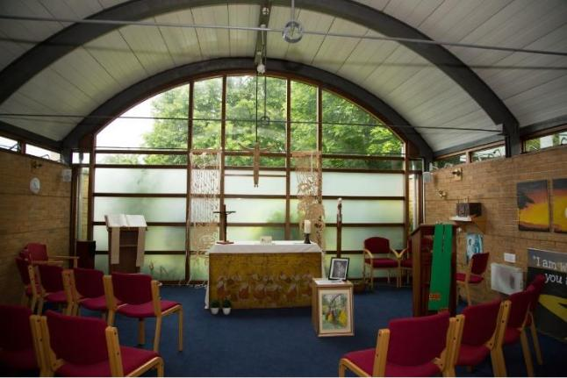

Benefits of working at The Saint John Henry Newman Catholic School
SUPERB WORKING CONDITIONS  - Excellent transport links – close to the A1 and 30 miles to central London. Stevenage to London is just over 20 minutes on the train.  - Stevenage is an area with more affordable housing, than other areas of Hertfordshire. Staff also choose to live in the beautiful villages and market towns of North Hertfordshire.  - Secure free car parking for all members of staff  - Excellent staff facilities including free tea and coffee and microwaves and fridges in the staffrooms  - Staff association which provides gifts, flowers and cards for leavers and staff with significant life events  - Social activities e.g. Friday after school football, staff choir, staff book group, running club, Christmas party, informal nights out, staff pantomime  - Child care voucher scheme  - Flu vaccinations for all staff  - Excellent teaching facilities with the new and refurbished buildings  - Supportive of flexible working  - Ensuring equality and diversity is a priority  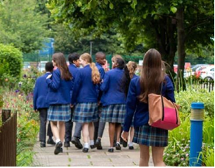  - Governors focused on Staff wellbeing | A THRIVING COMMUNITY WHERE YOU CAN ENJOY TEACHING  - Oversubscribed school with close link with the community and supportive parents  - Exemplary student behaviour which is always commented on by visitors  - Extensive range of extracurricular activities and enrichment  - All teachers are issued with a laptop  - Workload is constantly being reviewed e.g. email protocols to reduce number of emails, assessment policy to reduce time spent marking  - Generous non-contact time  - Very large sixth form so many opportunities to teach this age group  - Lessons are taught by subject specialists  - Many opportunities to work with students and participate and support in local, national and international fundraising and awareness opportunities  A SERIOUS COMMITMENT TO PROFESSIONAL DEVELOPMENT  - New staff induction program – September-November  - Performance Management that is focused on developing teacher’s careers in the areas that they wish  - Bespoke professional development opportunities – Masters, NPQs, Educator Led Development Program, exam board training, in school opportunities to develop teaching and leadership, ECT and ECT + 1 program  - Whole school CPD focuses on teaching and learning and there are many opportunities for staff to become in involved in the design and facilitating of INSET

Application Process

How to apply:

This recruitment is managed by The Saint John Henry Newman School, in line with the latest guidance on safer recruitment. Please apply online at www.teachinherts.com or send your completed application form to hr@jhn.herts.sch.uk. You can also contact us on 01438 314 643.

Application Form:

Applicants must use the standard application form provided (CVs are not accepted). Please complete all aspects of the form fully. Include your full work history with no unexplained gaps since leaving your education. Include all the training you have completed. Application is done by Teach in Herts, CES or DfE application. However, we will ask successful applicants to backfill an official CES application form.

Person Specification and Personal Statement:

When writing your personal statement, you must address each of the requirements in the person specification. Be sure to evidence additional aspects such as training and qualifications together with your background and experience.

References:

Please make sure your referees are aware of your application and that they are able to provide a swift turnaround. Preferred referees are your last two employers, and you should provide their official organisation email address for us to contact. If you have worked in a school previously one referee should be your last Headteacher.

School Visits:

School tours are a standard part of the interview process. However, School visits are welcomed by prior arrangements. To arrange this, please contact Mason Emoli, Office Manager emolim@jhn.herts.sch.uk or by phone 01438 314643.

Please Note:

Please note any job description is not necessarily a comprehensive definition of the post. The duties and responsibilities listed in the job description describe the post as it is at present, the post holder is expected to accept any reasonable alterations that may from time to time be necessary.

The job description will be updated regularly in line with school’s development plan.

Department Information
COMPUTING DEPARTMENT and BUSINESS STUDIES DEPARTMENT INFORMATION 2023-2024
The department currently offers the following courses:
- OCR GCSE Computer Science (9-1)
- OCR GCE Computer Science (AS & A Level)
Within the department there are two full time members of staff. We also have four teachers from other departments who teach Computer Science.
The majority of courses are mixed ability yet are always set where timetabling and pupil numbers allow.
As a department, we offer out of school time activities such as trips, Computer Programming Club, and our Robotics Club.
Classrooms are well equipped with electronic projectors and Smart Boards. We have five new Computer rooms in the two new blocks. Resources are well maintained and up-to-date, shared between staff and pupils. All users have access to a shared area on the school network. Every lesson is extremely well resourced and we will provide training for any new member of staff who needs to enhance their subject knowledge.
Staff are supplied with laptops when they join the school but every classroom has a teacher desktop as standard. Computer rooms are bookable by all departments when vacant. The schools’ IT network and facilities are overseen by a systems manager who leads a team of two full time technicians and additional external support as required.
In Computing we pride ourselves on our team spirit and enthusiasm; anyone applying to work with us would be expected to help to maintain our high standards, but would be made thoroughly welcome and supported by all of our very special team!
-Mr K Flain, Subject Leader of Computing

Job Description for Teacher of Computer Science
Job title: | Teacher of Computer Science
Job ref: | SJHN.A005
Publish date: | February 2024
Start date: | September 2024
Hours: | Full time
Salary band: | MPS1-UPS3
Contract: | Permanent
Reports to: | Subject Leader of Computer Science, Mr Kerry Flain
Department: | Computing
This job description is not necessarily a comprehensive definition of the post. The duties and responsibilities listed below describe the post as it is at present, the post holder is expected to accept any reasonable alterations that may from time to time be necessary.
The job description will be updated regularly in line with school’s development plan.

- INTRODUCTION

  - You are accountable to the Governing Body through the line management structure shown in the Staff Handbook.

  - You are required to maintain and develop the Catholic character of the School in accordance with the direction given by the Governors and expressed in the Mission Statement. You are required to support the Headteacher in implementing the Mission Statement and in maintaining the distinctive Catholic nature of the School.
- DUTIES OF A COMPUTER SCIENCE TEACHER

2.1 You are required to carry out the duties of a school teacher as set out in the current School Teacher
Pay and Conditions of Service Document. This requires you to carry out such duties as the
Headteacher may reasonably direct from time to time.

- JOB PURPOSE

3.1 Purpose of role:
- To contribute to the teaching of Computer Science under the direction of the Subject Leader
- To deliver the National Curriculum as outlined in KS3 and KS4 activity timetables provided by the Subject Leader
- To participate fully in the extra-curricular life of the school
- To be responsible for assisting in the development of schemes of work
- To carry out both Formative and Summative assessment procedures as outlined in the Department Handbook
- To effectively record assessments undertaken using the Department’s central record systems
- To complete whole school data collection tasks as directed
- To contribute to monitoring and learning ideas during department inset and participate in practical training days focused on sharing good practices where appropriate

3.2 You are also required to;
- To help in the organisation and supervision of departmental trips, visits and extra-curricular activities where appropriate
- In line with Department policy regularly liaise with parents on matters such as behaviour, participation levels and pupil achievement and anything relevant to the Department. Where necessary provide feedback through department concern and/or praise letters, telephone calls and/or messages through the pupil diary.
- Implement the Department’s Rewards and Sanctions policy (as outlined in the Department handbook).
- Attend Parent Consultation Evenings

- AccountabilITIES

4.1 You are responsible to the Headteacher, the Leadership Team Member with responsibility for your Department and the Subject Leader of Computer Science.

4.2 You are required to:
- Undertake all reasonable precautions to safeguard the health and safety of students and staff at all times.
- Ensure that all students are treated fairly, consistently and with respect, that opportunities for reinforcing positive self-images are sought, that gender and race discrimination are actively discouraged.
- Encourage an environment and ethos which underpins and enhances students; learning and rewards students; achievements.
- Take active responsibility for formulating fair and consistent standards of discipline and follow up concerns according to the school’s procedures

- EQUALITIES

  - Be aware of and support school policies that promote equality within and beyond the school community.

- HEALTH AND SAFETY

  - Be aware of and comply with policies and procedures relating to child protection, health, safety and security, confidentiality and data protection; and report all concerns to an appropriate person.

- DISCLOSURE & BARRING SERVICE

  - This post is classed as having a high degree of contact with children or vulnerable adults and is exempt from the Rehabilitation of Offenders Act 1974. An enhanced disclosure will be sought through the Disclosure and Barring Service as part of the pre-employment checks.

- MONITORING

  - To keep an accurate and up to date register for all classes taught

  - Regularly mark pupils work in line with the School’s marking policy.

  - Monitor pupil progress and address underachievement using Departmental policies.

  - To contribute to the development of self-evaluation procedures within the department.

- Safeguarding Children and Safer Recruitment

9.1 You will ensure that child protection and the safeguarding of students are given the highest
priority at all times.

9.2 The Saint John Henry Newman School is committed to safeguarding and promoting the welfare of
children and young people as required under the Education Act 2002 and expects all staff and
volunteers to share this commitment.
Signature of Postholder:
Date:

Person Specification
Essential | Desirable
Qualifications
- Qualified Teacher Status  - Good specialist subject knowledge of Computing through a degree  - High standard of written and oral communication  - Able to bring a portfolio of own work if invited to interview | - Evidence of recent relevant professional development
Teaching and Learning
- Ability to teach Computer Science to Key Stage 3 and 4  - Excellent classroom teacher, or potential to be one, with the ability to reflect on lessons and continually improve their practice  - Willingness to lead extracurricular learning activities after school.  - Ability to contribute to a culture of high expectations amongst students and staff within their curriculum area, both academic and in terms of behaviour and attitudes | - Experience as a Form Tutor  - Experience in contributing to curriculum planning and development, and the organisation of resources  - Good understanding of the recent and upcoming changes to the curriculum
Personal
- Genuine passion and a belief in the potential of every pupil
- Resilience and determination
- Motivation to continually improve standards and achieve excellence
- Ability to communicate effectively and relate well to others
- Good team player who contributes positively to teams
- Effective time management and organisational skills
- Commitment to equality of opportunity and the safeguarding and welfare of all pupils
- Fully support the School’s aims, values and Catholic ethos
- Demonstrate excellent attendance, punctuality and professional appearance


Headteacher: Mr D Carrasco-Morley

The Saint John Henry Newman Catholic School
Hitchin Road, Stevenage,
Hertfordshire, SG1 4AE

T: 01438 314 643
E: admin@jhn.herts.sch.uk

The Diocese of Westminster Academy Trust, Registration Number 7944160 Registered Office: Waxwell House, 125 Waxwell Lane, Pinner, England, HA5 3EP.

