**Computing @ NLA**

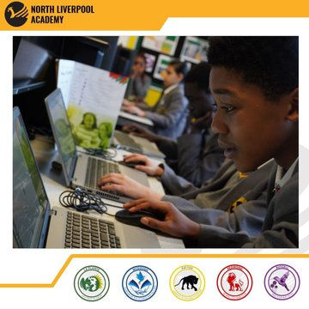The NLA Computing department is well resourced and supported and is established at the cutting edge of computing education. Our existing team is comprised completely of subject-specialists, who are embedded in our practice and are passionate about teaching computing. All departmental teachers have a dedicated computing suite with top of the range PCs and space dedicated to STEM activities. We are pioneers within our subject, and strive to remain at the forefront of computing education.

**Key Stage 3**

We enjoy higher than national average contact time within KS3 computing, recognising the importance of developing digital skills and ensuring our students have a solid foundation that will set them in excellent stead for the computing requirements faced by all subjects and the world of work beyond education. We utilise NCCE (National Centre for Computing Education) schemes of work designed to meet the requirements of the National Curriculum, adapted locally to ensure we can get the best out of our students as they prepare for the rigors of Key Stage 4. We also provide the opportunity from the very start for experiential learning, using our wide range of physical computing equipment. Our students in KS3 enjoy working with several of our robot kits, building and racing drones, creating apps, getting access to several of our class sets of BBC Micro:bits, and participating in national eSports leagues against other schools and colleges.

**Key Stage 4**

GCSE Computer Science

The start of our multi-keystage Quantum academic pathway begins with a cutting-edge GCSE in Computer Science. This subject develops student’s theoretical computing knowledge to support innovation and creativity across all sectors, utilising industry standard software to practically develop their programming and problem-solving skills, and enabling them to become digitally literate masters of their technological domain. Students that embark on a computer science journey achieve a renowned qualification that will support them in becoming valued members of society, able to keep pace with the change and demands of an ever-increasing digital workspace.

BTEC Digital Information Technology

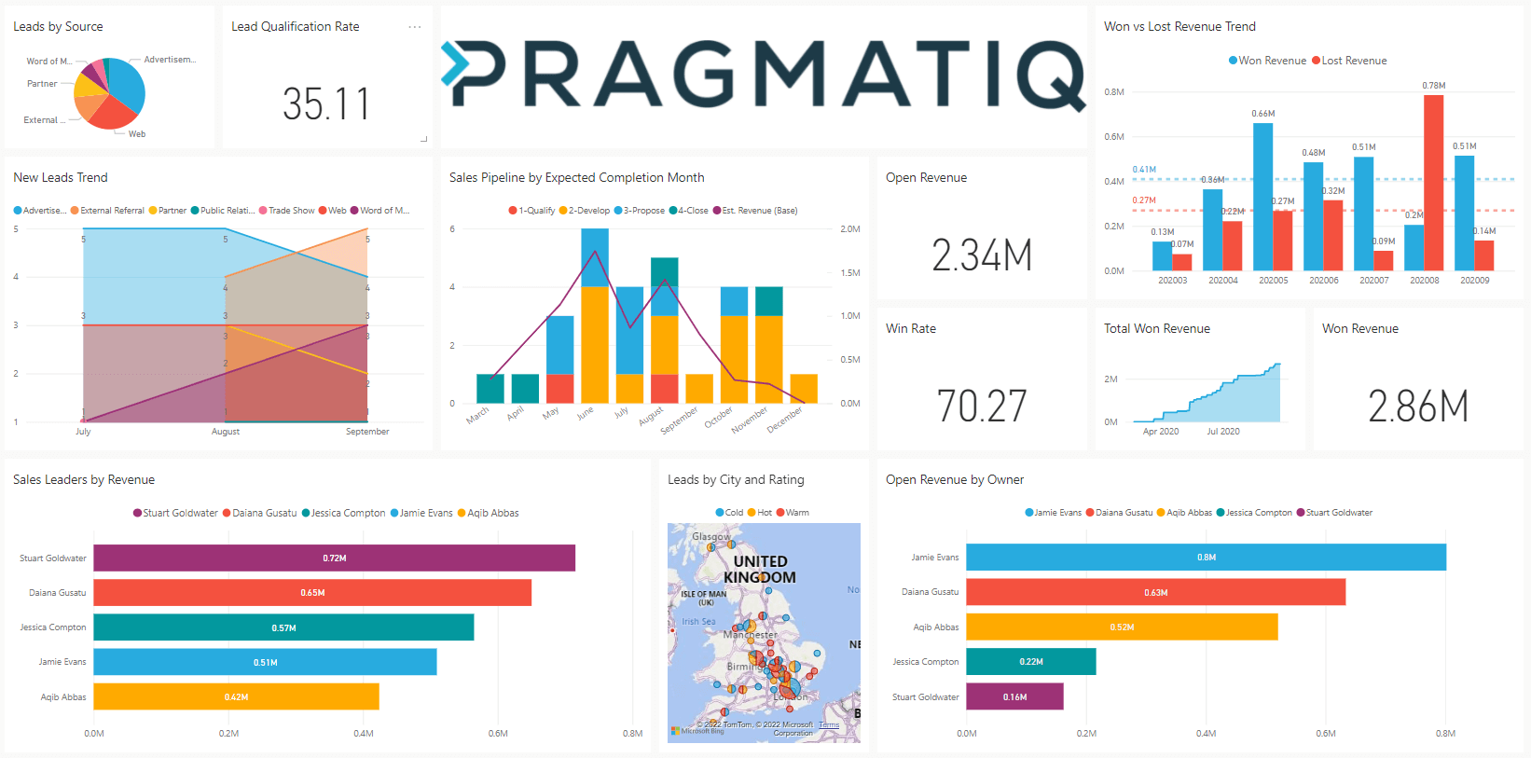We also offer a vocational pathway in KS4, allowing students to complete the Edexcel BTEC Digital Information Technology qualification. This is offered as either a separate alternative qualification to GCSE Computer Science, or in parallel for those students wishing to specialise in a computing pathway. This subject develops student’s mastery of using technology and software to create bespoke digital artefacts for a variety of real-world scenarios, whether it be creating a unique User Interface for a customer’s technology provision, or the sorting, manipulation and interpretation of big data sets to allow a customer to make timely business decisions. This course also provides a foundation in cyber security, enabling students to gain a vital understanding of safe working practices when using technology.

**Key Stage 5**

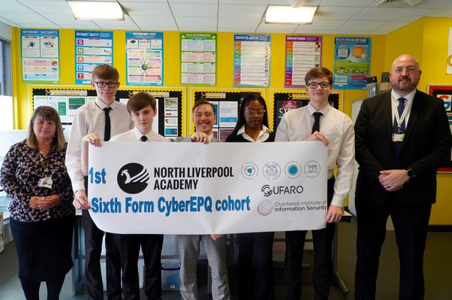

At NLA we are unique within our local school community, in that we offer A-Level Computer Science within our excellent sixth form provision. This subject provides an academic pathway for those students wishing to progress into computer science related careers via Higher Education. We are currently one of four centres within the North West that also offer the bespoke Cyber Extended Project Qualification via the Chartered Institute of Information Security (CIISEC). This course runs in parallel to our Y12 cohort, and enables students to achieve up to 28 UCAS points whilst gaining an industry level insight into cyber security and gaining access to industry standard training in practical cybersecurity elements.

**Enhanced computing provision and support**

In order to support not only our own students, but other students within our locality, we conduct outreach sessions with local primary schools. Our department visits a local primary school each week to deliver computing activities using our LEGO Spike Prime sets, engaging with Year 5 and Year 6 students and supporting their progression along the Key Stage 2 computing NC pathway.

We also host several CPD and outreach events for local teachers 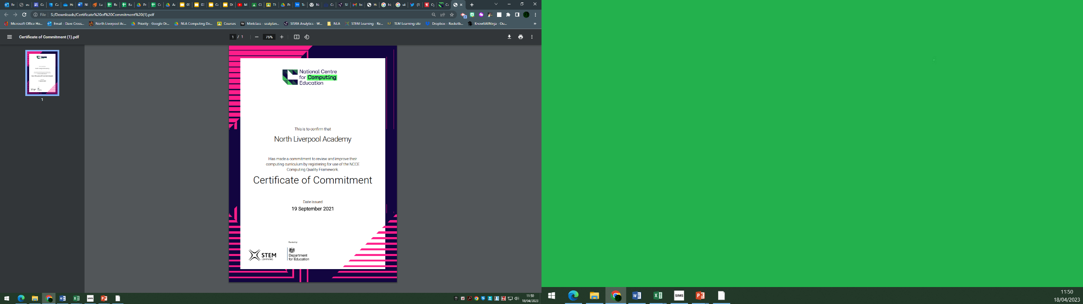so that we can share good practice amongst our community, network with like-minded colleagues and provide opportunities for our own and local students to develop vital soft skills and to enhance our curriculum offer.

We also are actively engaged with the CAS (Computing At School) community and have been involved with the trial of NCCE (National Centre for Computing Education) resources and materials for the teaching of Artificial Intelligence and Machine Learning at KS3, supporting their refinement prior to publication.

All members of our department have access to an excellent CPD provision, with every teacher having completed the NCCE Computer Science Accelerator (CSA) qualification and several members of our department having access to National Professional Qualifications (NPQs) to support their development and teacher journey. We are established mentors not only for Early Career Teachers, but also for Initial Teacher Training students who leave us having had an excellent experience and are fully prepared for teaching computing in their next role.

We are committed to providing an excellent computing provision at North Liverpool Academy, and this is evident in every facet of our department and delivery.

**House competitions and enrichment**

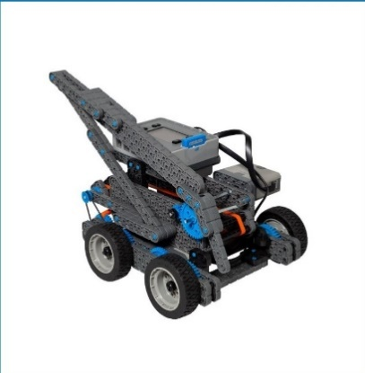

Our enhanced curriculum offering supports what we do in lesson time, but also provides valuable opportunities for students to excel and develop their computing related experiences. Each half term we offer access and participation within several clubs and house competitions, including eSports, Hour of Code, Bebras Computational Thinking Competition and many more. Within the last year we have had students across all key stages participate in:

* STEM Learning UK Cyber Centurion competition
* Bebras Computational Thinking Challenge
* Safer Internet Day initiatives
* UK Hour of Code activities
* British eSports Students championships participation in League of Legends and VALORANT matches against national opponents
* Oxford Computing Challenge
* Raspberry Pi ISS/ESA Mission Zero challenge
* Alexa Young Innovator Challenge
* Merseyside Police Cyber Challenge competition
* VEXIQ robotics national competitions
* Government CyberFirst Adventurers course

**For more information or to arrange a visit to the school, please contact Mr D.Cross, Curriculum Leader of Computing at (**[**d.cross@northliverpoolacademy.co.uk**](mailto:d.cross@northliverpoolacademy.co.uk)**).**

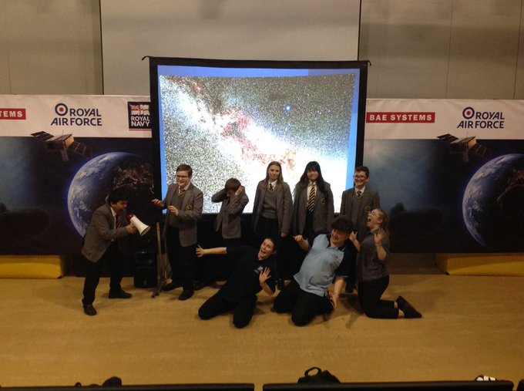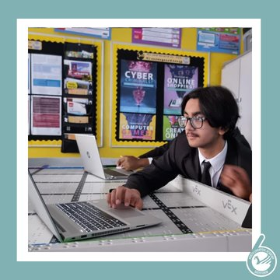

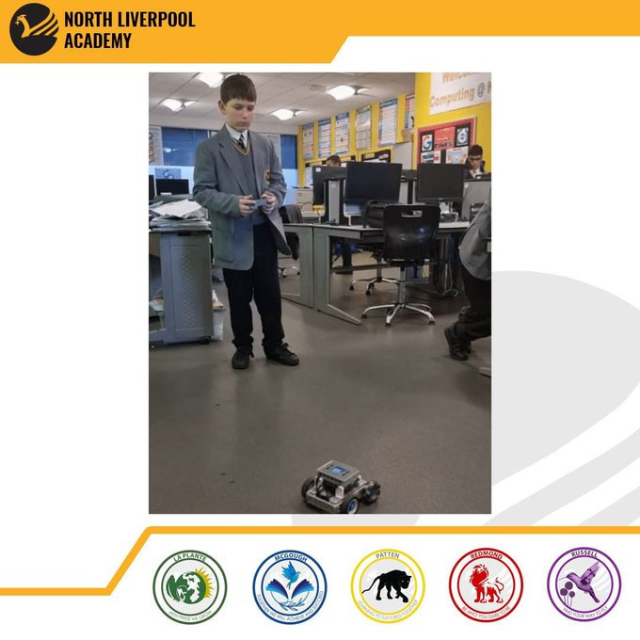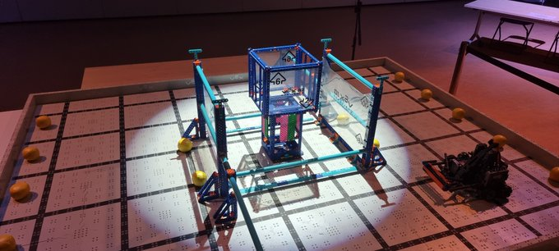

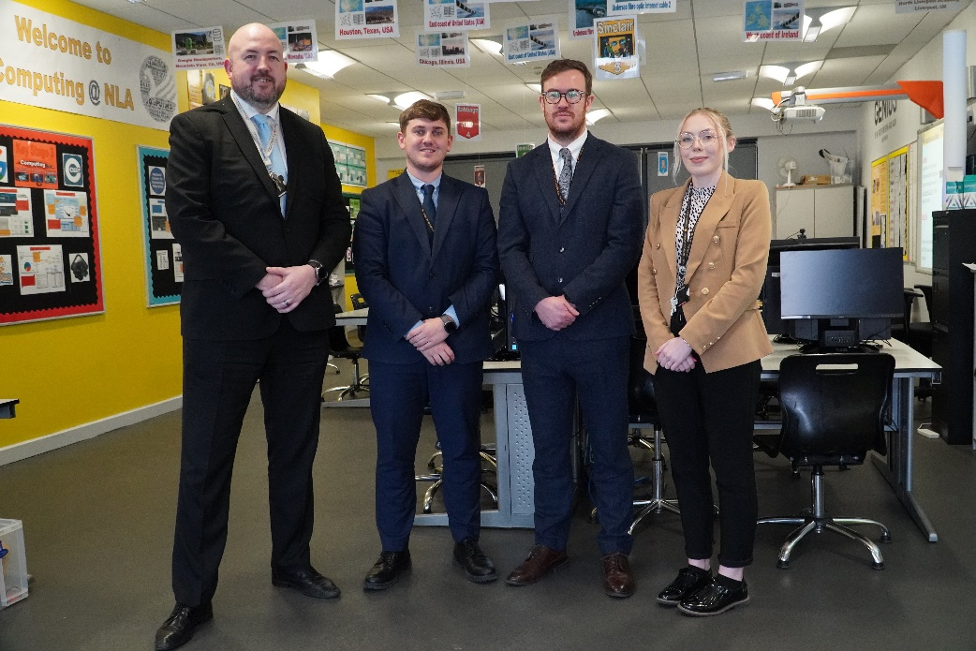

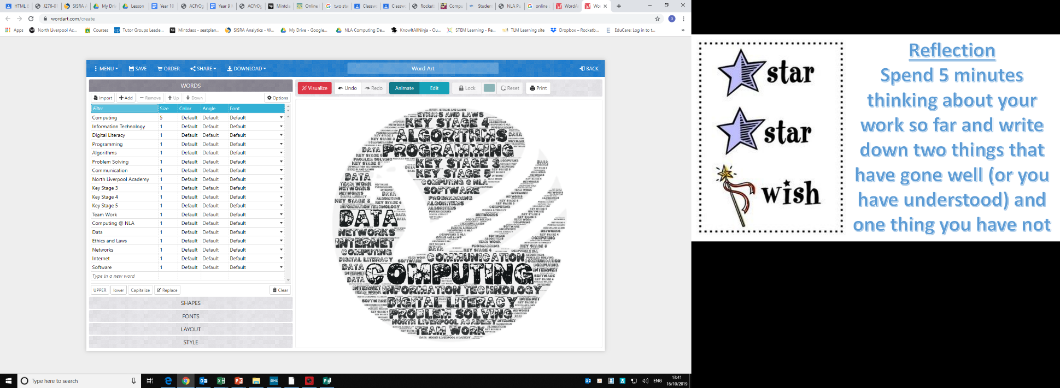

**We look forward to hearing from you!**