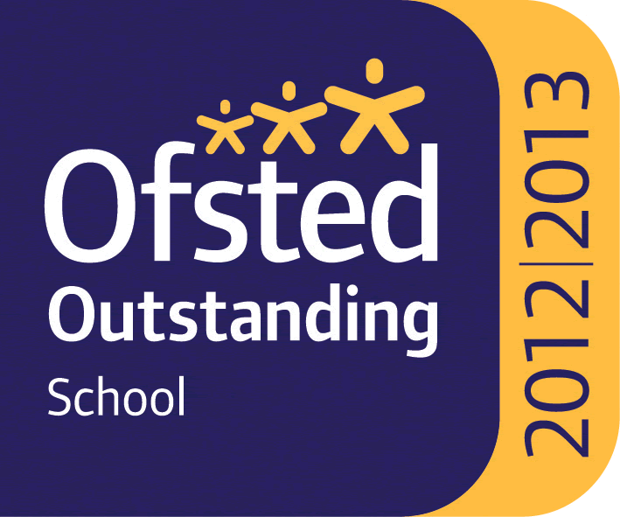

WHITLEY BAY HIGH SCHOOL
13-18 Mixed Comprehensive; NOR 1711 (604 in Sixth Form)

Deneholm, Whitley Bay, Tyne and Wear, NE25 9AS
Headteacher: STEVE WILSON

Outstanding – OFSTED May 2013

TEACHER OF COMPUTER SCIENCE and IT

We require for January 2022 a teacher of Computer Science to join a very successful and supportive department. Candidates must be able to teach the full age and ability range including A’ Level. Computer Science and IT are popular and growing subjects at the school with 88 students studying Computer Science and 104 studying IT at KS4 and 44 taking Computer Science and 53 taking IT at KS5. We expect these numbers to grow further in future years.

The school is heavily oversubscribed, achieves very high standards and has benefited from substantial investment to improve facilities over recent years.

All staff who join the school benefit from a carefully structured programme of training and support. Any applicant should be committed to making a significant contribution to the wider life of the school.

Please find the job description, application form, application details and school information on the school website ‘Vacancies’ section at: www.whitleybayhighschool.org

Completed applications and a letter (800 words maximum) explaining why your experiences to date have prepared you for this role at Whitley Bay High School, should be sent to jackie.patterson@whitleybayhighschool.org before the closing date below.

Closing date for applications is Monday 11th October 2021 at 10.00am.

We are committed to safeguarding and promoting the welfare of children and expect all staff to respect this commitment. This post is subject to an enhanced DBS check.

