Department Information- Computer Science

The Computer Science department at Hinchley Wood School is equipped with two newly refurbished, air-conditioned computer labs, together with a department office. There are two subject specialists (including a Head of Department) teaching across all key stages. The KS3–KS5 curriculum is fully resourced, with shared teaching materials and assessments available for all units. Teachers are supported in developing their subject knowledge and programming expertise through CPD and collaboration.
We welcome applications from both experienced Computer Science teachers and those looking to develop their subject knowledge within a supportive and collaborative department.

Computer Science is taught as a discrete subject at Key Stage 3 through a recently redesigned curriculum. The department has a collaborative culture, with staff sharing resources and supporting one another. All units are fully planned and delivered through Google Classroom, with interactive activities and self-marking assessments already in place. Homework is set through an online course that complements the work completed in class. While the department benefits from a strong set of shared resources, we also welcome new ideas and approaches to teaching and learning.
Computer Science is a popular option at Key Stage 4 with two classes in Year 10 and two classes in Year 11. In the Sixth Form, we run the Computer Science A-level, with an average class size of 15 students. Many of our students progress to Computer Science–related degrees at university.
Both GCSE and A-Level are delivered using the OCR Exam Board and we use the resources from Craig ‘n’ Dave, utilising the flipped learning approach. Students are given a bespoke exercise book to support this at GCSE and a structured folder at A-Level. We also have the full set of PGOnline resources.
Python is the programming language taught across all key stages, including A-Level.
Results for GCSE and A-Level are excellent and well above national averages.

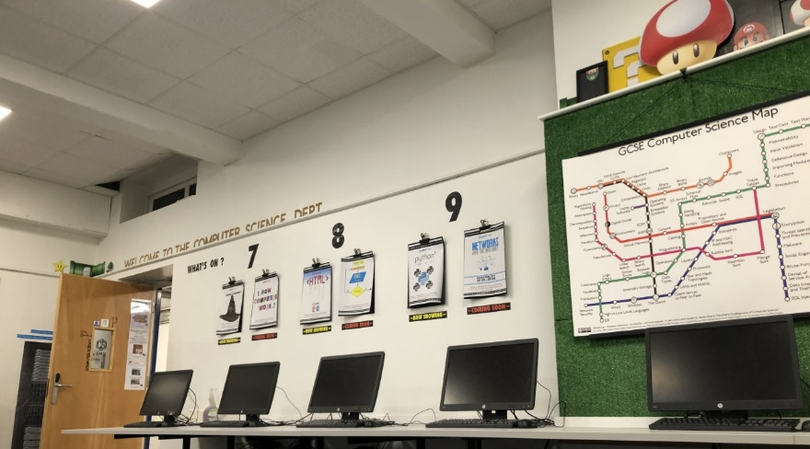
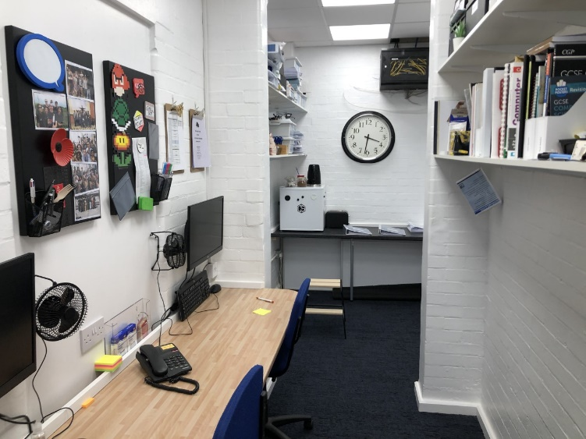

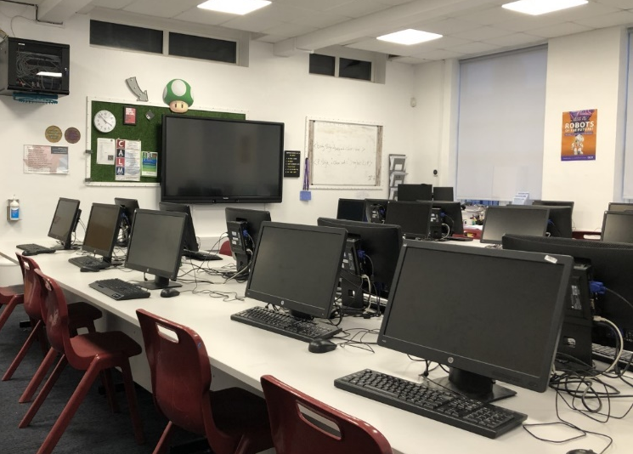
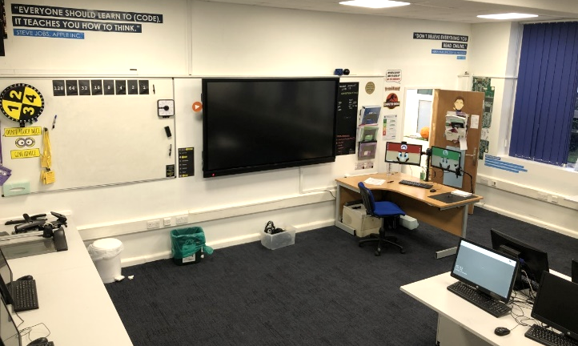

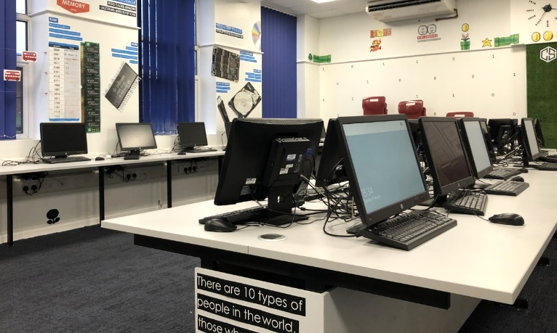

We run a wide range of established extra-curricular activities (listed below), many of which are supported by our subject ambassadors and student coordinators. There are excellent opportunities to contribute to and further develop enrichment, including competitions, programming clubs and national computing challenges, and we welcome new ideas and initiatives.

- Digital Schoolhouse eSports tournament (we are currently the national champions!)
- Lego Robotics
- Cyberfirst Girls
- Cyber Explorers
- Bebras Challenge
- Workshops
- Raspberry Pi Foundation Coding Challenge
- British Informatics Olympiad
- iDEA Award

We are looking for a teacher who:
- has strong subject knowledge in Computer Science
- is committed to high-quality teaching and learning
- enjoys developing engaging programming lessons
- is keen to contribute to the wider life of the department
- would like to support our growing enrichment programme

Hinchley Wood School Computer Science department offers:
- A friendly working environment
- A fully resourced department
- A commitment to your professional development and sharing good practice
- A willingness to listen to new ideas
- Excellent facilities
- And most importantly, motivated and enthusiastic students who are keen to learn!

All questions are welcome, so please get in touch with the Head of Department with any queries:
mconstantino@hinchleywoodschool.co.uk

