

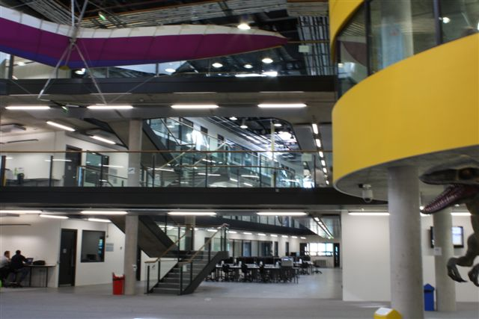

Headteacher: Alison Lusuardi

**‘You have a package of staff training and support with a clear focus on developing and sharing first rate teaching and learning’**

**(OFSTED November 2017)**

**IMAGINE** walking into school and seeing a dinosaur – or a plane - or a badger.  The Langley Academy is not just another school; it is a new way of learning.  As the UK’s first museum school, The Langley Academy has a museum within the building. Here you are encouraged to use your imagination to create new ways to ignite students’ desire to learn. We are ideally situated, only minutes from the M4 at Junction 5 and the M25, and with excellent rail links to Central London. If you chose to live here, renting is cheaper than in Central London, yet you are in town quickly. Windsor, Marlow or Henley are close and if you enjoy weekend travelling it takes about 15 min to Heathrow. We border Buckinghamshire, with no less than 100,000 acres which are designated Areas of Outstanding Natural Beauty - including a substantial part of the magnificently wooded Chiltern Hills. Whether you are into the outdoors or want to be close to London, working here is ideal.

**Teacher of Computer Science – Sept 2021**

**NQTs and experienced teachers are welcome to apply**

**(Teachers’ Main Pay scale)**

The Langley Academy is seeking to appoint a talented, well-qualified and inspirational Teacher of Computer Science to start in September 2021.

The successful candidate will possess an excellent degree in Computer Science, or related subject, with the ability to teach GCSE and a willingness to be involved in A Level teaching. We offer courses at KS3, GCSE, A-level and Level 3 Cambridge Technical across year groups 7 to 13.

The department has access to four specialist computer suites equipped with the latest hardware and software, including interactive displays in each classroom (Promethean). As well as the standard Microsoft applications (including Office 365), The Langley Academy uses a wide range of subject-specific software, including Scratch, FLOWOL, Python, HTML, CSS, and we have access to online applications and subscriptions to support the curriculum.

This post would be suitable for an ambitious, experienced or newly qualified teacher who wishes to work in a dynamic department which is striving to raise standards across all key stages. NQTs are well supported and developed by the Trust. **There are opportunities to take on extra responsibility for a suitably experienced candidate.**

We pride ourselves in the strong relationships between students and staff that enable our cohort to become outstanding citizens that we are truly proud of.

If you are interested in applying for this role and enhancing the lives of our students, please visit our school website ([www.langleyacademy.org](http://www.langleyacademy.org)) where you will find more information together with an online application form. If you would like further information please contact Tara Mackay, PA to Headteacher and HR Assistant, [tara.mackay@langleyacademy.org](mailto:tara.mackay@langleyacademy.org)

**Closing date: 19 April 2021, Interviews: w/k commencing 26 April 2021**

**The Langley Academy is committed to safeguarding and promoting the welfare of children and young people and expects all staff and volunteers to share this commitment. All appointments are subject to an enhanced DBS check**

**The trust reserves the right to appoint ahead of the deadline.**