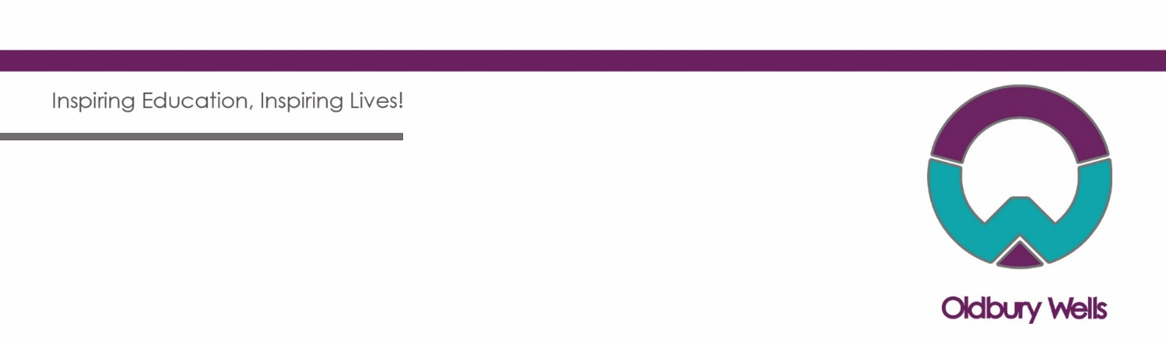

**OLDBURY WELLS SCHOOL**

BRIDGNORTH Shropshire WV16 5JD

**Teacher of Computing and ICT**

#### Job details

**Salary:** MS1 - US3

#### Contract Type: Full Time

#### Contract Term: Permanent

**Start Date:** September 2024 or January 2025

**Closing Date:** Monday 24th June at 9am

*\*Applicants are encouraged to apply early as the School reserve the right to start the interview process before the closing date.*

We are popular school at the heart of its community rated ‘Good’ by Ofsted with consistently positive outcomes at GCSE, our core purpose to “Inspire education and Inspire lives’. We are seeking to employ an inspirational and enthusiastic Teacher of Computing and ICT who shares our commitment to all students across our community.

We are seeking to employ an inspiring and enthusiastic Teacher of Computing and ICT to teach across the ability range. We are looking for candidates who will bring additional experience to a well-established team, who actively promote and understand what makes Oldbury Wells such an effective school and who appreciate and promote our inclusive school ethos. In return, we offer a school which is a great place to be and a great place to learn, where students Enjoy, Aspire and Achieve within all elements of their academic and personal development.

Oldbury Wells is a flourishing academy, the founding school of the TrustEd Schools which currently comprises a family of nine schools all based within Shropshire. Our Trust is committed to supporting local education and enjoys strong partnership arrangements with all local primary schools. At the centre of our work is quality and inclusive education for students of all abilities; all our partner schools work closely together to support professional development opportunities which ensure all members of the team are able to develop within their role. We are located just 20 minutes from the West Midlands conurbation where we enjoy a small town location in Bridgnorth within easy reach of the Birmingham and Telford areas.

Oldbury Wells School is committed to safeguarding and protecting the welfare of children and young people and therefore expects all staff to share this commitment. All appointments are subject to a satisfactory DBS check, online check and required pre-employment checks.

Further details of this vacancy can be downloaded from our website, [www.oldburywells.com](http://www.oldburywells.com). Alternatively, please telephone 01746 765454 or e-mail Mrs Kate Dwane, PA to the Headteacher, at [kate.dwane@oldburywells.com](mailto:kate.dwane@oldburywells.com). The closing date is **Monday 24th June at 9am**

*Please contact Mrs Dwane should you require any further information about the post, who will ensure a response to any questions you may have.*