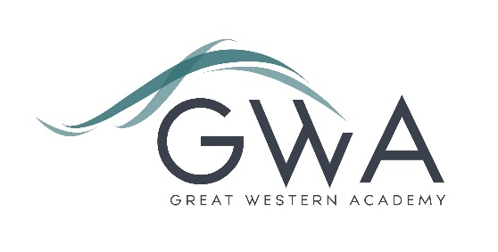

Information for Applicants

Teacher of Computing
Great Western Academy opened its brand-new state of the art facilities in September 2018 in North Swindon. The Academy is heavily oversubscribed in years 7, 8, 9, 10 and 11 and our first two cohorts of A-level students celebrated their exceptional results in summer 2021 and 2022, with strong destinations for all including three Oxbridge students and several prestigious apprenticeships. Computing is a popular choice at A-level, and also has a strong take-up at GCSE.
An applicant’s briefing pack with full information about Great Western Academy and the role is available on the GWA website at https://www.gwacademy.co.uk/vacancies
Application process

Please complete both the application form and equalities forms supplied and enclose a supporting letter, either in the space provided on the application form or as a separate document. The application form should be completed in full in black ink or type. A CV is not required and should not be submitted as part of the application.

Your supporting letter should be no more than 2 sides of A4 (with a font size no smaller than 11) and should enhance your application by providing further information, matched to the person specification, about your suitability for the post. This should include evidence of the impact on student outcomes you have made in your career to date.
Applications should be submitted electronically to recruitment@gwacademy.co.uk by 9am on Monday 15th April 2024. Interviews will take place as soon as possible after this date.

Please note we may interview before the closing date (and close the advert early) depending on the suitability,
and number of, applicants.

The interview process will include observation of your teaching, a short presentation, and a variety of other tasks and activities.
Great Western Academy is committed to safeguarding and promoting the welfare of children, young people and vulnerable adults and we expect all staff to share this commitment and undergo appropriate checks. All posts within the Trust are therefore subject to an Enhanced DBS and barred list check.

References: References will be taken up prior to interview.

