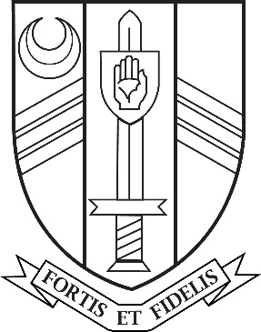

Job Vacancy

Computing/Maths/Business Teacher

Main Scale
Full-Time
Initially fixed term for 12 months from September 2021

Sir John Nelthorpe School is a successful and popular 11-19 mixed comprehensive school with a rapidly growing roll (approximately 700 students). It has a caring ethos and a long tradition of academic attainment.

We are looking to appoint a full-time Computing Teacher to teach key stage 3 with a potential to deliver some maths & business studies to across key stages 3 & 4 from 1st September 2021 initially on a 12 month fixed term contract.

The post is suitable for newly qualified teachers, who will have completed their training by September 1st 2021, and will be supported with an excellent induction and CPD programme.

If you have the qualities and ambition required for this post we look forward to receiving your application by post or by email to admin@nelthorpe.org.uk by 9:00am on Friday 7th May 2021 with interviews taking place the following week.

Sir John Nelthorpe School is committed to safeguarding and promoting the welfare of children and young people and expects all staff and volunteers to share this commitment. The successful candidate will be subject to an enhanced DBS check and supportive references.

Further details and an application form can be found on the school Website www.sirjohnnelthorpe.org.uk

