

**KING EDWARD VI CAMP HILL SCHOOL FOR BOYS**

**Teacher of Computing**

**Information for Applicants**

**MARCH 2025**

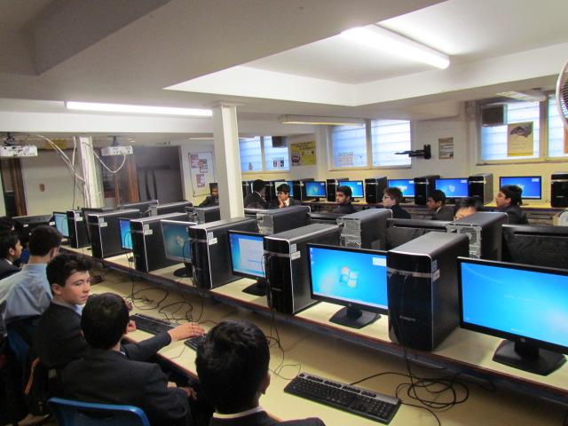

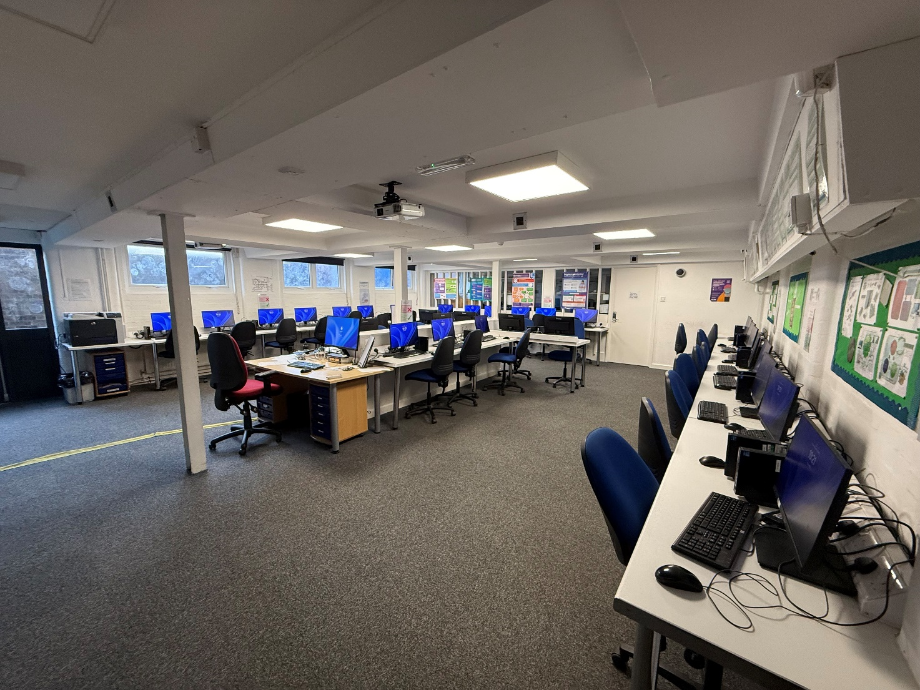

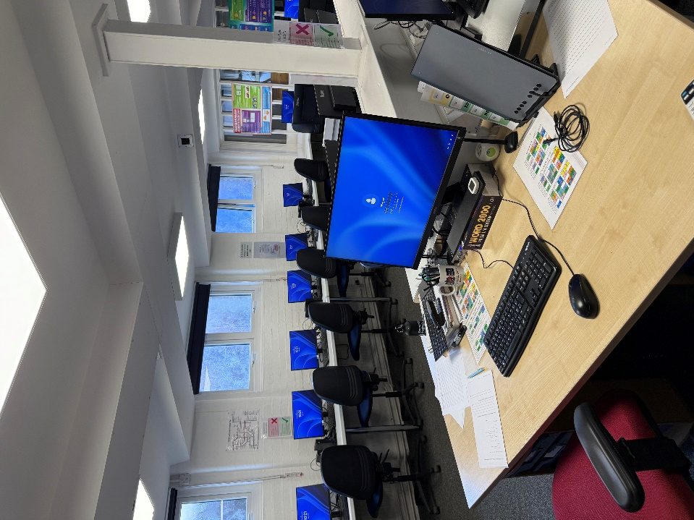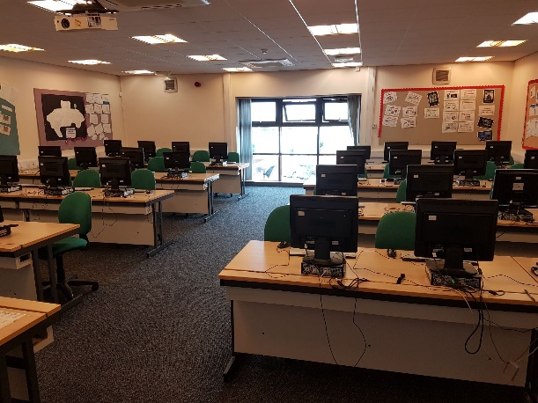

**GENERAL INFORMATION ABOUT OUR SCHOOL**

King Edward VI Camp Hill School for Boys is a selective state school; it is a member of the King Edward VI Academy Trust Birmingham, which is a group of eleven schools, six of which academically select their pupils.  These schools, together with two independent schools, form the King Edward’s Foundation. The school moved from the inner city to its present location on the former Cartland Estate in 1956. Kings Heath is a pleasant suburb in South Birmingham with easy access to the M42, M40, M5 and M6 motorways, to Stratford and to the Warwickshire/Worcestershire countryside. In recent years, we have benefited from a new Sports Hall, Library, laboratories, classrooms and Sixth Form Common Room.

There are 1054 students on roll, of whom 336 are in the Sixth Form. The school admits 120 students (150 in the current Year 7 & 9; 150 in next year’s Year 7) a year at the age of 11. Nearly all of the students stay on at the school to the age of 18 and proceed into Higher Education. Academic standards are very high – in 2024 the percentage of GCSEs passed at grades 8 and 9 was 74%.  At A Level the percentage of exams passed at A*-B was 83%.  20 (9 Cantab, 11 Oxon) Oxbridge hopefuls achieved their places.

**Computing at Camp Hill**

Staffing:

Mr Nick Frost (Head of Department)

Mr Zahid Khan (p/t – based at Camp Hill Girls)

Ms Lorne Pearcey (p/t – based at Camp Hill Boys)

Mr Kian Wells (based at Camp Hill Boys)

The Computing Department at Camp Hill combines staff from both Camp Hill schools to meet the needs of the different groups taught (boys, girls and mixed groups), under a single Head of Department. Teachers have the majority of teaching in their ‘home’ school but are expected to be flexible depending on timetabling requirements.

The two Camp Hill schools have worked closely for years and follow a Computing-focused curriculum at KS3, although we also aim to retain a balance with some traditional ‘ICT’. Having phased out GCSE ICT some years ago, the boys’ school introduced the new 9-1 GCSE Computer Science in 2016. At KS5 we work with mixed groups, and have provided A-level Computing/Computer Science for many years. All qualifications offered are through OCR, where the two previous Heads of Department have been senior examiners. The main programming language taught is currently Python although older students are encouraged to experiment with other languages.

Departmental results are consistently good and we have growing numbers of pupils applying for university courses in the subject. Group sizes are healthy and growing year on year – in 2024-25 we have 56 boys (and 38 girls) studying GCSE in Y10, with 32 in the Y12 A level cohort. Computer Science results for 2024 were 88.9% grade 9-8 at GCSE level (70.4% grade 9) and 70% A*-A at A level (33.3% A*). We also have a large number of students participating in extra-curricular activities in the field of Computer Science, whether they study the subject or not.

Dedicated accommodation includes a recently renovated computer suite for boys’ school use, with two further suites in the girls’ school that are currently used for the mixed A-level classes. Both schools share one physical network, maintained by a supportive network manager and two technicians, and pupils can access this from any computer on site. Machines used in the department are configured conventionally for maximum flexibility, while a VPN allows staff access to all systems from home as needed. We also make substantial use of the VLE for distributing resources and collecting work. [The school will be migrating from Google Classrooms to Microsoft Teams in June this year.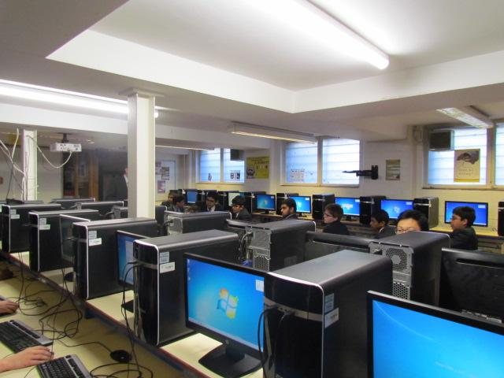]

THE POST

We are seeking a suitably qualified and talented classroom practitioner who can bring the best out of our students, and who is able and willing to make a contribution to the wider life of our school.

A job description is attached.

FURTHER INFORMATION

Candidates are asked to complete the application form and attach a letter of application giving examples of achievements, skills and experience which match those sought in the job description provided by the school. These documents should be sent to me as soon as possible, but by no later than **9.00 am** on **Friday 21st March** Interviews will take place shortly after.

Please do not hesitate to contact me if you require any further information ([headspa@camphillboys.bham.sch.uk](mailto:headspa@camphillboys.bham.sch.uk)) . Camp Hill Boys is a happy, flourishing and friendly community as well as an outstandingly successful grammar school. I look forward to receiving your application.

**R W Bowen**

**Headmaster**