Teacher of Computing

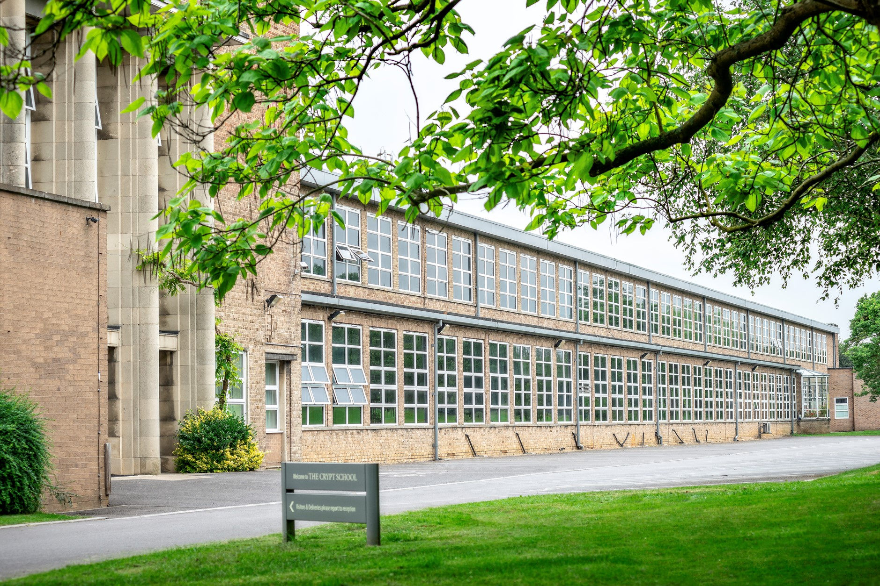

If you would like any further information on the role, please contact Sharon Bailey, HR Administration on sbailey@crypt.gloucs.sch.uk or T: 01452 530291.

The closing date for applications: Noon, Friday 29th January 2021

Interview date: Term 4 – exact date tbc

The Crypt School is committed to safeguarding and promoting the welfare of children and young people in its recruitment and selection of job applicants and expects all staff to share this commitment.

The successful candidate will be required to undergo an enhanced DBS check.

Message from the Headmaster – Mr. Nicholas Dyer

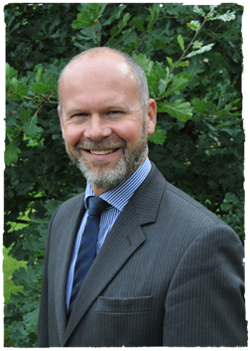
I am delighted that you are considering a role here at The Crypt School. I hope that you find this information helpful and we look forward to receiving your application.

The School is located just outside of the City of Gloucester in the West of England. Gloucester is known for its 11th century Cathedral and close; for Blackfriars, which is a stunning example of a 13th century medieval priory site; the British Waterways Museum, which celebrates the city’s industrial past, and now the vibrant Gloucester Quays, which has a selection of shops and restaurants. Gloucester is a vibrant and growing city, and the School is conveniently located close to the City, and close to good road and rail links to Cheltenham and the surrounding region, including Bristol for example.

Founded in 1539, The Crypt School’s vision is derived from its Latin motto “Floreat Schola Cryptiensis”: floreat means “to flourish” and at The Crypt we wish all our pupils and our young adults in the sixth form, as well as our staff, to flourish in all that they do both in school and in their later adult lives.

We are a vibrant co-educational selective school, a place where learning is valued for its own sake within an environment of strong pastoral care. At the centre of our school life, is a powerful sense of community, where pupils are supported and encouraged to learn and engage with each other. Confident, friendly and respectful, the high quality of our pupils’ personal development is remarkable and is one of the greatest strengths of the School.

We recognise the time and thought that goes into an application and we will certainly give yours our serious consideration.

If you have any further questions, or wish to visit the School prior to sending in an application, please contact Sharon Bailey via sbailey@crypt.gloucs.sch.uk who will be able to assist you.

With best wishes
Nicholas Dyer

The Appointment

A well-qualified teacher of Computing is required with the ability and enthusiasm to teach across the age range including to GCSE and to A level.

The successful applicant will be expected to be able to teach pupils using our remote learning platform (Google Classroom and Meets) that the School has been successfully using and which ensures the continuity of learning for pupils who are self-isolating at home for example. Training will be given.

The School currently has three well-equipped specialist computing teaching rooms which will seat 90 students, and in addition there are two other computer rooms available to students and classes.

The department comprises of two full time teachers who teach Computing from Year 7 to Year 13. There are two ICT technicians who support the work of the department and whole-school ICT. In Year 7 pupils can opt to take part in the School’s IPad purchase scheme which are used extensively throughout the school in all subjects.

Computing in Years 7 & 8 follows an organised scheme of work that is developed within department following CAS/Government guidelines. This is constantly being developed and improved. In Year 9, students will be taught R354 OCR entry level computer science to gain a recognised qualification and to help prepare them make an informed decision whether to study it further at GCSE.

At KS4 we offer OCR Computer Science and the number of pupils opting for the subject means that it is split between two classes. It is a popular GCSE option and results are excellent, ALPS 3 or above.

At KS5 we offer the AQA Computer Science course, which builds upon the knowledge gained at GCSE and develops their programming skills to a higher, more modular and object orientated level. Numbers are growing and it is expected that this increase will continue in future years. , this is due to excellent results and consistently being ALPS 3 or above.

Due to the fast-changing requirements and specifications available for Computing at all levels we are continuously reviewing and enhancing our delivery to our students. We have a close relationship with the National Cyber Security Centre who has funded the department with additional hardware to enhance our teaching and support. The post holder would be expected to run extra-curricular enrichment activities and promote computing throughout the school.

Job Description
Teacher of Computing

Name
Post | Teacher of Computing – Full-time
Scale | MPS
Relationships | The postholder is responsible to the Head of Computing
Purpose | The role of the subject teacher is to provide learning opportunities to which all students can respond with enthusiasm and commitment, and demonstrate real progress in their learning
Duties and responsibilities | Your duties and responsibilities are contained in the ‘School Teachers Pay and Conditions Document’ and in The Crypt School contract

Guidelines for the post of Computer Teacher

The subject teacher:

- under the guidance of the Head of Department, the subject teacher ensures curriculum coverage, continuity and progression in the subject for all students;

- plans lessons with clear objectives for learning outcomes, understands the sequence of teaching and learning in the subject, and effectively communicates such information to students;

- uses appropriate teaching and learning methods to meet the needs of the subject and of different students;

- ensures that there are opportunities for effective development of students’ literacy, numeracy and information communication technology skills through the subject;

- uses the school and departmental policies and practices for assessing, recording and reporting on students’ achievement, and uses this information to recognise achievement and to assist students in setting targets for further development;

- ensures that information about students’ achievement in previous classes and schools is used effectively to secure good progress in the subject;

- sets expectations and establishes clear targets for students’ achievement, and evaluates progress and achievement in the subject by all students;

- ensures that there are opportunities for the effective development of students’ individual and collaborative study skills necessary for them to become increasingly independent in their work and to complete tasks independently when out of school;

- is aware of the subject’s contribution to students’ understanding of the duties, opportunities, responsibilities and rights of citizens;

- establishes a partnership with parents to involve them in their child’s learning of the subject, as well as providing information about curriculum, attainment, progress and targets;

- ensures that there is a safe working and learning environment in which risks are properly assessed

- responsible for the safeguarding and promoting the welfare of students

- contributes to the extracurricular activities and support sessions that the department offers

As a form tutor the subject teacher:

- plays a key role in supporting, guiding and motivating students;

- monitors academic progress and attendance;

- monitors students’ planners;

- liaises with the Head of Year / Head of Key Stage;

- embodies the vision for the school

We are committed to safeguarding and promoting the welfare of children and young people and expect all staff and volunteers to share this commitment. This post will be subject to an enhanced DBS disclosure. The Crypt School values the diversity of our workforce and welcomes applications from all sectors of the community.

As part of the application process please read the following policies that can be found using the link:

- Safeguarding
- Recruitment, Selection and Disclosure Policy and Procedure
https://www.cryptschool.org/parents/parents-hub/policies-forms

