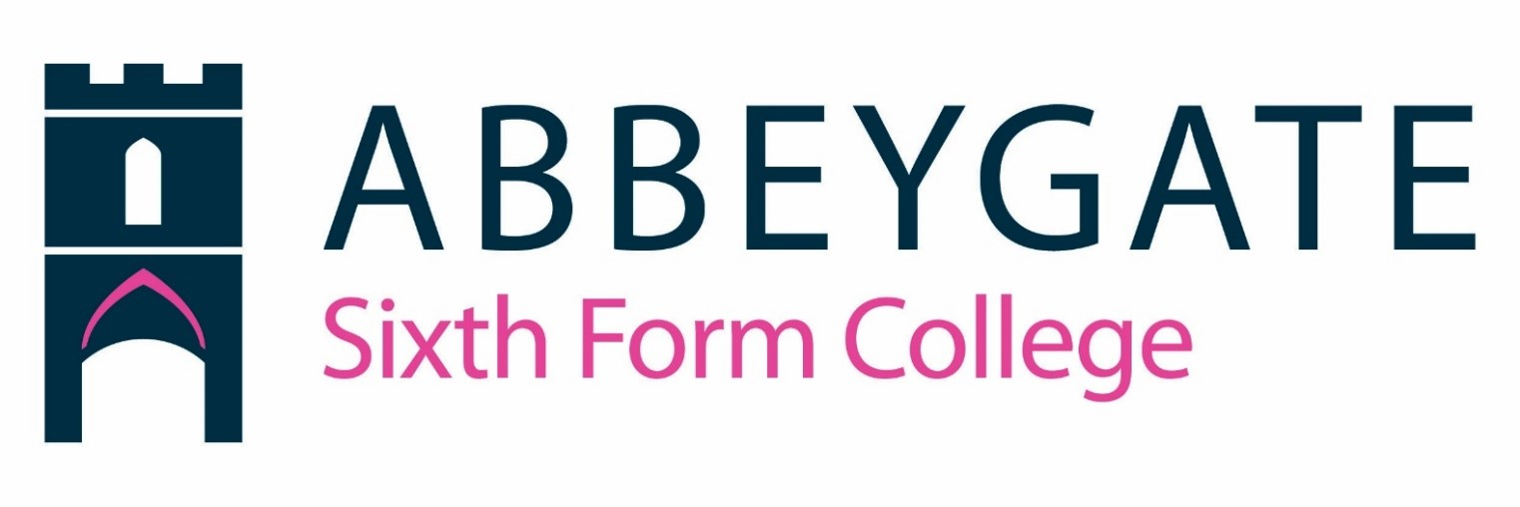

Job Description: Teacher
Accountable to: Head of Faculty
Abbeygate Sixth Form College has been set up under School Regulations and The School Teacher Pay & Conditions.
Salary: MPR & UPR
Job Purpose: Maximise student success

Abbeygate Sixth Form College’s vision is to provide a broad curriculum offer that enables students to flourish, achieve the best possible grades and enable them to progress on to the best universities or jobs with prospects whilst making a positive contribution to their community.

You will teach to motivate, inspire and encourage students to achieve the best possible grades, reach their full potential and enable them to progress. You will contribute to a culture of high expectations, outstanding teaching and robust tracking and support.

Main Accountabilities:
- To organise, structure and manage students’ learning experience including any necessary preparation and marking
- To carry out such assessment as required by Awarding Bodies in a fair, consistent and reliable way
- To devise appropriate schemes of work, lesson plans and individual learning plans in accordance with the College’s policy and procedures.
- To maintain all relevant course documentation and student records in line with the relevant Quality Assurance Procedures
- To contribute to curriculum development as required
- To attend and be an active contributor to Team Meetings, Curriculum and College Meetings and other cross-college meetings as required
- To attend and be an active contributor to Curriculum and College events
- To attend parents and open evenings
- To liaise with Curriculum Leadership, Student Services Manager, Student Achievement Mentors and other staff as required e.g. regarding learner support and assessment requirements
- To liaise with appropriate outside agencies and organisations involved in related work
- To assist in the College planning process including the monitoring, reviewing and evaluation of provision and performance, including value added measures.
- To take part in the recruitment, selection, induction, monitoring and review of students
- To review student progress in any units taught and complete relevant documentation
- To ensure learners are appropriately enrolled, withdrawn where necessary and adhere to registration and exam entry procedures
- To contribute to the implementation of the Curriculum and College Operational Plans
- To actively participate in planned professional self-development and team development activities

This is a summary of the key responsibilities and the incumbent will play a significant role in contributing towards our shared objective of maximising students’ achievements.

Teaching staff will be required to carry out duties as may be commensurate with the post, which do not change the character or purpose of the post and therefore may be altered from time to time to meet the changing needs of the College.

Teacher (MPR/UPR) – Person Specification

Criteria | Essential | Desirable | Method of  Assessment
Qualifications: | • Relevant teaching qualification. | • Relevant further professional studies  e.g. Further Degree. | Application form / certificates
Experience: | - A proven track record of raising standards for students of all abilities.  - Evidence of an innovative approach to development of teaching and learning.  - Experience of leading curriculum development and of monitoring and evaluation strategies.  - Experience in leading staff and pastoral development.  - Evidence of working in partnership with a range of stakeholders. | - Teaching experience within the 16-19 age range and the ability to teach at least one specialist subject to A-Level  - Knowledge and understanding of principles and practices  of performance management for all staff within a school or college. | Application form / interview/Micro Teach
Commitment | • Commitment to:  - Abbeygate SFC’s aims and objectives.  - Work in partnership with the wider community  including other schools, Governors |  | Application form / interview

and other partners/agencies.
- The promotion of ASFC and the recruitment and enrolment of suitably qualified learners to ensure a sustainable community.
Knowledge /  Skills / Abilities: | - Knowledge and understanding of curriculum developments and students’ learning styles in secondary schools or colleges.  - Ability to:  - Analyse and interpret student performance data and set challenging  but realistic targets.  - Ensure an ethos and structure for managing behaviour that enables all students to achieve.  - Contribute to action planning, observation and evaluation.  - Work effectively as part of a team and with governors, students and parents.  - A clear understanding of inclusion and SEN. |  | Application form / interview/Micro Teach
Communication and | • Excellent written and verbal |  | Application form / interview
interpersonal skills: | communication skills at all levels.  - Excellent presentation skills.  - Ability to analyse, synthesise, evaluate and communicate complex data.  - Effective team player.
Equality Issues: | • Knowledge and understanding of equality issues. |  | Application form / interview
Other  Requirements: | - Ability to work under pressure in a committed and professional manner.  - Ability to prioritise.  - Self-motivated and able to work with minimal supervision  - Energy and enthusiasm |  | Application form / interview

School Teachers’ Pay & Conditions Document 2020 available at www.gov.uk/government/publications/school-teachers-pay-and-conditions

