|  |
| --- |
| **Y:\Branding\Logos\UTC South Durham\jpeg_png\Portrait on White\UTC_South_Durham_Port_rgb.jpg** |
| **Teacher of Design and Technology / Engineering (Maternity Cover)**  **Application Pack** |
| **Y:\Branding\Logos\Founding members footer\UTC South Durham founding members logos high res.jpg** |

Contents

[Contents 2](#_Toc92871849)

[Message from the Principal 3](#_Toc92871850)

[Job Advert 4](#_Toc92871851)

The Student Leaver Profile [5](#_Toc92871852)

[The Curriculum 6](#_Toc92871853)

[The UTC Calendar 7](#_Toc92871854)

[Staff – Principles and Expectations 8](#_Toc92871855)

[About the Sponsors](#_Toc92871856) 9

[How to Apply 9](#_Toc92871857)

[Job Description 10](#_Toc92871858)

[Person Specification](#_Toc92871859) 14

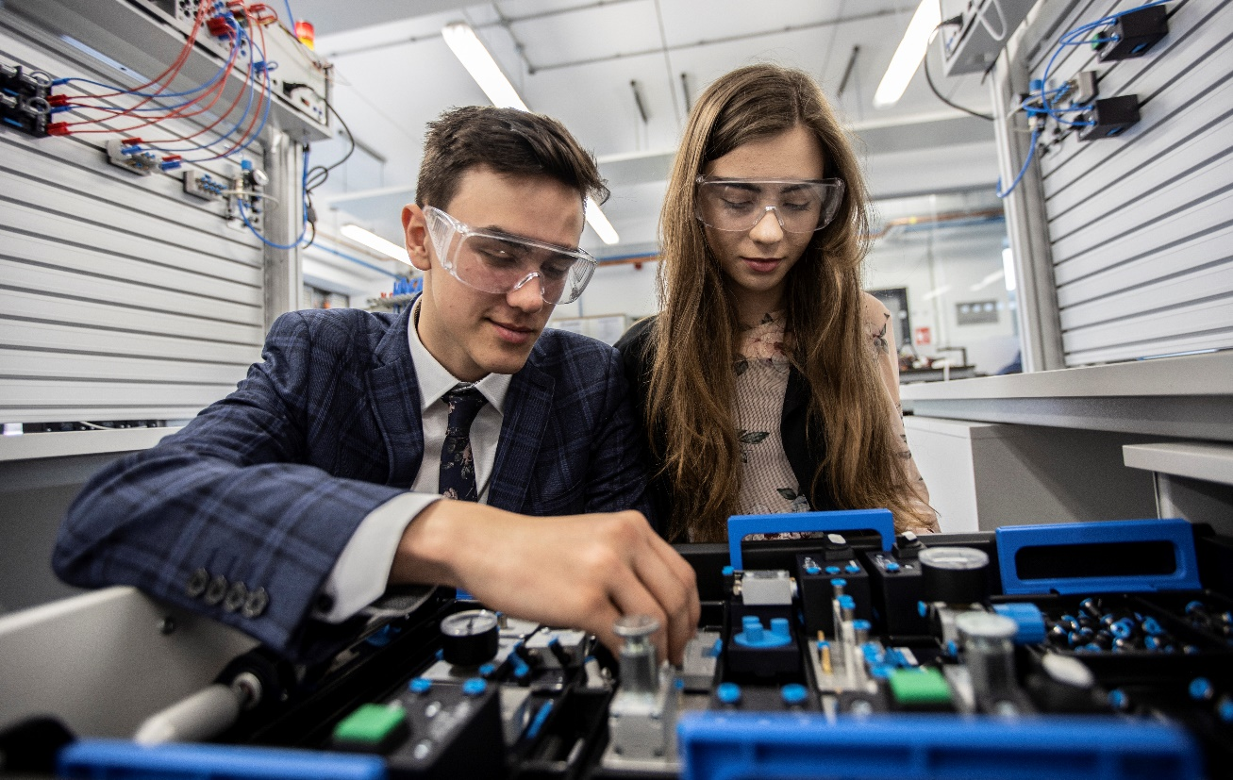

Message from the Principal

Thank you for your interest in the role of Teacher of Engineering. This is an exciting opportunity to join us in the creation of a very different type of education for students who have a strong interest in STEM subjects.

The chance to be a part of a rapidly expanding innovative education establishment is very rare and this is a wonderful opportunity. As a key member of a small team you will support the culture of the organisation and our students’ educational experience.

The education system tends to separate students into those who are academic and those who are vocational. I see no reason why talented young people, both boys and girls, who are interested in STEM subjects, cannot gain academic qualifications, build technical expertise and develop core skills through real experience in businesses. We call this our Student Leaver Profile and the focus of the UTC education is to ensure that students are Career and Life Ready.

Your primary focus will be on the high quality teaching and delivery of our Design and Technology and Engineering curriculum at KS4 and KS5.

We were the first university technical college in the North East and already play a significant role in the provision of education and skills for the engineering and manufacturing industry in the area. Our business sponsors, Gestamp Tallent and Hitachi Rail, are two of the biggest and most influential engineering employers in the North East. The University of Sunderland has a proud record of combining educational excellence with a deep commitment to careers and the well-being of the local area.

The founding partners, five years into our journey and success, are fully committed to the UTC and are demonstrating that in their level of support, but we do not underestimate the importance of appointing an enthusiastic teacher whose experience, energy, ambition and values match our own.

We have tried to give you a clear picture of our aspirations for the UTC in this pack and additional information can be found on our website [www.utcsouthdurham.org](http://www.utcsouthdurham.org).

Please don’t hesitate to contact our Vice Principal of Teaching and Learning if you have further questions.

Joining UTC South Durham will be a career-defining opportunity for the right person. If you think you are that person we look forward to receiving an application from you.

Yours sincerely

C:\Users\Tom\Desktop\Tom Dower\UTC\UTC South Durham\Marketing and branding\me\TD signature.png

**Tom Dower**

Principal

UTC South Durham



|  |  |
| --- | --- |
| **Job Advert**  **UTC South Durham – Teacher of Design and Technology / Engineering (Maternity Cover)**  **Preparing students to be Career and Life Ready for outstanding STEM careers. Can you lead our students to success?**  **NOR:** up to 600 | **Age range:** 14-19 | **Start:** September 2025  **Salary:** MPS/UPS  This post is suitable for an experienced teacher or a strong Early Career Teacher (ECT) | **Y:\Branding\Logos\UTC South Durham\jpeg_png\Portrait on White\UTC_South_Durham_Port_rgb_lowres.jpg** |

**Can you create an inspiring experience for our students?**

University Technical College South Durham provides an innovative education for 14-19 year olds, encompassing real, relevant workplace experience in partnership with world-class companies. With a focus on STEM, particularly advanced manufacturing and engineering, it is located on Aycliffe Business Park, County Durham and is expanding rapidly.

The UTC was rated Good by Ofsted in 2024 and has developed a reputation and track record of outstanding destinations for our students. It has a single focus – to help young people become career and life ready.

Design and Technology and Engineering are a vital part of our KS4 and KS5 technical programme. We are looking to appoint an outstanding teacher to join our teaching team. The chance to work in an innovative education establishment is rare and this is an exciting opportunity to join us as we continue to expand and develop; designing and delivering high quality learning experiences for our students. As a key member of the UTC team you will help shape our KS4 and KS5 curricula, set high expectations and inspire our students through making the subjects engaging and relevant. You’ll also build positive relationships with students, staff and parents and you’ll be able to demonstrate successful outcomes for your students at GCSE and A Level.

Our sponsors, Hitachi Rail, Gestamp Tallent and the University of Sunderland, are committed to creating an outstanding school that will provide a talented young workforce for companies in the North of England. If you have the expertise and commitment to make a life-changing impact on our students then we would like to hear from you.

*We are an equal opportunities employer and we are committed to safeguarding and promoting the welfare of children.*

**Closing date:** Noon on Monday 28th April 2025

**Interviews:** Full day, Wednesday 7th May 2025

To arrange an informal discussion, please email:

jobs@utcsouthdurham.org

Further information and application form is downloadable from:

https://www.utcsouthdurham.org/home/staff-information/current-staff-vacancies

***No agencies please.***

**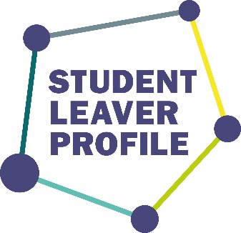**

**Our Student Leaver Profile**

The Student Leaver Profile is the cornerstone of our values, ethos and culture. It was created by our wider community of staff, students, parents, community and business leaders. We have an aspiration that all students leave us with an outstanding academic and technical knowledge and understanding, fantastic professional and career experiences and a well-rounded set of core skills ensuring that they are career and life ready.

**Excellence**

We strive for excellence in all that we do with every activity focused on providing an outstanding academic and practical technical education for students.

**Innovation**

We are inspired by and enthusiastic about science, technology, engineering and maths. We encourage our students and staff to experiment, invent and pioneer new technology, products, processes and learning methods.

**Collaboration**

We encourage partnerships amongst students and with employers, education providers and community groups, enabling students to develop core skills, form close links with businesses and prepare for their future careers.

**Accessibility**

We welcome to our community people from different backgrounds, gender, abilities and locations. All students, irrespective of their starting point, thrive and progress to meaningful education, employment or training.

**Integrity**

We expect high standards of our students and staff and we show mutual respect to others reflecting the UTC’s ethos as a grown-up place to learn.

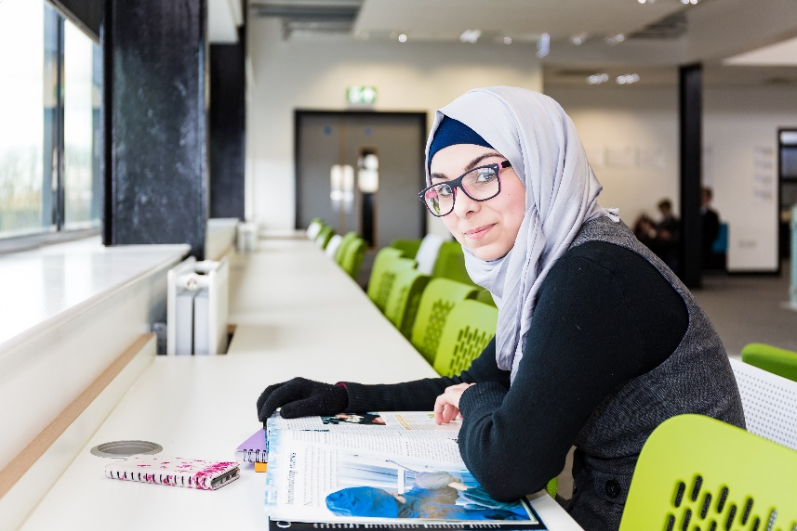



The Curriculum

The curriculum at UTC South Durham is designed to offer a different type of education for young people in order to prepare them effectively for the world of work. We provide an educational experience which is both academic and technical alongside developing a careers focus. As a school, we are bound by the statutory KS4 curriculum and have an important duty to deliver a wider moral and social education. Our KS5 curriculum remains to be focused on a technical education and is delivered via A Levels, Tech Levels, Performing Engineering Operations or our new T Level in engineering, which began in September 2022.

The key elements are:

* **Academic and Technical Knowledge and Understanding –** students study GCSEs, A-levels, Tech Levels, T-levels or nationally recognised equivalent qualifications. All students at KS4 study engineering and have a choice of other technical subjects.
* **Core Skills –** All students study a Crew Curriculum. Crew is a professional and personal development programme for students**.**
* **Career and Professional Experiences –** all students undertake visits and placements in companies as well as projects within the UTC.

More about our curriculum offer for KS4 and KS5 curriculum can be found [HERE](https://www.utcsouthdurham.org/curriculum/).

**Support and SEND**

Our students are supported by robust pastoral and safeguarding systems, with mentoring and SEND support for individuals as appropriate. We’re a small school and know our students well.

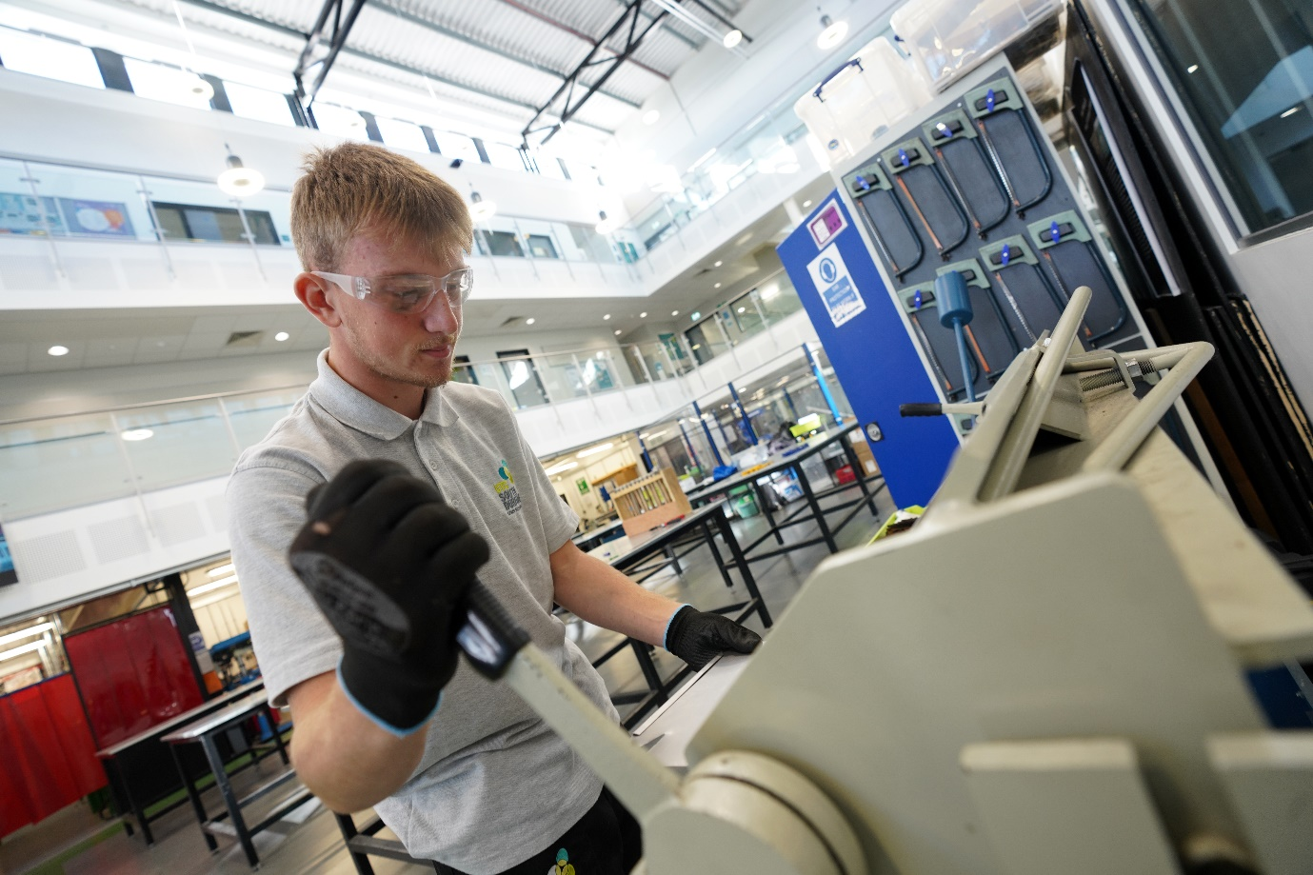

The UTC Calendar

**The UTC year**

The UTC operates the same term dates as Durham LA schools, minimising disruption for families with siblings at other schools and staff with children.

The UTC week is 30 hours, longer than most schools to reflect a professional working environment and allowing time for all students to undertake projects, visits, enrichment activities and have directed study time. No formal homework is set, though we expect students to carry on thinking, researching and designing outside of school on their stimulating projects and undertake exam revision both inside and outside school.

Students are encouraged to undertake activity such as relevant work experience during holiday periods in order to enhance their experience and skills in areas of interest.

**The UTC day**

There are no bells as students and staff take responsibility for their own timekeeping.

Example timetable:

|  |  |
| --- | --- |
| Period 1 | 8.45 |
| Period 2 | 9.45 |
|  |  |
| Break | 10.45-11.00 |
|  |  |
| Period 3 | 11.00 |
| Period 4 | 12.00 |
|  |  |
| Lunch | 1.00-1.30 |
|  |  |
| Period 5 | 1.30 |
| Period 6 | 2.30 |
|  |  |
| Break | 3.15-3.25 |
|  |  |
| Period 7 | 3.25-4.25 |

Students leave early on a Wednesday, Thursday and Friday at 2.30pm.

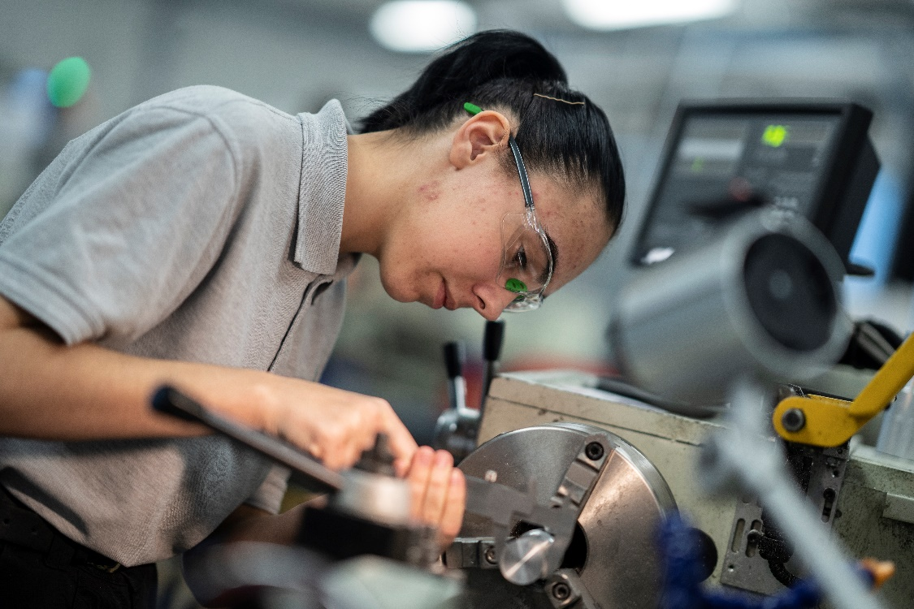

Staff – Principles and Expectations

**All staff of the UTC are expected to:**

* Model only the highest of standards in relation to work ethic, behaviour, dress code and conduct.
* Demonstrate personal and professional integrity, promoting the vision and values of the UTC.
* Enable a climate that engenders personal growth and success for all staff and students.
* Commit to the provision of a curriculum which enables real workplace experiences and the opportunity to engage in employer-led and industry-sponsored projects.
* Demonstrate and develop in students the Student Leaver Profile.
* Positively promote the belief that all young people can achieve beyond national expectations given their starting points and that all, without exception, will progress to university, employment and/or training.
* Commit unconditionally to ensuring that all groups of students, irrespective of their starting points will thrive, eradicating any notion of ‘gaps’ in performance or ‘labelling’ between groups.
* Be flexible in the way they work to meet the needs of the UTC students.

**Terms and Conditions**

For clarity of understanding and expectations, the main UTC staff policies, terms and conditions are based on nationally-recognised policies, terms and conditions that have been adapted to make them relevant to the operation of the UTC, with the differences made explicit. The key differences are:

* We have created a different learning climate for students and this means a different way of working for staff.
* Main-scale teachers will prepare and deliver a ‘standard’ teaching load of 23 subject lessons a week, plus enrichment and support time. This will be adjusted appropriately for those with leadership responsibilities, ECT and part-time staff.
* Staff will be required to be on site for the full UTC day – they are longer days than most schools.
* We follow Durham LA’s term dates. Six training days are built into the school year along and staff are expected to work the equivalent of two additional days a year. This is taken in the form of events for student recruitment. Flexibility is assumed in this approach to allow for individual needs and appropriate notice will be given of the events. Department time is given on a Wednesday afternoon and the Friday of every half term is committed to CPD with students working from home.
* Staff are expected to attend businesses on visits with students as appropriate.

About the Founding Members

The UTC has been set up and is governed by three leading regional organisations:

**University of Sunderland**

The University of Sunderland is one of a new generation of civic universities, innovative, accessible and outward looking, with global influence and remarkable local impact. Excellent teaching, internationally recognised research and an extensive business engagement portfolio all contribute to the University’s success.

**Hitachi Rail**

Hitachi Rail is one of the most significant inward investors in County Durham. The company is a total railway system supplier offering rolling stock, traction equipment, signalling, traffic management systems and maintenance depots. Hitachi draws on many years of experience as a leading supplier of metro, commuter and high-speed trains such as the Shinkansen (bullet train) for the Japanese and international markets. The manufacturing and assembly plant in South Durham was developed to support the Department for Transport-led Intercity Express Programme and future Hitachi projects.

**Gestamp Tallent**

Gestamp Tallent Ltd is part of Gestamp Automocion, an international group dedicated to the design, development and manufacture of metal components and structural systems for the automotive industry. Today, Gestamp Automocion is present in 22 countries, has 95 production centres across the world and employs over 25,000 people. In line with the demands of global customers for a global supply network, Gestamp is a truly international business, but the British operation has remained as robust as ever. As one of the five plants within the UK, the Newton Aycliffe plant is one of the region’s largest employers with a workforce of over 1,000 people.

|  |  |  |
| --- | --- | --- |
|  |  |  |

How to Apply

Applicants are required to submit an electronic UTC South Durham application form which is downloadable from [www.utcsouthdurham.org/vacancies](http://www.utcsouthdurham.org/vacancies). Please do not submit applications via TES. Applications should be returned to jobs@utcsouthdurham.org by the closing date.

**Closing date:** Noon on Monday 28th April 2025

**Interviews:** Full day, Wednesday 7th May 2025

To arrange an informal discussion, please email:

Laura McAllister, Vice Principal of Teaching and Learning

[jobs@utcsouthdurham.org](mailto:jobs@utcsouthdurham.org)

|  |  |  |  |  |  |  |  |  |  |  |  |  |  |  |  |  |  |  |  |  |  |  |  |  |  |  |  |  |  |  |  |  |  |  |  |  |  |  |  |  |  |  |  |  |  |  |  |  |  |  |  |  |  |  |  |  |  |  |  |  |  |  |  |  |  |  |  |  |  |  |  |  |  |  |  |  |  |  |  |  |  |  |  |  |  |  |  |  |  |  |  |  |  |  |  |  |  |  |  |  |  |  |  |  |  |  |  |  |  |  |  |  |  |  |  |  |  |  |  |  |  |  |  |  |  |  |  |  |  |  |  |  |  |  |  |  |  |  |  |  |  |  |  |  |  |  |  |  |  |  |  |  |  |  |  |  |  |  |  |  |  |  |  |  |  |  |  |  |  |  |  |  |  |  |  |  |  |  |  |  |  |  |  |  |  |  |  |  |  |  |  |  |  |  |  |  |  |  |  |  |  |  |  |  |  |  |  |  |  |  |  |  |  |  |  |  |  |  |  |  |  |  |  |  |  |  |  |  |  |  |  |
| --- | --- | --- | --- | --- | --- | --- | --- | --- | --- | --- | --- | --- | --- | --- | --- | --- | --- | --- | --- | --- | --- | --- | --- | --- | --- | --- | --- | --- | --- | --- | --- | --- | --- | --- | --- | --- | --- | --- | --- | --- | --- | --- | --- | --- | --- | --- | --- | --- | --- | --- | --- | --- | --- | --- | --- | --- | --- | --- | --- | --- | --- | --- | --- | --- | --- | --- | --- | --- | --- | --- | --- | --- | --- | --- | --- | --- | --- | --- | --- | --- | --- | --- | --- | --- | --- | --- | --- | --- | --- | --- | --- | --- | --- | --- | --- | --- | --- | --- | --- | --- | --- | --- | --- | --- | --- | --- | --- | --- | --- | --- | --- | --- | --- | --- | --- | --- | --- | --- | --- | --- | --- | --- | --- | --- | --- | --- | --- | --- | --- | --- | --- | --- | --- | --- | --- | --- | --- | --- | --- | --- | --- | --- | --- | --- | --- | --- | --- | --- | --- | --- | --- | --- | --- | --- | --- | --- | --- | --- | --- | --- | --- | --- | --- | --- | --- | --- | --- | --- | --- | --- | --- | --- | --- | --- | --- | --- | --- | --- | --- | --- | --- | --- | --- | --- | --- | --- | --- | --- | --- | --- | --- | --- | --- | --- | --- | --- | --- | --- | --- | --- | --- | --- | --- | --- | --- | --- | --- | --- | --- | --- | --- | --- | --- | --- | --- | --- | --- | --- | --- | --- | --- | --- | --- | --- | --- | --- | --- | --- | --- | --- | --- |
| |  |  | | --- | --- | | **Job description**  **UTC South Durham – Teacher of Engineering**  **Preparing students to be Career and Life Ready for outstanding STEM careers. Can you lead our students to success?**  **NOR:** up to 600 | **Age range:** 14-19 | **Start:** September 2025  **Salary:** MPS/UPS  This post is suitable for an experienced teacher or a strong Early Career Teacher | **Y:\Branding\Logos\UTC South Durham\jpeg_png\Portrait on White\UTC_South_Durham_Port_rgb_lowres.jpg** |   **Can you create an inspiring experience for our students?**  University Technical College South Durham provides an innovative education for 14-19 year olds, encompassing real, relevant workplace experience in partnership with world-class companies. With a focus on STEM, particularly advanced manufacturing and engineering, it is located on Aycliffe Business Park, County Durham and is expanding rapidly.  The UTC was rated Good by Ofsted in 2024 and has developed a reputation and track record of outstanding destinations for our students. It has a single focus – to help young people become career and life ready.  Design and Technology and Engineering is a vital part of our KS4 and KS5 technical programme. We are looking to appoint an outstanding teacher to join our teaching team. The chance to work in an innovative education establishment is rare and this is an exciting opportunity to join us as we continue to expand and develop; designing and delivering high quality learning experiences for our students. As a key member of the UTC team you will help shape our KS4 and KS5 curricula, set high expectations and inspire our students through making the subjects engaging and relevant. You’ll also build positive relationships with students, staff and parents and you’ll be able to demonstrate successful outcomes for your students at GCSE and A Level.  Our sponsors, Hitachi Rail, Gestamp Tallent and the University of Sunderland, are committed to creating an outstanding school that will provide a talented young workforce for companies in the North of England. If you have the expertise and commitment to make a life-changing impact on our students then we would like to hear from you.  *We are an equal opportunities employer and we are committed to safeguarding and promoting the welfare of children.*  **Closing date:** Noon on Monday 28th April 2025  **Interviews:** Full day, Wednesday 7th May 2025  To arrange an informal discussion, please email:  jobs@utcsouthdurham.org  Further information and application form is downloadable from:  https://www.utcsouthdurham.org/home/staff-information/current-staff-vacancies  ***No agencies please.***  **1. Teaching and learning**   * Deliver high quality learning experiences which engage and excite our students, in line with the UTC teaching and learning strategy. * Plan and teach well-structured lessons which engage students to learn curriculum content whilst also developing their Core Skills. * Bring the curriculum to life through practical application relevant to the world of work. * Adapt teaching to meet the needs of groups and individual students. * Be aware of and make provision for students with additional needs. * Have clear and high expectations of student attitudes and ensure that students are clear about how they should behave, manage behaviour effectively applying the UTC behaviour policy and apply a restorative approach where required. * Have clear and high expectations of student learning and ensure that students are clear about how they should present work and engage in learning. * Have clear and high expectations of learning behaviours. * Give students regular feedback and clear targets in order to help them improve. * Encourage students to reflect on their progress and support them to become successful independent learners. * Reflect on student learning and own teaching practice to improve future effectiveness. * Work with colleagues to evaluate teaching, giving and receiving feedback to help improvement. * Gather feedback from students and respond positively to suggestions for improvement. * Develop an inclusive and supportive approach so that all young people feel welcome and supported in their learning.   **2. Raising aspiration, achievement and attainment**   * Be accountable for students’ progress and attainment in all classes taught. * Have high expectations of students in achieving their academic targets, irrespective of background. * Work with leaders to use assessment data to set challenging targets for students and to accurately track their progress, with a focus on groups and gaps. * Use accurate and robust assessment methods to understand and track the progress of every student and design and implement appropriate strategies to support their learning. * Address the needs and aspirations of each student through personalised learning.   **3. Curriculum expertise**   * Maintain subject expertise across relevant Key Stages and qualifications. * Develop subject expertise, especially in areas with lack of experience or with new qualifications. * Contribute to the design and implementation of a curriculum in specified subject areas which meets the needs of all students, is consistent with the UTC’s Student Leaver Profile (SLP) and fulfils statutory requirements. * Ensure that opportunities are taken to develop the curriculum to reflect the specialist ethos of the UTC and so that it prepares young people for their range of future possibilities. * Ensure that students understand how the curriculum is relevant to the world of work and develops their Core Skills. * Support student development of literacy and numeracy skills and love of reading through curriculum and Core Skills delivery and throughout their experience at UTCSD. * Have an attitude of flexibility to teach subjects outside of specialism with appropriate support and CPD if and when required. * Contribute to a flourishing ‘Crew’ programme, which provides a broad and stimulating experience for all students.   **4. Pastoral Duties**   * Be a Crew leader/ mentor to an assigned group of students: build relationships with students and their parents/carers in order to support their development towards the Student Leaver Profile (SLP) * Register students, accompany them to briefings, encourage their full attendance at all lessons and their participation in all aspects of UTC life. * Deliver a programme of morning Crew/mentor time tasks. * Support and challenge students to:   + Support and challenge one another in all aspects of their UTC career.   + Celebrate one another’s successes and achievements, however small.   + Make a stand against injustices or causes that they feel strongly about.   + **Communicate** with one another and other students and adults professionally and effectively.   + **Organise** themselves – their time, equipment, learning goals and take initiative for their own learning.   + **Persevere** in the face of challenge, try things outside of their comfort zone and approach situations creatively.   + **Reflect** on their learning and experiences, welcoming critique and using it to inform future goal setting and approaches.   + **Collaborate** and share a collective responsibility, adapting to new and different ways of working and encouraging and supporting others to achieve.   + **Respect** resources, materials and their environment; act with integrity and comply with the rules and routines of the college, workplace and community.   + Use rubrics to reflect on their development towards all of the above.   + Build a portfolio of evidence demonstrating their progress towards the SLP over time.   + Conduct a Student Led Conference (SLC) in the Summer term or Y10 and Spring term of Y11 where they will present their own academic progress, character growth and work readiness to you and their parents/carers using their portfolio of evidence and the rubrics that they have been working from throughout the year.   **5. General Professional Duties**   * Operate at all times within the policies and practices of the UTC. * Have a working knowledge of teachers’ professional duties and legal liabilities. * Be proactive in marketing and recruitment activities: attending and contributing to open evenings and other events, taking a shared responsibility in promoting the UTC and its good reputation. * Take responsibility for and ownership of own professional development in relation to curriculum, T&L practice, UTC policies and practices and duties: welcoming and responding to feedback and critique, setting and prioritising goals and planning how to achieve them, being willing to move outside of comfort zone in order to develop and engage support where needed. * Contribute to wider curriculum developments. * Conduct duties during non-structured times of the UTC day (break time, beginning/end of day etc.) as directed by the leadership team. * Contribute to PSHE, Citizenship and SRE education in line with UTC policy. * Establish effective working relationships and set a good example through presentation and personal and professional conduct. * Communicate effectively, appropriately and professionally in both written and oral communication modes and establish professional and effective relationships with adults and young people. * Take care of resources, materials and environment to ensure efficiency and effective use so that the maximum impact on students can be achieved. * Comply with health and safety rules and legislation, ensuring the safety of students and staff at all times, specifically sharing responsibility for the health and safety in all technical areas. * Be committed and contribute to our culture, ethos and intent as an organisation.   Teachers will be expected to comply with any reasonable request from the leadership team to undertake work of a similar level that is not specified by this job description.  **UPS Teachers \***  \*Teachers paid on the upper pay scale are expected to conduct all of the duties and responsibilities listed above and be highly competent in all areas of the Teachers’ Standards. They should also be able to show the substantial and sustained impact that they have had beyond their classroom: on students in other areas of the UTC or the support and development of staff in other areas of the UTC. This should be reflected in their appraisal objectives and this level of impact should increase as they progress through the UPS pay scale.  Below are some examples of duties that could reasonably be expected of a UPS teacher. This is not an exhaustive list:   * Creating and implementing schemes of work and/or assessment for use across a team of teachers. Monitoring and evaluating their success/impact and adapting in response to this. * Supporting/coaching/mentoring another staff member or small group of staff. * Creating and implementing enrichment activities for students.   **Person specification**   |  |  |  |  | | --- | --- | --- | --- | | **Training and qualifications** | **Essential** | **Desirable** | **Evidence** | | Qualified teacher (QTS or equivalent) | ✓ |  | DfE check | | Degree or other Level 5 qualification | ✓ |  | Sight | | Higher degree or Level 6/7 qualification |  | ✓ | Sight | | Additional relevant qualifications/  subject specialisms |  | ✓ | Application | | Undertaken extensive relevant CPD |  | ✓ | Application |  |  |  |  |  | | --- | --- | --- | --- | | **Experience of teaching and**  **leading learning** | **Essential** | **Desirable** | **Evidence** | | Teaching/training experience in delivering Design and Technology in Key Stage 4 and Key Stage 5 | ✓ |  | Application/reference | | Teaching/training experience in delivering Engineering/Systems in Key Stage 4 and Key Stage 5 |  | ✓ | Application/reference | | Track record of high quality teaching leading to outstanding learning | ✓ |  | Application/reference/ interview | | Able to demonstrate impact of teaching through student progress and attainment | ✓ |  | Application/reference/ interview | | Successful experience of innovative partnership working with employers |  | ✓ | Application/interview | | Experience of working outside education |  | ✓ | Application/interview |  |  |  |  |  | | --- | --- | --- | --- | | **Professional knowledge and**  **Understanding** | **Essential** | **Desirable** | **Evidence** | | In-depth knowledge of Design/Engineering curriculum at KS4 and KS5. | ✓ |  | Application/reference/ interview | | Understanding of Cambridge National/Technical curriculum |  | ✓ | Application/reference/ interview | | Able to design and implement successful schemes of work | ✓ |  | Reference/interview | | In-depth knowledge of the most effective teaching and learning strategies | ✓ |  | Reference/interview | | Ability to set robust targets, analyse performance and report accurately | ✓ |  | Reference/interview |  |  |  |  |  | | --- | --- | --- | --- | | **Core Skills** | **Essential** | **Desirable** | **Evidence** | | **Communication** | | | | | Ability to establish and develop professional and effective relationships with adults and young people | ✓ |  | Application/ Interview tasks | | Outstanding communication skills both written and oral that are delivered professionally and appropriately | ✓ |  | Application/ Interview tasks | | Excellent interpersonal skills and builds positive relationships with staff, students, business and all stakeholders | ✓ |  | Application/ Interview tasks | | To listen carefully to others and actively respond in a professional manner | ✓ |  | Application/ Interview tasks | | **Organise** | | | | | To be punctual and be able to organise, prioritise and meet deadlines | ✓ |  | Application/ Interview tasks | | To set and prioritise personal, educational and professional learning goals and plan how achieve them | ✓ |  | Application/ Interview tasks | | To actively take responsibility for our own learning; use initiative; ask questions; seek help when needed | ✓ |  | Application/ Interview tasks | | Work efficiently and accurately | ✓ |  | Application/ Interview tasks | | Excellent ICT and organisational skills | ✓ |  | Application/ Interview tasks | | **Persevere** | | | | | To be willing to move outside of comfort zone in order to develop, deepen and promote successful outcome | ✓ |  | Application/ Interview tasks | | To always apply full effort and drive towards success, even if not always successful first time | ✓ |  | Application/ Interview tasks | | To approach situations creatively, take pride in our work and produce to a high standard | ✓ |  | Application/ Interview tasks | | Able to respond calmly to challenging situations and demonstrate stamina and resilience | ✓ |  | Application/ Interview tasks | | Willingness to take on responsibilities beyond previous experience with suitable support | ✓ |  | Application/ Interview tasks | | **Reflect** | | | | | To welcome feedback and apply it positively to improve our work and ourselves | ✓ |  | Application/ Interview tasks | | To evaluate personally and seek others opinions to improve | ✓ |  | Application/ Interview tasks | | To take critique and learn from it to set future goals | ✓ |  | Application/ Interview tasks | | **Collaborate** | | | | | Able to work as part of a wider team with a flexible approach to the role | ✓ |  | Application/ Interview tasks | | To help others to achieve by encouraging them and supporting them academically, emotionally and professionally | ✓ |  | Application/ Interview tasks | | To adapt to different ways of working, to work hard and strive to achieve team goals | ✓ |  | Application/ Interview tasks | | To share responsibility for outcomes and contribute to planning and goal setting | ✓ |  | Application/ Interview tasks | | **Respect** | | | | | Absolute commitment to the UTC ethos and attitude towards students as young adults | ✓ |  | Application/ Interview tasks | | Committed to equality and diversity | ✓ |  | Application/ Interview tasks | | Honesty, integrity and professionalism | ✓ |  | Application/ Interview tasks | | To act with integrity at all times and be mindful of how actions can affect others. | ✓ |  | Application/ Interview tasks | | To be compliant with the rules and routines of the college, community and workplace. | ✓ |  | Application/ Interview tasks | | To take care of resources, materials and environment and use them safely and responsibly | ✓ |  | Application/ Interview tasks |  |  |  |  |  | | --- | --- | --- | --- | | **Special requirements** | **Essential** | **Desirable** | **Evidence** | | No adverse criminal record | ✓ |  | DBS check | | Full driving licence with access to a car to use for work purposes |  | ✓ |  | | Two satisfactory references from current and previous employers | ✓ |  |  |   UTC South Durham is committed to safeguarding and promoting the welfare of children and young people. We expect all employees and volunteers to share this commitment. |  |