Design and Technology Department

“In Design and Technology students combine practical and technological skills with creative thinking to design and make products and systems. It is the department’s aim to structure experiences leading to the production of quality outcomes from our students.”

At Wood Green Academy, we have a highly motivated and driven team of professionals who are committed to ensuring all students make progress and enjoy their learning and school experience.
The Design and Technology Department consists of 10 members of staff, our current postholders include:
Mrs Claire Eccleston Head of Design and Technology
Mr R Greenslade Assistant Head of Design and Technology, KS4 Manager.
Mr M Mahroof Teacher of Design and Technology, KS3 Manager.
Mrs Stephanie Norton Teacher of Design and Technology. Cross Phase Co-ordinator.
Mrs Bally Bratch-Mysk Teacher of Design and Technology.
Mrs Caroline Thornton Head of Food Technology
Mrs Gillian Grainger Teacher of Food Technology
Miss Rachel Donaghie Teacher of Food Technology. Year Leader for Year 8
Mr Roy Harrington Design & Technology Technician
Mrs Sue Talbot Food /Textiles Technician

Department Resources:
Design and Technology is a pleasant and exciting area that can facilitate a wide range of relevant activities using up to date equipment. The department workshops are multi-functional accommodating work in wood, metal, plastics and design activities. The workshops are situated around a central design suite with 20 computers dedicated to promoting high quality products using CAD/CAM.
The department also has an ICT suite with an additional 20 computers and CAM facilities dedicated to the delivery of knowledge, understanding and skills in 3-Dimensional drawing and Systems and Control software. The textiles room includes ICT facilities to support students at all key stages.
Food Technology is situated in Turing Block and has up to date catering facilities, an ICT room and a further classroom used for delivering design tasks.

It is a priority of the department that each child should achieve his or her full potential. The department expects students to achieve results equivalent to/or better than the results they achieve in other areas of the curriculum.
Great importance is attached to the contribution that the subject makes to cognitive development and in preparing students to participate in tomorrow's rapidly changing world, but more than this the department feels that the subject is worthy of study in its own right equipping students with skills and experiences that they can use and enjoy throughout their life.

Curriculum and Examinations:
Students at Wood Green Academy follow a two-year Key Stage 3. The KS3 course is studied over two years; students have 2 hours of lesson time per fortnight during years 7 and 8. They also receive regular homework to complement the learning within lessons. Key stage 4 begins in Year 9 where we currently offer Edexcel GCSE Design and Technology. At Key Stage 5, the department offers Edexcel A Level Design and Technology.
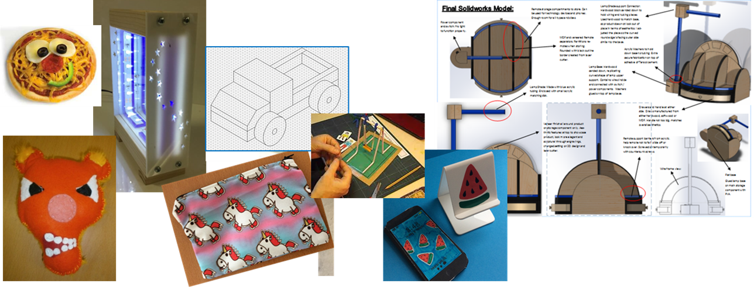

Department Successes:
In summer 2020, the Design and Technology Department achieved the following results:
- 61% grade 5+ in GCSE Design and Technology
- 100% A*-B in A-Level Design and Technology

Support and CPD:
As a school, we are committed to ensuring all staff have opportunities for professional development. In joining Wood Green Academy, you will be offered opportunities to participate in a range of CPD sessions to further enhance your teaching and to support professional development. We have dedicated CPD time each Wednesday afternoon for whole school training, departmental activities and individual progression time. These activities are based on current educational research, such as supporting students’ memory, recall and retention and developing students’ character / learning traits. Whole school CPD also includes the opportunity to become a member of a Working Group, which includes the High Potential, SEND and ‘I Can, I Will’ Working Groups.

Within the Design and Technology Department, all staff have opportunities to lead projects, contribute to the evaluation of our curriculum and schemes of learning, as well as shadow and observe other members of the team to further their teaching and support professional development. A successful candidate will be well supported by another member of the department and by postholders. As a department, we continually strive to support all students in achieving their best and we are proud to be part of Wood Green Academy. We look forward to being joined by like-minded professionals who are motivated, dedicated and passionate and will join a supportive, committed and innovative department.
I look forward to hearing from you.

Mrs Claire Eccleston
Head of Design and Technology

