PERSON SPECIFICATION – TEACHER OF DESIGN TECHNOLOGY
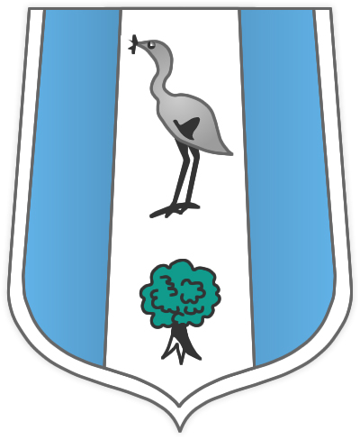

ATTRIBUTES | ESSENTIAL | DESIRABLE | HOW IDENTIFIED
Experience | Successful secondary teaching experience  Experience of delivering the curriculum at Key Stage 3 and 4 | Experience of intervention and monitoring student achievement  Experience in the role of Form Tutor  Experience of delivering the curriculum at KS5  Experience of writing Schemes of Work at KS3, KS4 or KS5 | Application forms  References  Interview
Qualifications | Degree or equivalent in Design Technology  Teaching qualification |  | Application Form  Interview
Training | Confidence in ICT/CAD/CAM as a tool for teaching and learning |  | Application forms  References  Interview
Practical and Intellectual Skills | Effective and successful classroom teacher  Strong planning and classroom management  Excellent communication skills  Excellent organisational skills |  | Form and letter of application  References  Interview
ATTRIBUTES | ESSENTIAL | DESIRABLE | HOW IDENTIFIED
Personality and Attitude | Team worker  Enthusiasm and inspiration  Commitment to hard work  Ability to work as part of a team  Willingness to contribute to department extra-curricular activities  Commitment to CPD |  | Form and letter of application  References  Interview

