 | JOB DESCRIPTION | 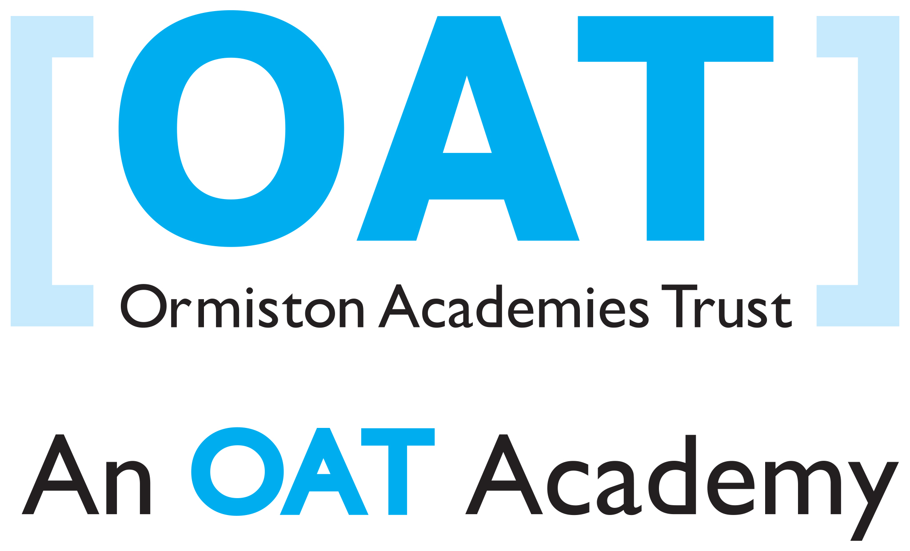

Subject Teacher – Design and Technology (Engineering / ICT)

MPR/UPR

Reporting to Head of Faculty

There are no line management responsibilities associated with this post.

Purpose of role:

- To facilitate high standards of learning and achievement for students by providing good quality teaching within a challenging and secure environment.

Key responsibilities:

- To ensure that high quality teaching and learning takes place in all allocated classes.
- To teach the subjects, classes and groups as allocated by the Head of Faculty and the Leadership Team.
- To teach the classes allocated, and provide a well-planned, challenging and purposeful learning environment for students.
- To set homework on a regular basis and mark student work promptly.
- To assess, monitor, record and report on student achievement in line with Academy and Faculty policy, including writing student reports and attending parents’ meetings.
- To share in the development of course outlines, specifications and schemes of work in the Faculty.
- To follow the course outlines, specifications and schemes of work agreed by the Faculty.
- To make effective use of student performance data, and student and staff target-setting; and provide relevant information to the Head of Faculty.
- To monitor and record student attendance in line with Academy policy, and support the Head of Faculty, Heads of Year and the Vice Principal in the maintenance of high levels of student attendance.
- To prepare for and attend Faculty meetings.
- To support and carry out policies and practices to promote positive student behaviour and achievement in your subject within the framework of the Academy Behaviour Policy.
- To participate in and support the Appraisal process.
- To be a form tutor and provide pastoral care for students.
- To undertake such other duties as reasonably required by the Principal.

This appointment is subject to the current conditions of employment contained in the Academy Teachers’ Pay & Conditions Document, the Education Act 1997, the required standards for Qualified Teacher Status, other current educational legislation and the academy’s articles of governance.

This job description may be amended at any time following discussion between the Principal and the member of staff, and will be reviewed annually.

Whilst every effort has been made to explain the main duties and responsibilities of the post, each individual task undertaken may not be identified. Employees are expected to comply with any reasonable request from a manager to undertake work of a similar level that is not specified in this job description.

Employees are expected to be courteous to colleagues and to provide a welcoming environment to visitors and telephone callers.

The academy will endeavour to make any necessary reasonable adjustments to the job and the working environment to enable access to employment opportunities for disabled job applicants or continued employment for any employee who develops a disabling condition.

All job descriptions are current at the date shown but following consultation with you may be changed by the Leadership Group to reflect or anticipate changes in the job and to meet the needs of the Academy.

