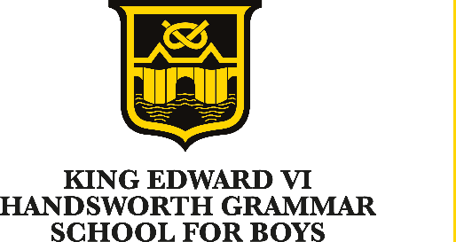

King Edward VI Handsworth Grammar School for Boys
Grove Lane, Handsworth, Birmingham, B21 9ET
Tel: 0121 554 2794
www.handsworth.bham.sch.uk

Teacher of Design & Technology
Salary: Main Scale / UPS

We wish to appoint for January 2023, a well-qualified, enthusiastic teacher of DT to teach at all key stages. The successful applicant will be joining a specialist team that has a consistently impressive track record of securing high achievement at GCSE.

We aim to consolidate recent developments and move the School on to higher achievements, while improving the facilities we provide for the students and staff. Recent developments include substantial work on the curriculum, teaching and learning and also on monitoring, evaluation and review. Considerable work has also been carried out in improving the School’s facilities with the recent completion of a £1.6 million Sixth Form Centre.

For further details and an application pack and/or to arrange a visit please contact Agnieszka Uzlis (HR Manager) on 0121 554 2794 ext.208 or email auzlis@handsworth.bham.sch.uk or visit the School website www.handsworth.bham.sch.uk

Closing date for applications is 9am, 7th November 2022
Interviews will be held on 11th November 2022

We place a priority on safeguarding children and are an equal opportunity employer

