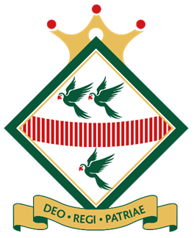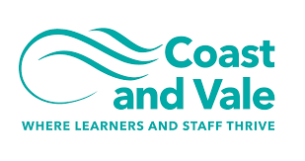

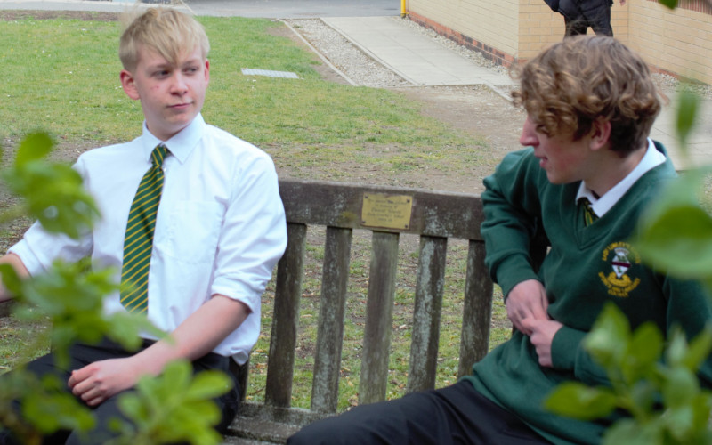

Teacher of Design Technology
Closing Date: Thursday 19th May 2022, 9am
Recruitment Information Pack
Lady Lumley’s School
Swainsea Lane, Pickering, North Yorkshire
YO18 8NG

Contents

Welcome from the Headteacher 3-4
Our Visions and Values 4
Our schools 6-7
Application process and how to apply 8
Job Description/Person Specification 8-12

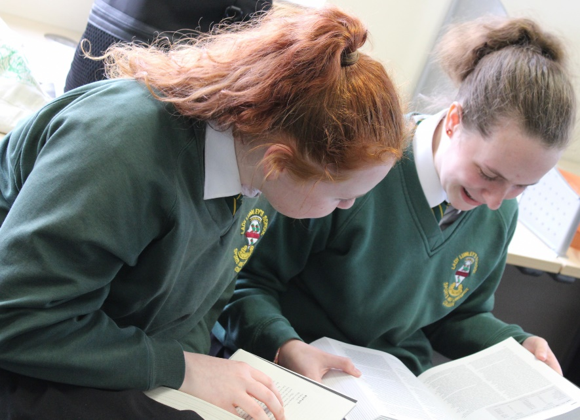

Dear Applicant

Thank you for taking an interest in joining our staff at Lady Lumley’s. I hope reading about our school gives you a sense of a driven community school, ambitious to do all we can to see staff and students thrive.
Lady Lumley’s school has a proud tradition and heritage of providing quality education. A trailblazer in the pursuit of education for all – welcoming the children of farming families and girls long before this was a requirement. Building on those foundations, Lady Lumley’s is a truly comprehensive school of 900 students drawing from the town of Pickering, surrounding villages and rurality as well as from Scarborough and all points in between.
‘Being our best’ signals Lady Lumley’s commitment to school improvement. We are ambitious for all our students and staff and strive to improve teaching and learning through constant evaluation and positivity. Our curriculum offer is broad and balanced, giving students a clear progression route through the school that builds the fundamental knowledge and understanding to allow them to specialise for Key Stage 4 then again at Key Stage 5. Lady Lumley’s curriculum gives all students the best chance of being successful at GCSE, A Level and Vocational Provision, ensuring our above national average outcomes open doors for life chances.

Our staff are integrated into thorough well-constructed CPD that looks to build strength in the classroom as well as modelling the pursuit of improvement. Ensuring all our strategic planning is built of evidential educational research is fundamental to ensuring we are investing staff time where it will reap rewards. A love of learning is a necessary mindset to thrive at Lady Lumley’s.

Lady Lumley’s is equally ambitious for our students to experience an enriched learning journey with a diverse offer of experiences. From trips abroad to Bordeaux, Saint Émillion and Dune de Pyla in France and Weiz in Austria our students also visit Belgium and France in Year 10 for the GCSE Battlefields Experience and Krakow and Auschwitz in Year 11, 12 and 13 for Religious Education. There are numerous theatre and music trips and visits taking in everything from Opera to Pantomime. The excellent sporting facilities are always fully booked with traditional team sports running alongside rock climbing and table tennis. Our Duke of Edinburgh scheme is ever popular and Lady Lumley’s students show leadership in this testing qualification right through to the Gold Award. With regular orienteering, canoeing and mountain biking our students also contribute hundreds of hours to volunteering and raise thousands of pounds for charity. Nurturing the growth of students through Enriching their experience enables Lady Lumley’s to prepare students to thrive locally or to move on to different cultures and experiences.

We value our pastoral staff and system as the cement that holds the school together. There are very high expectations of students conduct and a transparent and fair policy for rewards and consequences. All our students are supported through school with dedicated tutors and a Pastoral Officer with additional expertise available from the Pastoral Team and SLT. There are weekly ‘Life’ lessons to educate students with powerful knowledge to enable them to keep themselves safe and to have well placed confidence outside of school. Our staff and students deserve to feel safe and valued throughout their time at Lady Lumley’s.

Lady Lumley’s benefits from the knowledge and experience of Coast and Vale Trust as we are a unique school with a shared Trust vision. Through leadership development, collaboration and investment Lady Lumley’s is enabled to maintain its identity whilst belonging to a larger family of schools.

If you have read this and are committed to joining a school that is driven by ambition to be better, values a comprehensive community school and thrives on being part of a team, then we look forward to meeting you.

Yours sincerely

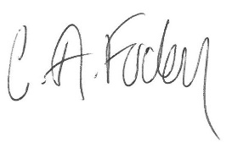
Clair Foden
Headteacher

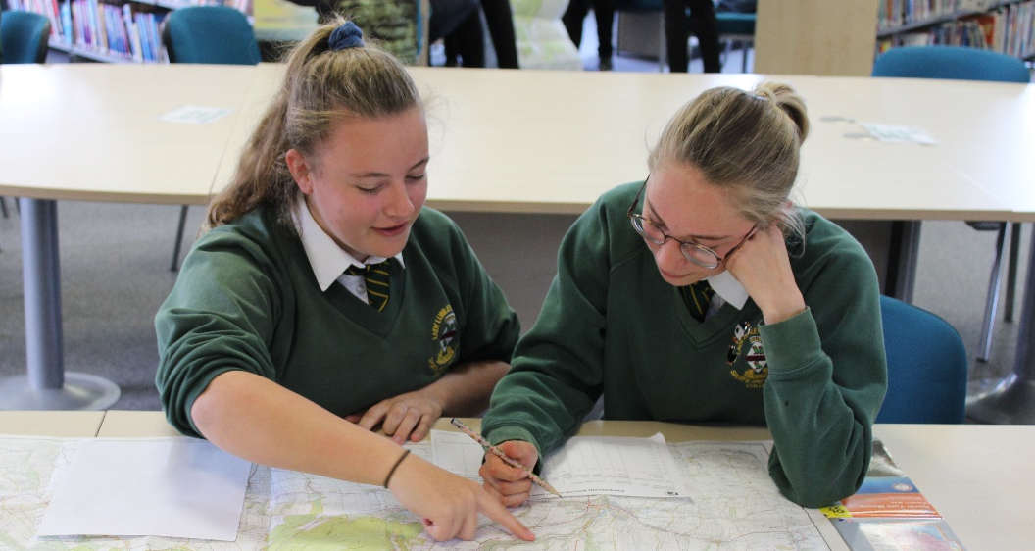

Visions and Values

Lady Lumley’s School is driven by the vision of ‘Being our best’. All staff and all students are asked to commit to our core values:

Learning
Lady Lumley’s core purpose is supporting our students and staff to make progress and continually adapt and develop to become lifelong learners.

Leading
Students and staff have regular opportunities to lead within and outside of the classroom to improve themselves and the community.

Ambition
We are relentlessly positive about improving and seeing all mistakes as ways to learn and improve and exceed our potential.

Progress
The journey through Lady Lumley’s for staff and students is a journey of improvement. Through striving to be our best we will face some setbacks but will build progress over time.

Our schools

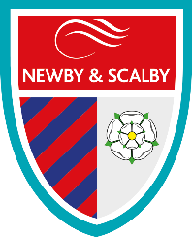
Newby and Scalby Primary School

We are one of the schools of choice in our community and we are within commutable distance of Whitby, Teeside, York and surrounding areas. Ofsted in 2018 judged us to be ‘good’ in all areas and as a school we are very much outward facing both in terms of teaching and learning and in constantly thinking about how we can improve.
Since our “good” Ofsted, we continue to build on our successes and we are a family and a team, where everyone is given the challenge and support to be the best they can possible be in a safe, welcoming and positive environment. Children and staff will work and play together developing skills so that we all become ambitious and reflective lifelong learners as well as being respectful and respected members of the community.
To learn more about us please visit us at:
Newby and Scalby Primary School - Home (coastandvale.academy)

Friarage Primary School
We are proud to serve the communities around the Castle Ward area of Scarborough as ‘Together we can’ make a real difference to the life chances of children and young people in Scarborough.

Children and staff will work and play together developing skills so that we all become ambitious and reflective lifelong learners as well as being respectful and respected members of the community.
We are committed to Restorative Practice Principles to nurture respect for all in our school community.

To learn more about us please visit us at: Friarage Community Primary School - Home (coastandvale.academy)

Scalby School
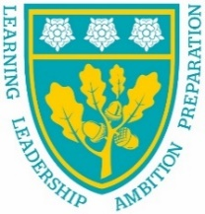
Scalby School is a successful and popular 11-16 community school and in recent years we have become the school of choice in our local community. We were judged ‘good’ by Ofsted in 2019 and in 2019 we celebrated sustained results. Our provisional P8 score has placed us in the top 20% of schools nationally. We are proud of our broad and balanced GCSE based curriculum.
To learn more about us please visit us at: Scalby School - Home (coastandvale.academy)

Lady Lumley’s School
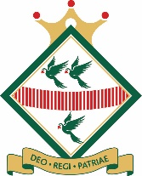
Lady Lumley’s School (11-18) in Pickering is on a transformational journey. We are a school that is popular with parents and is easily accessible across North Yorkshire, East Riding and Wolds and Vale. The communities we serve around the Pickering, Ryedale and wider Coastal area deserve and need our school to play a leading role in terms of teaching, learning, progress and outcomes.

In April 2020 we welcomed our new Headteacher Clair Foden who joined us at the same time we joined our Trust - Coast and Vale Learning Trust. Lady Lumley’s is on an ambitious journey of school improvement.

To learn more about us please visit us at Lady Lumley's School - Home (coastandvale.academy)

Useful Links
Lady Lumley's School - Home (coastandvale.academy)
Welcome to Pickering. Gateway to the North York Moors, Yorkshire

Scarborough University Technical College

Scarborough UTC is a growing University Technical College (year 9 to year 13) based in a new building, with fantastic technical facilities in the centre of Scarborough. As a University Technical College, we offer a high quality academic and technical education for our students through the specialisms of engineering, health and cyber security. Our unique approach provides students with an excellent range of opportunities including Combined Cadet Force (CCF Navy), strong links to our industrial partners, project-based learning and our flagship Career Development Programme for our Sixth Form students.

Our work with employers and universities ensure we are able to deliver an innovative blend of technical, practical and academic learning which ensures our students make good progress and go on to outstanding destinations.

Our staff are our greatest resource and we have invested in both our teaching and support staff teams which has ensured that educational standards have improved significantly. We have built a staff team of key support and teaching practitioners who are proud to work at our University Technical College.

To learn more about us please visit us at: https://www.scarboroughutc.co.

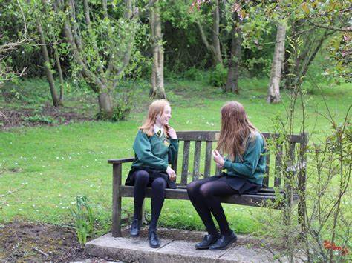

Application Process

ECT applicants are welcome to apply.

The closing date for all applications is Thursday 19th May 2022, 9am.

Interviews will be held shortly after the closing date.

Completed applications must be returned to Garry Morrison at garry.morrison@northyorks.gov.uk

If you think you’re the person for the job, please complete the enclosed application form and send to the email address above by the closing date.

An email will be sent to shortlisted candidates with details of the interview process. If you have not heard from us within a week of the closing date please assume your application has been unsuccessful.

Queries
Please contact Garry Morrison at garry.morrison@northyorks.gov.uk or on 07814935700

Job Description

JOB TITLE: Teacher of Design Technology

GRADE: MPS/UPS

RESPONSIBLE TO: Curriculum Leader for Food and Design Technology

JOB PURPOSE: Promote effective learning, appropriate student achievement and educational, social and personal progress of all pupils for whom the teacher is designated as being responsible, consistent with the aims of the school and the unique needs of each individual.

KEY RESPONSIBILITIES:

1. Develop and maintain an up-to-date knowledge and understanding of the areas of teaching and student support for which post-holder is responsible

2. Plan work to meet the learning needs of allocated pupils in a consistent and effective way

3. Use appropriate teaching and classroom management strategies to motivate pupils and enable each to progress appropriately

4. Monitor the progress of students for whom the postholder is responsible to set expectations and give constructive feedback

5. Maintain appropriate records to demonstrate progress made by students

- Participate fully in professional development activities to develop practice further, sharing the learning from these as appropriate

- Make an active contribution to the policies and aspirations of the school

8. Safeguarding and Promoting the Welfare of Students

Working with the Designated Child Protection Person the post holder will:
- Identify and record any child protection concerns
- Contribute information as required for Common Assessment or Multi-Agency meetings
- Act at all times in line with the school’s Child Protection procedures.

9. To Comply with the School Policy on Health and Safety

10. To fulfil all of the responsibilities and duties required by the school’s policies on Teaching and Learning.

11. To achieve any performance criteria or targets arising from the School’s
Performance Management arrangements

12. To fulfil all of the requirements and duties set out in the current Pay and Conditions Documents relating to the conditions of employment of teachers

Person Specification – Teacher of Design Technology
CRITERIA | ESSENTIAL | DESIRABLE | ASSESSMENT
Qualifications | - Qualified Teacher Status | - Degree  - National Governing Body Awards | - Application form
Experience | - Experience of Key Stage 3/4 Design Technology  - Experience of planning and delivering curriculum at relevant KS and/or subject(s) | - Experience of teaching in more than one school  - Experience of teaching Key Stage 5 | - Application form  - Interview
Knowledge | - A thorough knowledge and understanding of all relevant aspects of the National Curriculum in relation to the post  - Willingness to engage in CPD activities in relation to learning and teaching | - Knowledge of GCSE and A level exam specifications | - Application form
Personal Qualities | - Ability to relate to and build relationships with pupils, parents and other members of the school community  - Enthusiasm and commitment to the aims and objectives of the school  - Good communication skills  - Take a full and active role in the extra-curricular programme | - Willingness to participate fully in school life | - Interview  - Application form  - Reference

