13 June 2022

Dear Candidate

RE: Permanent, full-time Teacher of Design & Technology
with a specialism in Product Design & Graphics
Required ideally for a September 2022 start, but a later start will be considered, up until January 2023, for a suitable candidate.

Thank you for your recent enquiry in respect of the above vacancy.

Enclosed/attached is an application form and recruitment pack setting out the duties and responsibilities of the post, which I hope you will find helpful. Please note to be considered for this post you must fully complete the application form and Recruitment and Monitoring form and return them to me by noon, Monday 4th July 2022.

In addition, write a letter in support of your application which includes a brief description of your educational philosophy and your approach to teaching Product Design & Graphics within a 13-18 High School. Your letter should be no more than two sides of A4.

If you require any further clarification or information relating to this post please do not hesitate to contact my P.A., Mrs M Barnes on 01785 337400.

Yours sincerely
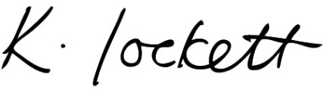

Ms K Lockett
Headteacher

