JOB VACANCY

**Teacher of Music and Drama**

**An exciting and rewarding opportunity has arisen for an enthusiastic and self-motivated individual to teach Drama and Music across the age and ability range within a forward thinking and innovative school environment**

**Role:** Teacher of Music and Drama

**Reports to:** Head of Drama

**Hours:** Full-time, 1.0 FTE permanent

**Salary:** MPS/UPS

**Start Date:** 1st September 2024

**Experience**: Suitable for ECTs and experienced teachers

**ABOUT THE ROLE**

You will teach across the key stages and have knowledge of the GCSE Drama curriculum, working with external partners, such as LIPA, where necessary to extend the curriculum.

You will also develop a program of performance events and extra-curricular activities, demonstrating your sound subject knowledge and ability to work within an established team.

The school is driven by values of positivity, ambition, resilience, and thoughtfulness and building our students’ character is a fundamental priority in securing their future success. The Drama provision will play a critical role in embedding these values and developing our young people

The main priority of the school is to secure the highest quality learning through the provision of high quality teaching in the classroom. Subject to the relevant legislation and regulations, all teachers are required to perform general professional duties as reasonably assigned by the Headteacher from time to time and in a manner consistent with the school’s policies. This is a key post in an ambitious and well supported department.

**ABOUT YOU**

We are looking for a passionate individual with a desire to transform lives, helping our students to make connections, embrace diversity, find their voice, and be extraordinary.

You must be an enthusiastic and adaptable individual with high professional standards and excellent communication skills.

The successful candidate will have QTS, with a first or second class degree in a relevant area. It is essential that you are able to develop genuine, empathetic relationships with young people, with the ability to communicate effectively in a variety of situations.

You will have the ability to work in line with the vision of the School and Trust, showing energy, resilience, and enthusiasm whilst working under pressure.

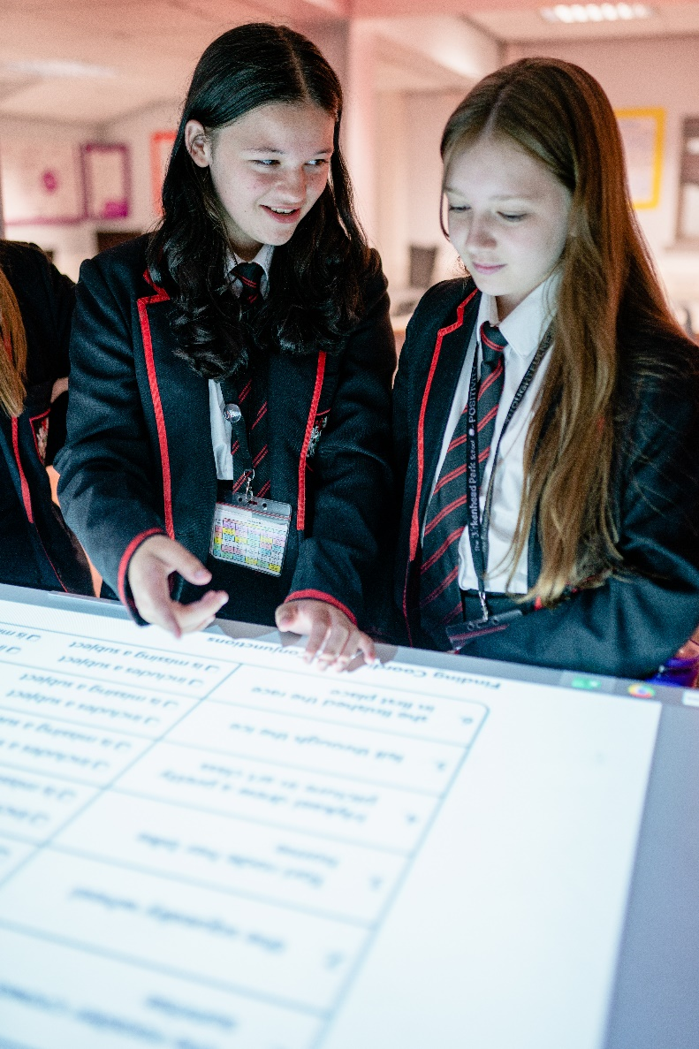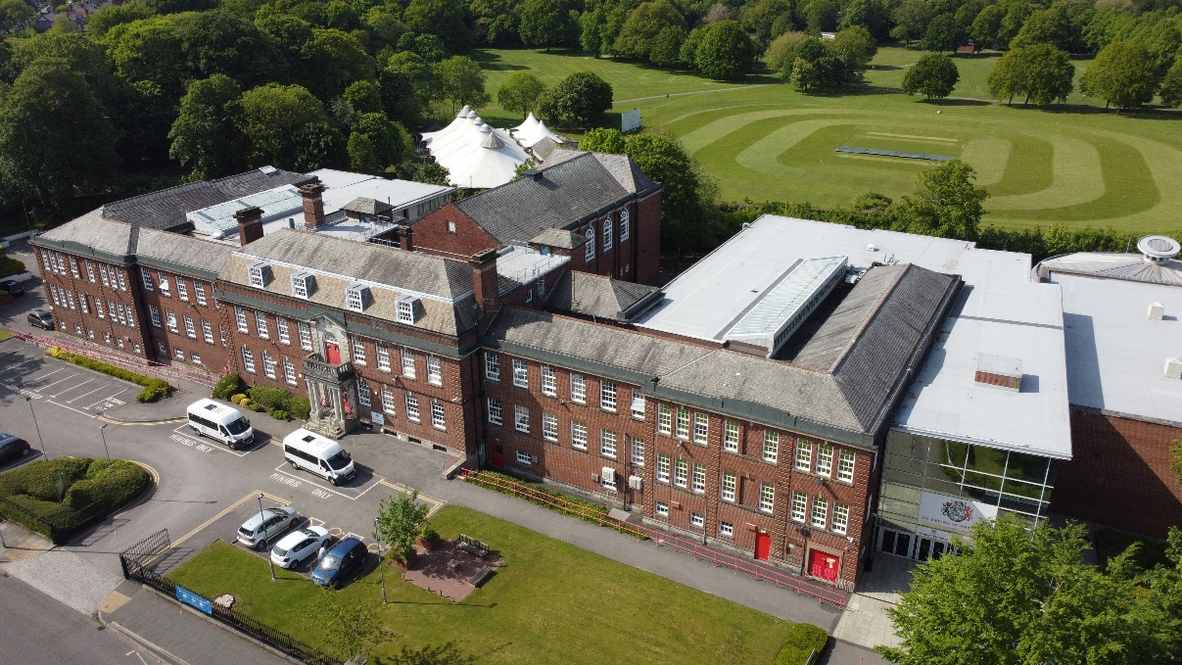

**APPLICATION DEADLINE:** Midday Wednesday 5th June 2024

In

**HOW TO APPLY**

1. **Apply by completing the Teachers Application form which can be found at:** [www.birkenheadparkschool.com/job-vacancies](http://www.birkenheadparkschool.com/job-vacancies)
2. **Completed applications should be returned to the HR Department by email to:** recruitment@birkenheadparkschool.com

**The Birkenhead Park School**

Park Road South, Birkenhead

Wirral, CH43 4UY

0151 652 1574

www.bikenheadparkschool.com

**ABOUT US**

The School is part of the BePART Educational Trust which includes Birkenhead Sixth Form College, an Ofsted Outstanding post-16 specialist. The School and the College work collaboratively to share and develop educational best practice and create an inspiring culture with opportunities for career development.

The Birkenhead Park School aims to achieve **“Ambition and Excellence for All”** and we are committed to providing the best possible education for every student. The School is driven by the values of **Positivity**, **Ambition**, **Resilience**, and **Thoughtfulness**.

In 2022 The Birkenhead Park School began a transformation: a new leadership team, a new approach and a renewed focus on excellence.

In November 2023, Ofsted recognised the huge progress that we’ve made and said “**the school is on a rapid journey of improvement”**.

Behaviour has improved significantly with the introduction of ‘Learning Habits’ and there has been an improvement in student attendance of seven percentage points, the best improvement in the Wirral.

Underpinning every element of what we do is our staff, and a staff survey this year showed that:

**98%** of staff are proud to work at the school

**93%** of staff believe the school has improved over the last year

The Birkenhead Park School is committed to safeguarding and promoting the welfare of children. Successful applicants will be subject to an enhanced DBS check. Applications will only be considered when submitted on a fully completed School application form. All applicants will be considered on the basis of suitability for the post regardless of age, sex, race or disability.