**Recruitment During Coronavirus Outbreak**

Despite current challenging circumstances, we continue to plan to ensure we have even more excellent colleagues working with us when normal school life returns.

Your wellbeing, and that of all colleagues is our primary concern. Please be reassured that our recruitment process will be conducted in a way that allows you to stay at home. Should you decide to apply, you will receive a phone call from a senior leader to give you the opportunity to ask questions about the role and our school. If you are shortlisted, then interviews will be conducted using technological solutions.

**September 2020**

# Welcome to Beckfoot Trust

Thank you for taking an interest in Beckfoot Trust and its schools, we really appreciate it. We are working to create remarkable schools where no child is left behind. We need great people to join us in that endeavour.

We established the Trust in 2013 with two schools and have steadily built up to ten, with four secondary, four primary and two special schools. We created the Trust because we believe that schools are stronger by working together. To join the Beckfoot Trust a school has to be located in Bradford, be genuinely comprehensive in character and critically, to believe in the power of collaborative practice to drive improvement.

We educate over 7,300 learners aged 2 to 19 and have 1100 staff. All of our schools are improving at pace and we have seen some remarkable transformations. There is huge pride across our community in what we stand for and are seeking to achieve.

Please take the time to read our Strategic Vision document: ‘Creating Remarkable Schools’. It sets out very simply our core purpose, our key features and our ambitions for young people and our staff. ‘No child left behind’ is our mantra. Equally, please read our ‘Workload and Well Being 10 pledges’. Everything we do is shaped by these two documents.

We use formal collaborative networks and extensive professional development programmes to share best ideas, identify talent and develop it. We work with external partners to accelerate our development.

We believe that Beckfoot Trust is a great place to work. We offer competitive salaries, dedicated INSET days for planning, bespoke professional development including career stage leadership development programmes and much more. In particular, our Early Years Career Strategy ensures that teachers new to the profession are well supported as they transition from trainees to accomplished teachers.

Please read more about us across our website and contact us at BeckfootTrust@beckfoot.org if you would like to visit us and talk about our work in more detail. It would be lovely to see you.

**David Horn**

**CEO Beckfoot Trust**

January 2020

# Beckfoot Oakbank

**Thank you for your interest in our school and the work we are doing to transform life chances for young people in Keighley.**

At Beckfoot Oakbank we are incredibly proud of our students and their desire to be involved in shaping the way the school moves forward. 2019 saw Beckfoot Oakbank host the first Trust wide student leadership conference – a great moment for our student leaders

Some of the other highlights last year included:

* Three great celebration events where students were recognised for academic attainment, attitude to learning, community contributions, progress and sporting successes.
* Our school show – High School musical!
* Enrichment week saw our students engage in a raft of activities that added to their educational experience ranging from arts and crafts, a tour of Yorkshire to residential trips in Europe.
* In enrichment week the year 10 students engaged in a range of activities that would help prepare them for their next steps.
* We also had a range of winners in a prestigious engineering competition.
* Sporting success were many as are the opportunities to be involved in a range of sports and activities.

The summer results saw all of our Post 16 students be successful in their progression to higher education and at GCSE we saw a real increase in the number of top grades for individual students. We are not complacent and are working hard to develop our curriculum and improve outcomes for all our learners. Our students are polite and respectful towards their peers, staff and visitors as acknowledged by the Ofsted inspection team in May.

As a school we know we are on a journey of improvement and our aim is to be a truly great school. We are keen to involve our families and our local community in this journey in order that we ensure that our students love learning, celebrate diversity and are inspired to be self-confident open minded, decisive young adults with the skills and experience to succeed in life.

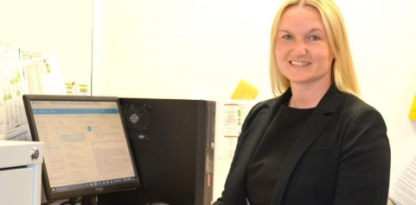



**Tina Smith**

**Headteacher**

# Schools in the Beckfoot Trust

Please see below a brief introduction to all our schools. You will also be able to see more about them by visiting their websites.

**Our Primary Schools:**

## Beckfoot Allerton Primary and Nursery School

Beckfoot Allerton Primary and Nursery is a two form entry primary school. It joined the Trust in September 2016. It was judged as Requires Improvement in 2018 following a number of years of poor results. Outcomes have improved dramatically in 2019 across all key stages. The school is rapidly re-establishing itself as a fantastic school.

## Beckfoot Heaton Primary and Nursery School

Beckfoot Heaton Primary and Nursery is a three form entry primary school. It joined the Trust in September 2016. The school was judged by Ofsted as Requiring Improvement prior to joining the Trust and in December 2019 it was judged as a Good school, a remarkable achievement. The school has developed a reputation locally and nationally for its innovative practice.

## Beckfoot Priestthorpe Primary School

Beckfoot Priestthorpe is a one form entry primary school. It joined the Trust in September 2017. The school was judged by Ofsted as Good prior to joining the Trust. It is a rapidly improving school with a clear strategy to progress from good to great.

## Beckfoot Nessfield Primary School

Beckfoot Nessfield joined the Trust in September 2018 having been through a very difficult period. A change in leadership of the school in 2018 is steadily transforming the culture and the progress of the school.

## Beckfoot Phoenix Primary Special School

Beckfoot Phoenix is a school for students with special educational needs aged 2 – 11 years old. It joined the Trust in September 2017. The school was judged by Ofsted as Good prior to joining the Trust. This is a rapidly improving school with a clear strategy to progress from good to great.

**Our Secondary Schools:**

## Beckfoot School

Beckfoot School formed the Trust in 2013. It is an 11-18 secondary school with 1687 pupils. The school secured an Outstanding Ofsted judgement in 2014. It established a Teaching School in 2015 and secured a ‘World Class Quality mark’ in 2016. It continues to be a very successful school.

## Beckfoot Oakbank School

Beckfoot Oakbank is an 11 -18 secondary school with 1564 pupils. The school joined the Trust in September 2016. It was judged by Ofsted as Requires Improvement in 2019. Under fresh leadership since June 2018, the school has identified a clear strategy to accelerate achievement rapidly. The school moved into new purpose-built accommodation in April 2018

## Beckfoot Thornton School

Beckfoot Thornton is an 11-18 secondary school with 1399 pupils. The school joined the Trust in September 2016. The school was judged by Ofsted as Requires Improvement prior to joining the Trust and this judgement was achieved again in 2019. A change in leadership of the school in April 2017 has transformed its progress demonstrated by a significant improvement in GCSE outcomes in 2019.

## Beckfoot Upper Heaton School

Beckfoot Upper Heaton is an 11-16 secondary school with 595 pupils. The school joined the Trust in September 2015 having been through a very difficult period. The school was judged by Ofsted to be Good when inspected in 2018, a remarkable transformation in a short period of time. The school is now over-subscribed in the lower years and achieving outcomes that are amongst the highest in the country for progress made. The school moved into a new purpose-built accommodation in January 2017.

## Hazelbeck Special School

Hazelbeck is a school for students with special educational needs aged 11 – 19. It was the first school to join the Trust in 2013. Within 18 months the school had moved from one requiring improvement to outstanding in 2015 in every category. Following a recent Ofsted inspection (May 2019), Hazelbeck school continues to be outstanding. It is co-located with Beckfoot School. It is a remarkable school.

# Working at Beckfoot Trust

Working at Beckfoot Trust has many benefits, we are an employer that invests in staff wellbeing and welfare, professional development and conditions of service.

## Conditions of Service

Beckfoot Trust employs staff on nationally recognised terms and conditions and then adds more to ensure its staff feel cared for at work and in their home and family lives. We’ve tried to think of everything an employee might want to know about working at Beckfoot Trust and documented it in or Work and Families policy that you can read on the Trust website.

## Staff Wellbeing

We know that working in schools is a challenging and worthwhile profession and you will make a difference to the lives of young people. We also know that sometimes everyone needs a little support, that’s why we publish our workload pledges and that’s why there will always be someone to listen to any concerns you may have.

## Professional Development

Professional development is a right when you join Beckfoot Trust. We expect people to want to learn new things and expand their horizons for every one’s benefit. That’s why Beckfoot Trust has a reputation for great continuing professional development and you can see the offer explained in our Trust CPD offer documentation found on the Trust website.

# Working and living in Bradford

## Five Reasons to Teach in Bradford from BradfordTeaching.org

<https://www.bradfordteaching.org/>

1. Demand for good quality teachers is high. We are the youngest city in England – almost a third of people living in Bradford are under 20 – so education is key to our future.
2. You’ll get experience of working with different people and cultures in one of the most diverse cities in the UK. About half of our school students are from black, Asian or minority ethnic communities.
3. You’ll find school leaders on a mission to deliver the best education possible to create life chances for young people. We have one of the first research schools in the country and strong multi-academy trusts, offering exciting career opportunities.
4. You will change lives here. About a quarter of our children are classified as living in poverty. If you believe that opportunity should never be limited by a child’s family income, then we need your passion and your skills in Bradford.
5. We’re a growing, ambitious city with an entrepreneurial spirit and a trend of educational improvement. Be part of our success story.

## A Wonderful City to Live in

<https://www.visitbradford.com/visitor-information.aspx>

An award winning, cultural destination and one of the youngest, most vibrant places in the country. Combine a UNESCO City of Film and World Heritage Site with wild and beautiful moorlands, throw in world class artists such as David Hockney, and literary greats, The Brontës, couple that with a vibrant city, packed with heritage and fun things to do, and you have Bradford! With attractions such as Brontë Country, Keighley and Worth Valley Railway, the Cow and Calf rocks, Ilkley Lido, Salts Mill, the National Science and Media Museum, and the Alhambra Theatre, all just a short train journey apart; it’s no wonder Bradford has been awarded the title ‘Emerging Destination 2018’ by the Luxury Travel Guide.

It is a cultural city with many attractions and an impressive history, which is reflected in the striking architecture found throughout. Take in the high profile exhibitions and interactive galleries at the National Science and Media Museum, which overlooks the multi award winning City Park, a beautiful water feature and an arena for a spectacular events programme throughout the year. Bradford city centre is home to the Alhambra Theatre and newly reopened St George’s Hall. Both over one hundred years old, they offer a complementary mix of comedy and west end shows. Proud to have been one of the richest cities in the country due to its international recognition for wool, the Wool Exchange, built in the 19th Century, still shows the wealth and importance wool brought to Bradford through its architecture. Nowhere is this more evident than in Little Germany, a unique collection of 19th Century buildings, 55 of which are listed.

## Travel and Transport Links to get you Around

Getting to Bradford district couldn’t be easier whether you choose to drive or use public transport. Once here you can travel around the district with a great range of public transport available connecting you to all the must see places.

# How we Create Remarkable Schools

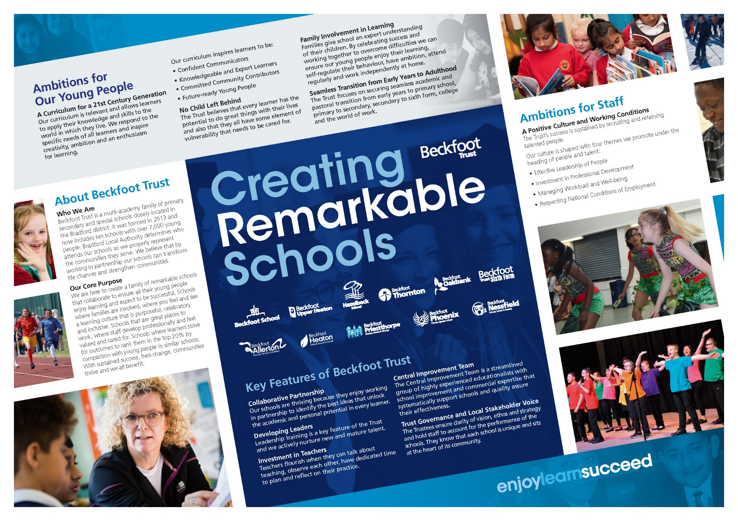

# How we work and look after each other

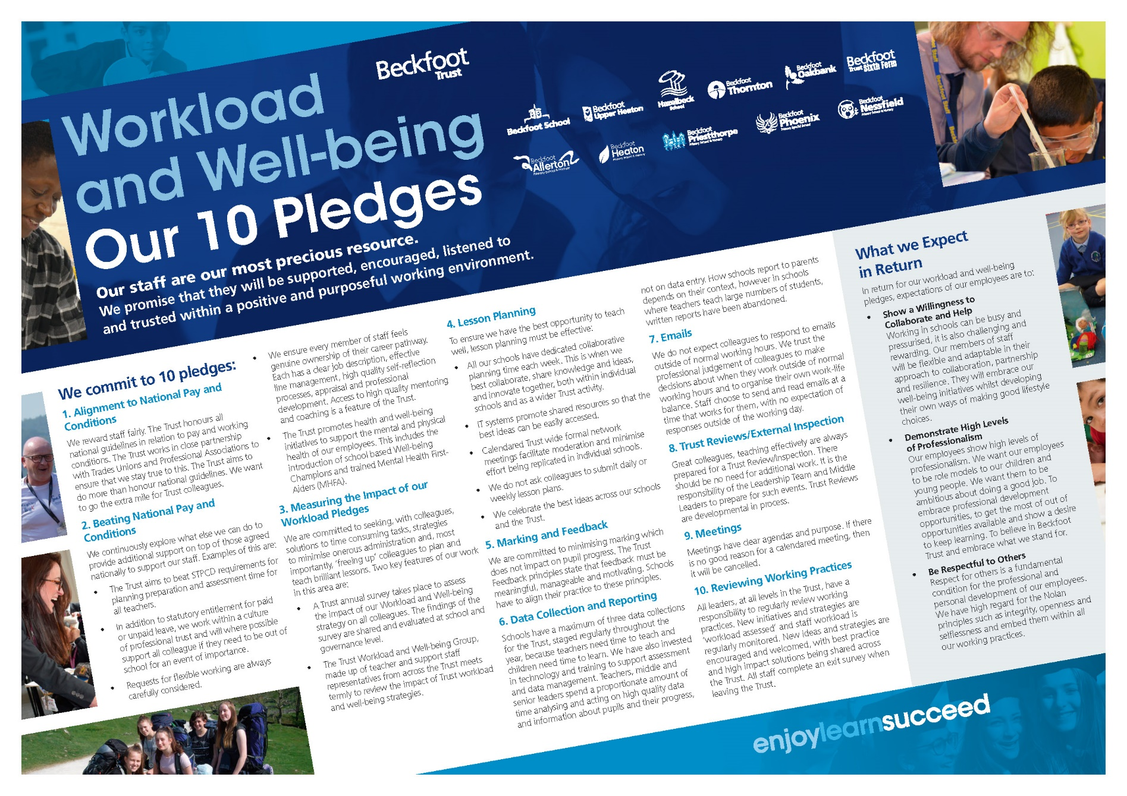

# Application Process

Please visit our website http://www.beckfoottrust.org/ to view and apply for our current vacancies.

## Application Form (Online Process)

Please fully complete the online application form providing full details of your education and continuous employment history, including any unpaid or voluntary work. Where there are gaps in your employment history, please explain why (e.g. gap year, career break).

Use the job description and person specification as a guide and give specific examples, where possible, to demonstrate how well your knowledge, skills and experience match the requirements of this post.

We require details of three referees, one of which must be your current or most recent employer. Please provide their names, email addresses and daytime contact numbers. It is our policy to take up references for shortlisted candidates prior to interview where possible.

If you have a disability that prevents you from completing the application form, please contact the school to discuss.

Please check the closing date and allow time to submit your application. If you are called for interview, you will be asked to sign a paper copy of your application to ensure the declaration requirements are complete.

## Important Information

Applications will be evaluated against the requirements of the post, with those candidates that best fit the requirements being shortlisted for an interview. Everyone who applies for one of our vacancies will be notified of the outcome of their application, whether shortlisted for interview or not. Successful shortlisted candidates will receive details of the interview programme after the closing date.

We strongly encourage you to browse our websites as it will give you a good idea of what ours school are like.

Please note we can only consider applications from people who the right to work in the UK.

## Safeguarding Children

Beckfoot Trust makes reasonable decisions about the suitability of prospective employees based on checks and evidence including: criminal record checks (DBS checks), barred list checks and prohibition checks, together with references and interview information.