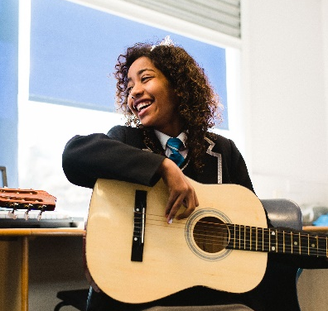

BIRCHES HEAD ACADEMY
Birches Head Road
Stoke-on-Trent
Staffordshire
ST2 8DD
Tel: 01782 233595
Web: www.bircheshead.org.uk

Principal: Ms K Dixon

TEACHER OF DRAMA

Required for September 2022
Permanent
MPR / UPR

Birches Head Academy is a part of the Frank Field Education Trust and we work collaboratively with others in our FFET family, allowing our students and staff many opportunities to develop. This is embodied in the FFET vision: ‘Social Justice through Excellence in Education’ and in the Academy motto: ‘Aspire to be More’.

Birches Head Academy wish to appoint a suitably qualified Teacher of Drama who will work as part of the Performing Arts department, the ability to teach Dance would be desirable but not essential. With your knowledge and passion for the subject you will develop a great curriculum experience in line with the whole Academy ethos, enabling all students to make exceptional progress. The successful applicant will be passionate about academic excellence, collaboration and delivering high quality teaching for every student.
The successful candidate should be an outstanding practitioner, with an enthusiasm for teaching both Key Stage 3 and Key Stage 4. You should be an innovative teacher who is passionate about teaching and learning, research and practice.

Applications from both experienced teachers and ECTs (NQTs) are warmly invited.

We welcome applications from all parts of our community as we aspire to have a staff body that matches the social and cultural diversity of our student intake.

Closing date for applications: Wednesday 18th May 2022, 9:30am
Interviews to take place week commencing Monday 23rd May 2022

For further information, including the recruitment pack and application form, please visit our website at: www.bircheshead.org.uk. Alternatively, you can contact the school for an information pack.

Completed application forms should be emailed to jbracegirdle@bircheshead.org.uk

Birches Head Academy requires an application form to be completed in order to be considered for this role. Please note that CVs alone will not be accepted.

Birches Head Academy is committed to safeguarding and promoting the welfare of children and young people. Applicants will, therefore, be subject to stringent vetting and induction processes, including an enhanced DBS disclosure. References will be requested prior to interview.

All applicants will be considered on the basis of suitability for the post regardless of age, sex, race or disability.

Social Justice through Excellence in Education

