job description
Teacher of Drama
reports to: Head of Drama
hours: Part time 0.25 higher fraction available to a candidate who can offer GCSE, or A level English
salary: T1-T9 £30,500- £47,133 (FTE)
start date: 20th August 2024
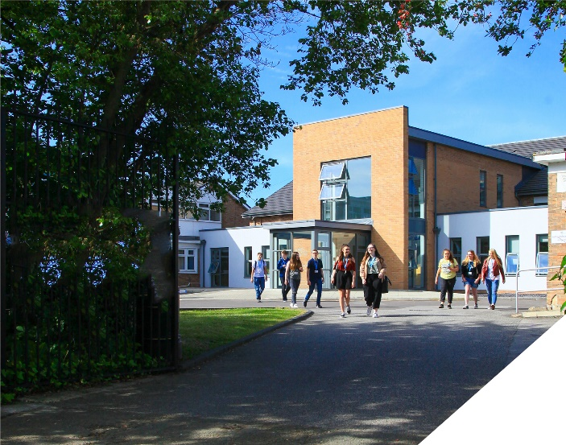
This is an exciting opportunity to teach Drama at a leading Sixth Form College.
about the role.
We seek to appoint a highly effective and outstanding drama teacher. A-level Drama and Theatre is a well-established course at the College. Approximately 50 students study A-level Drama at the College and we are confident this will continue to grow. The course follows the AQA specification.
Initially the role will be to teach one group of A-level Drama, however this curriculum area is expanding and there is a likelihood that more teaching in this area will become available. In September 2024, we are introducing BTEC Performing Arts to run alongside our A-levels in Drama and Dance and enhance the performance curriculum we offer. We also offer BTEC Extended Certificate in Digital Music that support the performance culture in the College.
The subject area is managed by a dedicated and hard working Head of Subject who is current examiner for AQA and also has additional responsibility for College performances. College performances has been a highlight of the College year with sell out audiences most recently for ‘Grease’ and ‘Mash Up of the Musicals’. We seek to appoint an individual who will support these events.
This is an exciting role for someone who is enthusiastic and passionate about drama. The drama role is 0.25, however this fraction can be increased if you are able to offer an additional subject such as GCSE or A-level English.
about the College.
You will be joining a highly successful, innovative and nationally recognised sixth form College. The College has received numerous awards for its innovation, social mobility and student experience. The most recent being in November 2023 where the College won ‘Most inspiring Sixth Form’ at the Educate North Awards.

In response to the pandemic and disruption to the learning of students the College introduced a new timetable in 2021/2022 to combat the deficits that students have. This timetable has huge benefits to both students and teachers. Students receive an additional 60 minutes teacher each week, meaning that students will receive 5.5 hours of teaching in each of their subjects each week. Whilst student teaching time has increased, the new timetable has reduced the overall teaching time for teachers each week. Full time teachers will teach a maximum of 4 classes, 4 times a week and teachers have their own groups. This is designed to give teachers the time to plan, assess and monitor their students. The timetable change has been a major success.

The College currently has a 16 to 19-year-old student population of 1500. Demand for places for places at the College is very high and as a result the College has recently expanded with the opening of a 1.7m new state of the art teaching facility in September 2021. A further brand new 3 storey classroom block was opened in April 2023 as part of the College’s expansion project.

The College is committed to its core values of Positivity, Ambition, Resilience and Thoughtfulness, and these values shape everything we do. Our ethos is centred on the scientific evidence that tells us that everyone can achieve success through purposeful hard work as opposed to the talent myth, and this enables learners to make rapid progress unshackled by any limits previously placed upon them.

person specification.
Qualifications | essential | desirable
Degree in Drama or equivalent qualification | 
Qualified Teacher Status | 
Experience
Experience of teaching A-level Drama | 
Experience of delivering AQA Drama |  | 
Experience of working in a demanding environment where high levels of organisation are required | 
Knowledge / Skills / Abilities
Ability to teach up to A-level | 
Up to date knowledge & understanding of educational developments relating to the curriculum area | 
Ability to work flexibly as part of a team | 
Ability to form & maintain appropriate relationships & personal boundaries with young people | 
Ability to respond flexibly & creatively to new challenges & opportunities | 
Ability to prioritise & meet deadlines | 
Ability to use Information Technology effectively | 
Excellent communication, interpersonal & organisational skills | 
To demonstrate a commitment to
The Colleges values of Positivity, Ambition, Resilience & Thoughtfulness | 
Personal development and training | 
Safeguarding & promoting the welfare of students | 
Equality & diversity | 
how to apply.
If you are ambitious and determined to make a meaningful difference in one of the country’s leading sixth form Colleges then we would be thrilled to have you join our team.

There are 3 parts to your application please ensure you submit all three to be considered:-

- Please complete the Teacher Application Form which is available on the College website: www.bsfc.ac.uk
- Please submit a summary of the last 3 years of examination results (if appropriate – if you are an NQT please skip this part of the application procedure)
- On a separate document, answer the following specific questions (each question should be answered separately with each answer being no more than 150 words):

- Aside from your stated qualifications, please outline what you believe makes you academically suited to the position applied for.
- The College does not currently operate a gifted and talented programme. What is your view on this approach?
- Please identify one or two skills or techniques you have used in the classroom to drive learning.
- Select one of the College values and describe ways you demonstrate this in your day to day work.
- You should have provided an accompanying sheet summarising the results you have achieved over the last three years. Is there any context or background you would like to give to these?

Please email these to: hrdept@bsfc.ac.uk

closing date: 12 noon on Wednesday April 24th 2024

Application Form can be downloaded from the College website: www.bsfc.ac.uk

General Information
Birkenhead Sixth Form College has a commitment to safeguarding and promoting the welfare of students and expects all staff and volunteers to share this commitment. If you are invited for interview, your suitability to work with children will be explored as well as your suitability for the post.
All posts are subject to Enhanced Disclosure Clearance through the Disclosure & Barring Service.
The College is an Equal Opportunities employer and all members of the College have a personal responsibility to implement the policy, to carry out their responsibilities in accordance with it and to maintain an equality of opportunity for all.
The Governors and staff of the College take their duties under the Disability Discrimination Act (as amended by the Special Educational Needs Act 2001) very seriously. They will ensure that all reasonable adjustments are made to ensure that disabled people are treated fairly and that they are not placed at any substantial disadvantage. The College is committed to interview all applicants with a disability who meet the minimum criteria for the post and to consider them on their abilities.

Reference Checking

On the application form, you are asked to provide details of two employment referees (preferably your line manager from your current and previous or most recent employer/s), who can comment on your suitability for the post. References from relatives or individuals writing in the capacity of friends will not be accepted.

The College will seek references on short-listed applicants before interview, and will approach previous employers for information to verify suitability for the post, dates of employment, particular experience or qualifications, attendance / punctuality history and details of any disciplinary offences.

In addition, if you are currently working with children or young people, on either a paid or voluntary basis, your current employer will be asked about your suitability to work with children and any disciplinary offences relating to children or young people. This will include any offences for which the penalty is time expired (that is where a warning could no longer be taken into account in any new disciplinary hearing for example) and whether you have been the subject of any child protection concerns, and if so, the outcome of any enquiry or disciplinary procedures. If you are not currently working with children but have done so in the past, that previous employer will be asked about those issues. Please note providing false information is an offence and could result in your application being rejected, or dismissal without notice if you have been appointed and possible referral to the police.

