Wood Green School

Candidate Information Pack
Teacher of Drama, maternity cover

Details of the Post
Job Title: | Teacher of Drama
Start date: | September or October 2022
Status of post: | Full or part time, maternity cover
Closing date for application: | 20th June 2022, applications will be considered on receipt and  may result in this advert closing early
Interview Date:

WELCOME – Headteacher
Dear Prospective Candidate,
Thank you for your interest in our post. Wood Green School is an oversubscribed 11-18 Academy school serving the town of Witney and surrounding villages.
This is a very exciting time for Wood Green. We have a clear vision of a Wood Green student, and we are developing our Baccalaureate that encourages and celebrates everything that a school should develop in young people: engagement in all subjects, learning skills such as research and communication and personal skills such as thoughtfulness for others. We believe strongly in a culture of mutual respect and strong relationships, demonstrated in our Behaviour Policy built on restorative principles and our Diversity, Equality and Inclusion Policy. Everything is underpinned by our LEARNWell values. Our strong reputation and results improving year-on-year have led to a rapid rise in student applications.
Wood Green School is part of the Acer Multi-Academy Trust. The Acer Trust consists of seven schools: Wood Green School, Chalgrove Primary School, Stadhampton Primary School, Botley Primary School, Icknield Community College, Watlington Primary School and Matthew Arnold School.
All seven schools have strong track records of high performance or rapid improvement and share similar values. This partnership adds real benefit to Wood Green School, especially opportunities for staff development. The key values of the Acer Trust are Trust, Collaboration and Opportunity.
Wood Green has developed several innovative external partnerships, for example with Nuffield Health for Wellbeing, Oxford University for teacher development and student access to the university and with the National Baccalaureate Trust. These all bring great opportunities for students, and also for staff development. I believe that investing in staff is crucial to achieving our mission. At Wood Green, we provide a comprehensive programme of staff development, sharing best practice in-school and giving staff the opportunity to work with other schools through our local and national partnerships. All teaching staff have the opportunity to undertake the OLEVI Teacher Programmes, to carry out action research with Oxford University and to work with coaches in school. Our work with Nuffield Health considers staff as well as student wellbeing.
Thank you again for your interest in this post and I hope to receive your application in the near future.
Yours sincerely
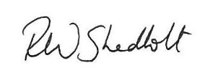
Rob Shadbolt
Headteacher

Our School Philosophy
“Head, Hands and Heart”

Our School Philosophy can best be summarised by the phrase ‘Head, Hands and Heart’. Head, Hands and Heart represents the whole child:
- The Head represents learning
- The Hands represent creativity and practical skills
- The Heart represents respect and nurture for others and ourselves.

Mission, Vision and Values

Mission Statement
“Our mission is to develop exceptional, well-qualified and well-rounded young people who make a positive contribution to our school, our community and the world.”

Our Vision Statements:
Wood Green students
- Are inquisitive, independent and creative thinkers who communicate powerfully, respond well to feedback and who work well by themselves and with others
- Believe they can improve, are proud to try hard and to be successful and are not scared to fail
- Have integrity and honesty and take responsibility for themselves
- Manage themselves well and develop good relationships with all students and staff
- Take care of others, their community and their environment and respect all others
- Know how to keep themselves healthy and safe
- Achieve highly and leave prepared for their next exciting challenge

Our Values
Our LEARNWell values reflect our commitment to developing the whole person and underpin everything we do:

LEARNING EFFORT ASPIRATION RESPECT NURTURE WELLBEING

Department Information
The Drama Department is a dynamic, creative and forward-thinking department which is keen to develop students’ knowledge and understanding of Drama and Theatre. The Department obtains very impressive results, at GCSE and A Level, and would like to appoint a teacher who will be able to work with the team and contribute to its further development. We run regular trips to local and London theatres. Recent trips have included ‘The Woman in Black’ and ‘Dead Dog in the Suitcase’. We offer a rich programme of extra-curricular drama clubs which take the form of a musical or a play or a showcase evening.
We encourage leadership skills in drama and our older students run workshops and activities for younger students. We also organise workshops and trips for KS3 students to harness a love of the subject at an early age.

Staffing
The Department of Drama consists of three specialist teachers and a Drama Technician. We work collaboratively across all Key Stages and opportunities for career development and progression are made available whenever possible. The Department teaches in a set of two practice rooms and a Drama Studio, all housed in the same building, along with a department office. The Department is well resourced.

Ethos
The Department is committed to developing effective learners who are confident performers, collaborative team players, who can both give and receive feedback and who can develop their creative talents. We directly challenge the students to examine attitudes, thoughts and feelings of others in a safe, thought-provoking environment.
The department works with high expectations to develop the confidence and individuality of students and enable them to present and perform high quality performance work in a happy, supportive and motivated environment.
It is the Department's aim that every student be able to express themselves for the world of work when they leave the school. We aim for our students to be able to use intonation, gesture and body language in order to project themselves positively in the outside world.

Curriculum
Alongside the classroom curriculum, the Department enjoys theatre trips for all Key Stages to inspire students in their own performance work. Last year our trips included seeing An Inspector Calls and Blood Brothers in Cheltenham, Equus in London and Peter Pan in Oxford. We have also produced successful whole-school musicals and plays. Most recently this has included The Royal Shakespeare Production of Beauty and the Beast (2019) and Bugsy Malone (2018). The Christmas show this year is a showcase evening of Grimm Fairy Tales which all year groups will be contributing towards. The week of the show is a fantastic showcase of student talent, as well as comradery. These productions create memories for life for our students and are a crucial part of the Department.

Key Stage 3
At KS3 Drama students are given the opportunity to harness essential life skills such as negotiation, leadership, group work and empathy. We aim to provide all students in the school with the skills to speak confidently, think quickly and assess a situation from another's point of view. As well as this, the lessons also have a skills-based focus to ensure that students are fully prepared for the GCSE course. Students are assessed in three areas: Creating, Performing and Responding. The topics over the three years vary from exploring plays from Shakespeare to contemporary playwrights such as Mark Wheeller. Theme topics such as knife crime to devised exploration of Drama using inspiration from Grimm Fairy Tales, Visual Comedy and Ancient Greek Theatre.

Key Stage 4
Students at Wood Green currently follow the Eduqas Drama and Theatre Studies course at GCSE. The curriculum is structured to allow students to build on the wide range of theatrical influences they have experienced at KS3 so that they can begin to specialise in a certain field of Drama. This approach gives students the tools to become truly independent when creating their own work. The department is also committed to making sure that students become confident in writing like a director, designer and actor in the written exam.

Key Stage 5
We offer Drama and Theatre Studies A Level (Edexcel) which is an exciting combination of practical exploration of performance texts; theoretical approaches to creating, evaluating and staging drama and opportunities to see and perform in live performances. There is a strong focus on contemporary playwrights and practitioners, as well as traditional, historical texts. The course has been structured to ensure that students can use the knowledge and skills developed over Key Stage 3 and 4 to become experts in their chosen area of theatre. Students are given the opportunity to develop as performers, designers and critics.

Department Development and Future Plans
As a department we are currently working on how to improve our KS3 assessments to allow for better feedback to students. We are also working to raise the level of challenge at KS3 to help equip students for the more challenging GCSE course. As well as this, we are continuing to explore ways to increase student confidence in the written exam at GCSE and A Level. This includes developing resources, coaching each other and working with another school within the Acer Trust to share good practice.

Exam results
GCSE
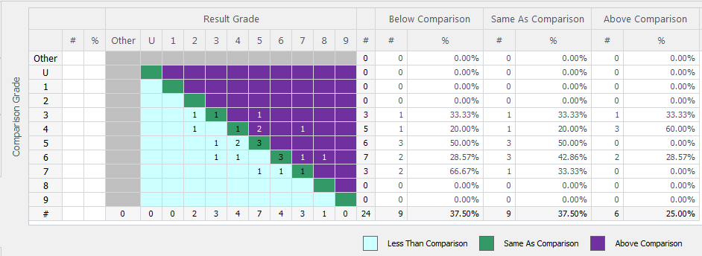
A Level

A Level results department overview | A*-A % | A*-B % | A*-C % | A*-E % | Entries
A - Drama & Theatre Studies | 20 | 60 | 80 | 100 | 10

Job Description
Job Title | Teacher of Drama
Job Description | This job description forms part of the contract of employment of the successful applicant. The appointment is subject to the conditions of employment of Teachers contained in the School Teachers’ Pay and Conditions document and other current educational and employment legislation.
Review Date of Job Description | June 2022
Establishment | Wood Green School, Woodstock Road, Witney, OX28 1DX
Responsible to: | Head of Drama
Responsible for: | Teaching and supporting all designated classes in Drama
Purpose of Post | - To implement and deliver an appropriately broad, balanced, relevant and differentiated curriculum for students and to support a designated curriculum area as appropriate  - To monitor and support the overall progress and development of students as a Teacher/Form Tutor  - To facilitate and encourage a learning experience which provides students with the opportunity to achieve their individual potential.  - To contribute to raising standards of student attainment  - To share and support the school’s responsibility to provide and monitor opportunities for personal and academic growth
Teaching | - To undertake a designated programme of teaching across all key stages  - Teach consistently high-quality lessons  - Plan and deliver schemes of work and lessons that meet the requirements of the KS3, 4 and 5  - Be a role model for students, inspiring them to be actively interested in Drama  - To maintain appropriate records and to provide relevant accurate and up-to-date information for Management Information Systems etc  - To complete the relevant documentation to assist in the tracking of students  - Set expectations for staff and students in relation to standards of achievement and the quality of learning & teaching  - Prioritise and manage time effectively, ensuring continued professional development in line with the role  - To follow the school policies and procedures  - To ensure the effective/efficient deployment of classroom support  - To maintain discipline in accordance with the school procedures, and to encourage good practice with regard to punctuality, behaviour, standards of work and homework  - Follow schemes of work for Drama at all Key stages  - Promote aspects of Personal Development related to Drama  - Updating professional knowledge and expertise as appropriate to keep up to date with developments in teaching practice and methodology, in general, and in the curriculum area of Drama  - Promote Drama learning through out of hour’s activities  - Ensuring a high-quality learning environment throughout the Drama area.
Assessment, Feedback and Tracking | - To lead, monitor and evaluate the assessment and feedback to students in line with whole school and department policy  - To follow department monitoring and tracking systems relating to students’ attainment, progress and achievement  - Mark, grade and give written/verbal and diagnostic feedback as required  - Undertake assessment of students as requested by external examination bodies, curriculum areas and school procedures  - Assess, record and report on the attendance, progress, development and attainment of students and to keep such records as are required  - Complete the relevant documentation to assist in the tracking of students  - To follow department policy regarding department tracking of student progress and use information to inform learning and teaching  - Follow setting and co-ordinating assessment arrangements in Drama at all Key Stages, and in all areas as required by school policies, including standardising those assessments.
Staff Development | - To continue personal development in the relevant areas including subject knowledge and teaching methods  - To engage actively in the Performance Management process  - Participate in whole school CPD programmes  - To take part in the staff development programme by participating in arrangements for further training and professional development.
Student Support and Progress | - To be a Form Tutor to an assigned group of students  - To promote the general progress and well-being of individual students and the Tutor Group as a whole  - To liaise with the relevant pastoral leaders to ensure the progress of students  - To register students, accompany them to assemblies, encourage their full attendance at all lessons and their participation in other aspects of school life  - To evaluate and monitor the progress of students and keep up-to-date student records as may be required  - To lead the Wood Green Baccalaureate within the tutor group  - To contribute to the preparation of Action Plans and other reports as required  - To alert the appropriate staff to problems experienced by students  - To communicate as appropriate, with the parents of students and with persons or bodies outside the school concerned with the welfare of individual students, after consultation with the appropriate staff.  - To contribute to PSHE and citizenship and enterprise according to school policy  - To apply the Behaviour for Learning policy so that effective learning can take place  - Meet with students over whom there are concerns and contact home where necessary in conjunction with student support team and department heads.
Safeguarding | Be keenly aware of the responsibility for safeguarding children and to help in the application of the Safeguarding and Safe Practices policy within the school.  Comply with the school’s Safeguarding Policy in order to ensure the welfare of children and young persons.

Person Specification
criteria |  | qualities
Qualifications  and training | - Qualified teacher status  - Successful teaching experience  - Evidence of professional development relevant to this role
Skills and knowledge | - Good classroom practice, constantly showing a positive and resilient approach to students and staff  - Excellent communication and organisational skills  - Knowledge of effective teaching and learning strategies  - A good understanding of how children learn  - Ability to adapt teaching to meet students’ needs  - Ability to build effective working relationships with students  - Knowledge of guidance and requirements around safeguarding children  - Knowledge of effective behaviour management strategies  - Effective communication and interpersonal skills  - Ability to build effective working relationships with staff and other stakeholders
Personal qualities | - High expectations for all students and belief in bringing out the best in all  - Commitment to upholding and promoting the ethos and values of the school  - Commitment to always act with integrity, honesty, loyalty, and fairness to safeguard the assets, financial integrity, and reputation of the school  - Ability to work under pressure and prioritise effectively  - Commitment to always maintaining confidentiality  - Commitment to equality

We are not looking for the impossible! If you think that you have at least some of these attributes, we would very much like to hear from you.
Appointment will be subject to enhanced DBS check, qualifications and experience checks and satisfactory references.
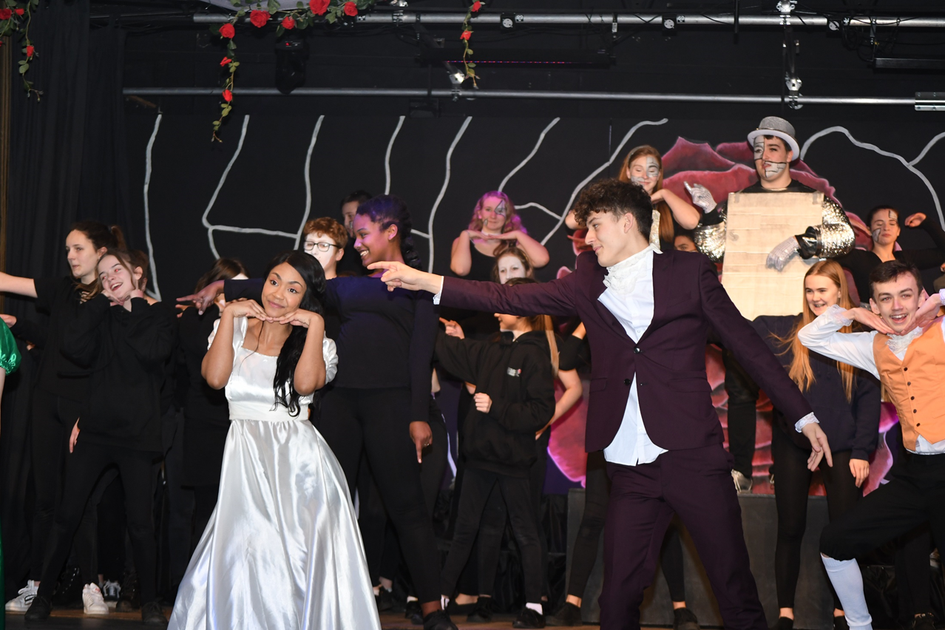
Drama Production of Beauty and the Beast - 2019

Wood Green School
Woodstock Road
Witney
OX28 1DX

01993 702355
vacancies@wgswitney.org.uk
www.wgswitney.org.uk

