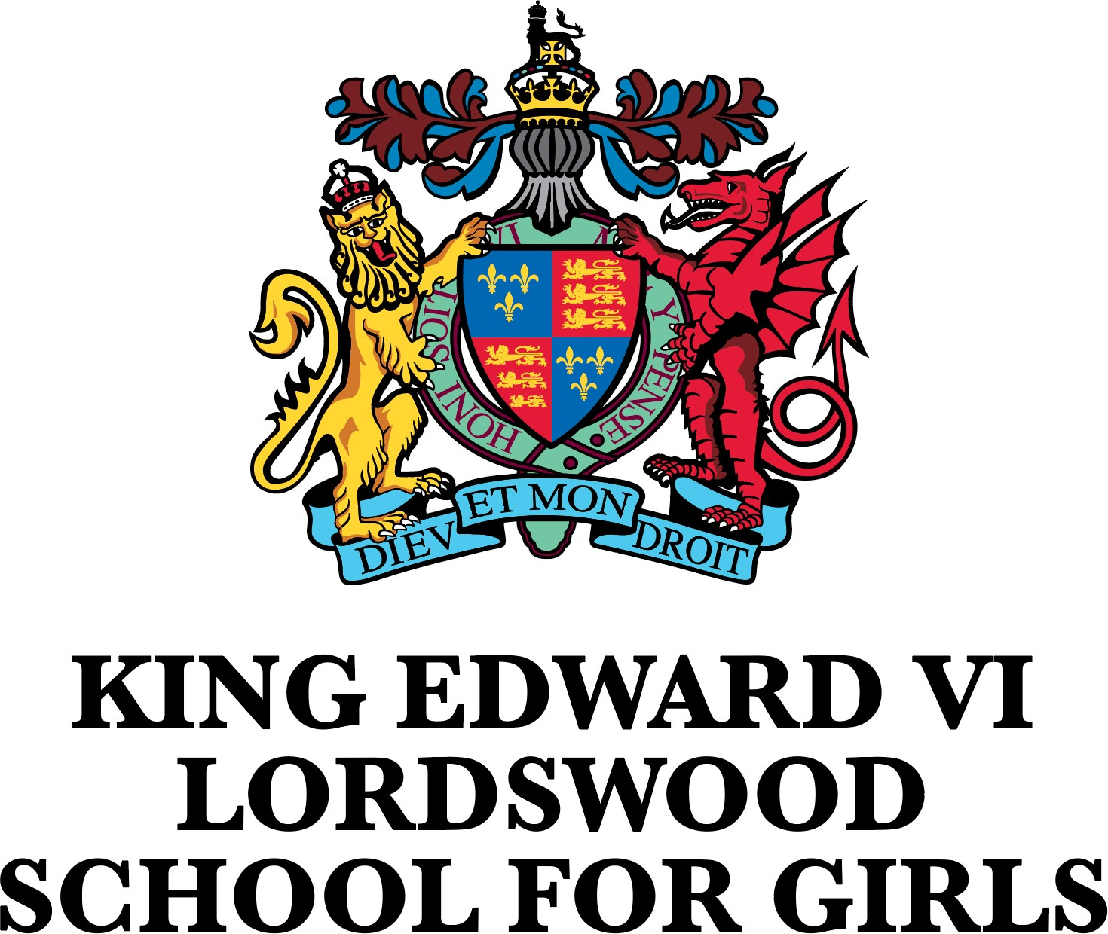
Teacher of Drama (0.6)

About the Academy Trust
King Edward VI Academy Trust in Birmingham is committed to safeguarding and promoting the welfare of children and young people and expects all staff and volunteers to share this commitment. Shortlisted candidates will have online content checks undertaken before interview. The successful applicant will also be subject to an enhanced DBS check. Please note, where a role involves engaging in regulated activity relevant to children, it is a criminal offence to apply for the role if the applicant is barred from engaging in regulated activity relevant to children.

King Edward VI Academy Trust in Birmingham is committed to equal opportunities in employment and positively welcome your application irrespective of your age, disability, gender reassignment, marriage and civil partnership, pregnancy and maternity, race, religion or belief, sex, or sexual orientation.

Vacancy Details
Salary: | MPS/UPS
Hours: | Part-Time (0.6), Permanent
Location: | KEVI Lordswood School for Girls, Harborne, Birmingham B17 8QB
Start date: | September 2024
Closing date: | Noon on Monday 24th June 2024
The King Edward VI Foundation, Birmingham, is a progressive charitable organisation which has supported excellence in education across the City since 1552. Our schools are diverse in nature but have a common purpose and commitment to achieving our mission of “making Birmingham the best place to be educated in the UK”.

Our Academy Trust currently consists of two independent schools, six selective, and five non selective academies. Our recent expansion into a wider diversity of local communities is enabling us to accelerate our strategies for improving the life chances of young people in Birmingham, whatever their background.

The King Edward VI Academy Trust Birmingham (“the Academy Trust”) was established in 2017 and is made up of the academies outlined above. The academies receive back office central support services including governance, from the Foundation Office (a central support services function), with several staff being seconded from the Foundation to deliver support services to the Academy Trust and the academies themselves.

Our highly focused five-year strategy aims to build on our existing strengths and heritage and deliver our ambitious growth strategy which aims to bring in a further five academies over the next five years.

King Edward VI Lordswood School for Girls, Harborne, offers an excellent academic education within a happy and
purposeful community. High quality teaching, good behaviour, and valuing each individual are central to our
exciting approach to pre and post-sixteen study.

All students are encouraged to realise their fullest potential, to live and work in harmony with others and to be ambitious for their futures. Students are supported in their work by a team of highly professional and caring staff.

Student outcomes are significantly above national figures, but this is not what makes us most proud. Our school is a community, and whilst we value academic success, this is not the only objective of our school. We pride ourselves in growing good citizens, we help to develop girls who have the knowledge, skills and the desire to make a difference to the world in which they live.
The world today is changing rapidly and our aim is that all students will leave as flexible, positive and assured young people. Past students provide fine examples of this by excelling in a wide range of careers and interests.

King Edward VI Lordswood School for Girls, is a happy, active place; students work hard and have fun. The facilities are excellent, the opportunities on offer are exciting, but it is the people who make it special. We hope that you will want to be one of those people.

We are now looking to appoint an excellent Teacher of Drama to join our successful team, who is creative and
passionate about their subject area and able to inspire all students to reach their full potential.

The post offers excellent working conditions and a comprehensive development programme.

We encourage all interested applicants to visit the school and this can be arranged by contacting Sheila Allport via
email, s.allport@lsg.kevibham.org.
How to Apply
A full job description and an application pack for this post can be found at: https://lsg.kevibham.org.

Completed application forms should be forwarded to Sheila Allport via email, s.allport@lsg.kevibham.org, by noon on Monday 24th June 2024.
The Schools of King Edward VI in Birmingham is an educational charity supporting eleven schools and is committed to safeguarding and promoting the welfare of children and young people and expects all staff and volunteers to share this commitment. Applicants will be required to undergo child protection screening appropriate to the post, including checks with past employers and the Disclosure and Barring Service (DBS).
This post is covered by Part 7 of the Immigration Act (2016) and therefore the ability to speak fluent and spoken English is an essential requirement for this role.

Charity Number 529051

