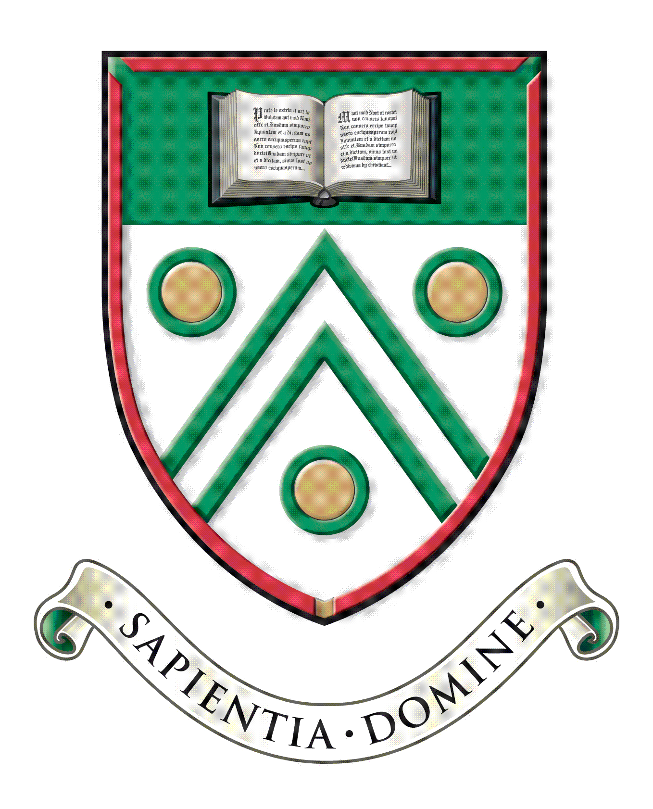

Langley Grammar School
Reddington Drive
Langley, Berkshire. SL3 7QS

Tel: 01753 598300
e-mail: school@lgs.slough.sch.uk
web: www.lgs.slough.sch.uk
Headteacher: Mr J Constable

Teacher of Economics
Main scale (London Fringe)
Part-time (0.6-0.8 FTE negotiable)

Required for September 2023

We are seeking to appoint an outstanding and inspirational teacher of Economics to join a thriving department. The successful candidate work with the Subject Leader to teach A-Level Economics to both Year 12 and 13 students. Candidates should have a track record of successful Sixth Form teaching and should have the academic background and knowledge to teach Economics to highly motivated and aspirational students. The successful candidate would be expected to develop, maintain and stimulate students’ curiosity, interest and enjoyment of Economics through consistently planning and delivering high quality and engaging lessons. The ability to teach a second subject other than Business Studies would be advantageous.

Langley Grammar School is a co-educational 11-18 selective school with academy status, located within easy reach of Langley station and the M4. The school was inspected by Ofsted in November 2021, and was graded outstanding in all categories. We have approximately 1240 students, over 330 of whom are in the Sixth Form. The school is heavily over-subscribed and draws students from a wide geographical area and range of backgrounds. Alongside promoting excellent academic outcomes, our school ethos supports students to become confident and well rounded, independent and creative, responsible and caring. Our students are capable, hardworking and a delight to teach. We are a National Teaching School with a record of nationally recognised innovative practice, and an Apple Distinguished School in recognition of our leading-edge use of technology for learning. In recent years major building programmes have included the construction of excellent sports facilities, a distinctive Sixth Form Centre and new classrooms, workshops, laboratories, ICT suites and staff accommodation. In February 2020 we took possession of our new teaching block and the current building programme was completed in autumn 2021. We enjoy fantastic new teaching spaces and communal areas.

Information packs and application forms are available on request from the school, or can be downloaded from the school website at www.lgs.slough.sch.uk.

We are committed to safeguarding and promoting the welfare of children and expect all staff to share this commitment. Applicants must be willing to undergo child protection screening appropriate to the post, including checks with past employers, online checks and with the Disclosure and Barring Service.

Applications should be returned by midday on Monday 6th February 2023 to Mrs Dionne Cheyne, Head’s PA at vacancies@lgs.slough.sch.uk. Interviews will be held thereafter. We reserve the right to interview promising candidates prior to the closing date.

