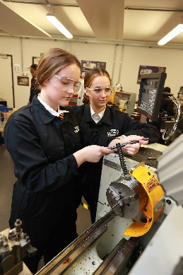
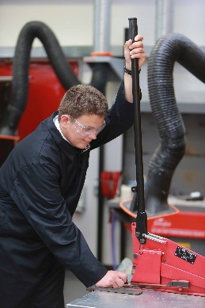
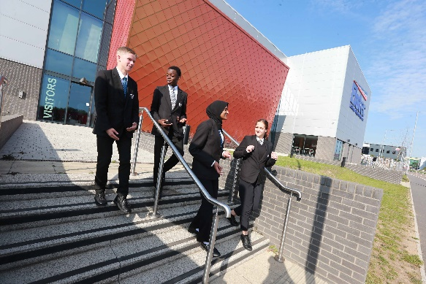

TEACHER OF ENGINEERING
(PART-TIME OR FULL-TIME)

COMMENCEMENT: APRIL 2022

We are looking for an enthusiastic and committed professional to work as part of our team to deliver outstanding teaching and pastoral support to our students.

We have extensive workshop facilities and focus on delivering our lessons to our students through practical activities. Our commitment to our students is to develop their skills to enable them to problem solve, create and design solutions using the applications and skills used in industry. We have strong links with industry and use their expertise to further enhance the students understanding, through extra curricula projects.

Working across KS4 and KS5, this is an opportunity for a hard-working professional to work with students who have are passionate about STEM subjects. You will be working in a supportive, nurturing culture that sets high expectations of educational outcome whilst supporting students to fulfil their academic potential and achieve their goals of a STEM destination.
Elutec Academy is housed in an impressive new building in Barking and Dagenham, part of the Business and Science Park which is soon to be joined by an exciting new film studio complex. The school has excellent transport links, with Dagenham East tube station a short walk away.

The school’s exceptional sponsors include Ford Motor Company, one of the world's foremost design, engineering and manufacturing enterprises, and the Faculty of Engineering at University College London (UCL), ranked as one of the top 20 universities in the world.

We offer staff the opportunity to work full or part-time along with on-going opportunities to continue their professional development.

THE POST
Teacher of Level 2 and Level 3 Engineering
Potential for career development within the department for the right candidate.

How to apply
Please return your completed application form by email to: s.marsh@elutec.co.uk
CVs will not be accepted.

Pre-employment checks
Confirmation of appointment is conditional upon a satisfactory enhanced DBS check and occupational health check.

References
Confirmation of appointment is also subject to the receipt of two satisfactory references.

Salary
Inner London Main Scale (depending on skills and experience)
For a candidate with the potential for further leadership, the salary will reflect the additional responsibilities.

Commencement
April 2022

Closing date for applications: 12 noon, Wednesday 26th January 2022

Visits and informal discussions

If you would like to have an informal discussion about the post, in the first instance please contact Claire Bannister: c.bannister@elutec.co.uk or telephone 0204 524 7257

Engineering Teacher Person Specification
Category | Essential | Desirable
Qualifications | - Honours degree in the relevant teaching subject or equivalent  - Relevant subject specialism  - QTS | - Engineering qualifications
Experience | - Teaching 14-19 year olds  - Ability to use a range of teaching and learning strategies to secure excellent learner progress  - Planning and recording – able to plan a curriculum scheme of work, plan lessons that ensure good student progress, measure attainment and progress and produce information for accurate data tracking to identify and ensure timely intervention  - Track record of excellent teaching | - Ability to teach KS4 & KS5  - Further study, work in industry, professional development undertaken
Knowledge, Understanding and Experience | - Knowledge of the curriculum at Key Stage 4 & 5 and relevant awarding body syllabuses for technical qualifications at level 2 and 3.  - Excellent classroom teacher with detailed understanding of pedagogy  - Of effective assessment for learning strategies  - Of how students learn with evidence to show how this can be effectively translated into classroom practice and an impact upon the levels of student achievement  - Understanding of differentiated teaching strategies to ensure progress of all students in a teaching group | - Able to demonstrate a knowledge of initiatives to link numeracy and literacy and the broader curriculum into their subject
Other Skills and Abilities | - Command respect of students and staff and be an advocate for the UTC  - High standard of interpersonal skills. Excellent written and oral communication skills with the ability to communicate effectively to a variety of audiences  - Commitment to working in partnership with parents and employers  - Excellent at working in teams  - Ability to manage time and prioritise well, meet deadlines and work under pressure  - Able to demonstrate a knowledge of innovative approaches to the teaching of an agreed subject specialism  - Evidence of high quality teaching skills  - Strong team working skills and the ability to work effectively with people at all levels  - Able to create project based scenarios rooted in the local community or relevant industry | - Ability to demonstrate innovation and creativity in their subject  - Interest in whole school developments and the wide life of the school
Personal Qualities | - Commitment to the aims and values of the UTC  - Honesty, integrity, ability to build trust  - Resilience  - Energy, enthusiasm and a sense of humour  - Confidence, communications skills and fluency to deal with employers, students, parents and community organisations  - Awareness, understanding and commitment to equal opportunities  - An understanding of the needs of young people  - Maintains high professional standards at all times  - Commitment to own professional development | - An understanding of the needs of business and industry

