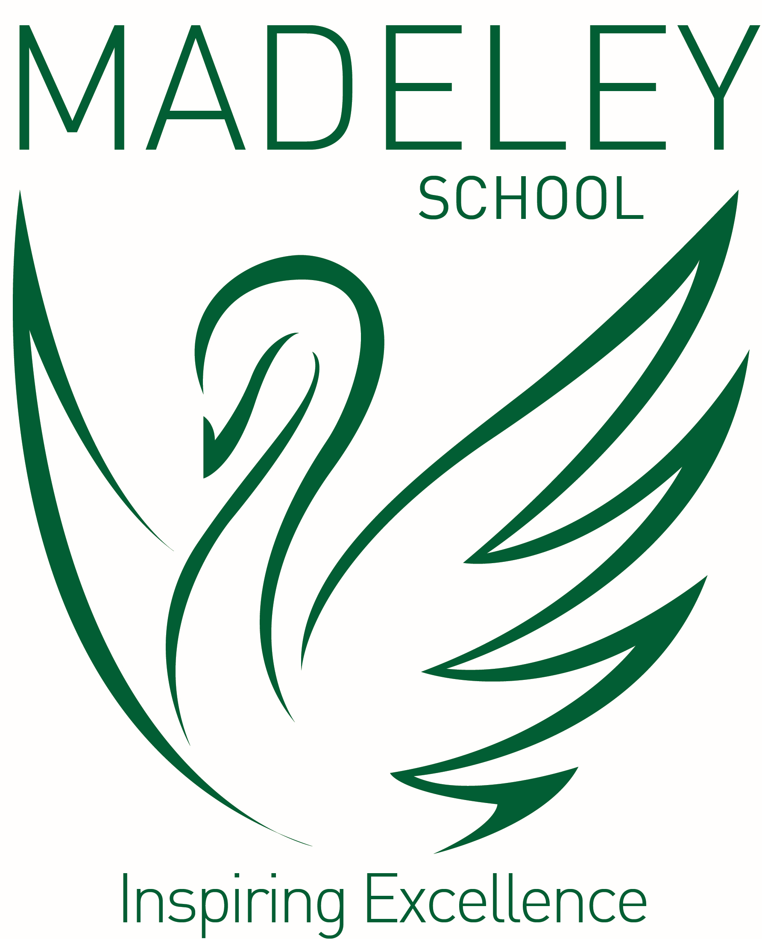
 | Faculty Teacher of English (Maternity Cover)
Salary: | M1 - U3, £28,000 - £43,685 FTE Salary per annum
Working hours: | 32.5 hours
Contract type: | 12 months Fixed Term Contract - Maternity Cover
Start date: | September 2023

We are seeking to appoint a motivated and professional Teacher of English to join our innovative and forward looking Faculty of English and Literacy. The successful candidate will be an outstanding Teacher, able to teach high quality lessons across the age and ability range. This position would also be suitable for an outstanding NQT wishing to begin their career as part of a supportive, collaborative and forward-looking subject team.
The successful candidate will be:
- Professional, creative, flexible and innovative with the drive and determination to successfully contribute to whole school improvement
- A dedicated team player who develops excellent relationships with learners and colleagues
- An individual who communicates clear expectations, leads by example and always promotes positive behaviour for learning
- Willing to fully support and always uphold the policies and positive ethos of the school
- Willing to participate in personal continued professional development

Madeley School has an excellent reputation locally and is oversubscribed. Our OFSTED report in December 2019 praised pupils’ exceptional attitudes to learning in a school where they achieve strong outcomes.

Madeley School is an academy within the Shaw Education Trust. The Trust is led by an Executive Leadership Team steeped in school leadership and improvement experience: www.shaw-education.org.uk. They are committed to the continued professional development of all members of staff and the sustained successful performance of all its academies.

SHAW EDUCATION TRUST was established in 2014 and is sponsored by Shaw Trust and is a growing group of dynamically awesome academies providing education to children of all ages and abilities. Staff across our team of schools are dedicated to ensuring that every child has the opportunity to be successful, whatever their starting point in life. Unlike other MATs, we don’t enforce a curriculum for all our schools to follow. Instead, we support each individual school to offer a programme that enables our students to deepen their knowledge, develop their skills, sparks their imagination and fires their curiosity.

To achieve this, we pledge an unswerving commitment to improve, accelerate and enable ambitious life goals amongst all our students, and provide our schools with the support they need to deliver the highest possible quality of education. Every action we take as a Trust is guided by our core values, with the best interest of our students and staff members at the heart of everything we do.

The Shaw Education Trust offer the following benefits with your Teaching or Support Staff employment:
- An excellent Local Government Pension Scheme Teachers Pension (Teaching Staff)
- Access to health and wellbeing support via Occupational Health
- Cycle to work scheme
- Access to our Institute of Education and fantastic opportunities to help you grow, contribute and flourish in your role and in the Trust.

Colleagues within the Trust benefit from:
- Access to a full range of courses both in-house and professionally accredited. These courses include all of the National Professional Qualifications – NPQH, NPQSL, NPQML.
- High quality subject and thematic networks across the Trust and the region.
- Experienced leadership and subject-specific support.
- Guidance from former HMIs and serving Ofsted Inspectors within the Trust.
- Access to the Trust’s Teaching School, Research School, Institute of Education and SCITT.
- Opportunities to work with different schools within the Trust as a Professional Advocate.
- Participating in peer reviews.
- Access to a suite of online courses.
- Placement projects within our family of schools.

To Apply, click - https://ce0524li.webitrent.com/ce0524li_webrecruitment/wrd/run/ETREC179GF.open?WVID=17491515f0&VACANCY_ID=7240963LI7

Madeley School is committed to safeguarding and promoting the welfare of children and young people and expects all staff and volunteers to share this commitment, click here to review Safeguarding and Pupil Protection Policy https://www.shaw-education.org.uk/our-trust/key-information

This position is subject to appropriate vetting procedures including a criminal record check from the Disclosure and Barring Service (formerly CRB) which will require you to disclose details of all unspent and unfiltered spent reprimands, formal warnings, cautions and convictions.

We are an Equal Opportunities employer and will ensure that all our recruitment and selection practices reflect this commitment.

In accordance with our safer recruitment policy CV’s alone will not be accepted.

Application deadline: Friday 21st April 2023
Interview date: To be confirmed

We reserve the right to appoint before the closing date, therefore, we encourage early applications.
Successful candidates will be subject to a fully Enhanced DBS check along with other relevant employment checks.

